
Video #4 of Keys to Speech and Debate Success
“The WINNING Key”
Watch Video 4

KEYS TO SPEECH AND DEBATE SUCCESS is a compact video course designed to prepare you for a successful speech and debate season.

Review
I sure hope the updated KEYS TO SPEECH AND DEBATE SUCCESS helped put a new focus on Season 21. You’re going to be more ready than ever! These videos are a “path to success”:
- VIDEO #1: The Foundational Key
- VIDEO #2: The Practical Key
- BONUS VIDEO: Interview with the Jeub Kids
- VIDEO #3: The Strategic Key

Key #4: The Winning Key
“Join the Champions.”
You get consistent coaching ALL YEAR LONG when you become a Monument Member. Season 21 will be here very, very soon. You’ve gotten the chance to browse the site here at the end of Season 20. You can imagine:
- Members are trained throughout the year. They zero-in on the events they compete in, and source material is released every “Monument Monday” to consume throughout the year.
- Members are set up for success. The source material and the mountains of instructional material are all available to members. Why? To get you a trophy at your next tournament!

Four Levels of Membership
The four levels of membership is brand new to Monument this year, essentially including two new levels (an entry level and an partnership level). Here they are, listed with the three main benefits of each:
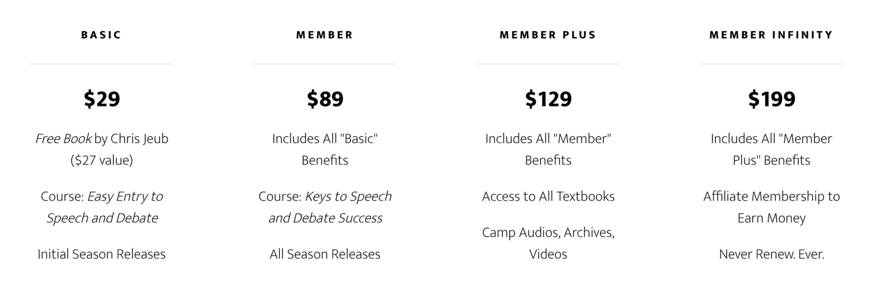

30-day Money-back Guarantee
Not satisfied with your Monument Membership? No problem. We’ll refund your payment and part ways, no questions asked. (No risk at all!)

time-sensitive upgrade
Member Infinity Limited Entrance
The new “Member Infinity” carries a membership to Monument’s source material that never expires. It includes all library items in the Member Plus member, too. The price of $199 is its introductory price, but it may go up in the future. Also, this membership opportunity only opens up at certain times of the year.
This is our newest member level, and it is the only level that offers the affiliate option. Starting off Season 21 Infinite Members will earn 20% commission on all member sales, effective immediately. This optional upgrade is perfect for coaches, tournament directors, and competitors who want a little extra income to help pay competition expenses.
ANNOUNCEMENT: I will be coming out with a new course soon called EASY ENTRY TO THE WORLD OF SPEECH AND DEBATE, a similar course to KEYS but aimed at the extreme “newbie” to speech and debate. This course will be heavily advertised through Google and social media. Affiliates will be allowed to advertise with their own affiliate code and make commissions.

Monument’s Purpose: IMPACT
I end on a note that I hadn't fully anticipated. Teaching an e-learning course sometimes rolls that way. KEY #4 unveils the new pricing and member benefits — some of the deals are timely. But I end on what I call an "evangelical" community of speech and debate.
Something magical happened on Wednesday when I released the BONUS video of my family. And then the next day (Key #3) I posted videos of my son and daughter competing. Both are starting families of their own, and they both attest to the powerful experience of speech and debate in their life.
Here's a picture of Micah, myself, and his beautiful new daughter — born not even a month ago:

Micah and his wife, Kya, met at an NCFCA tournament years ago, and now they're married and having children. My, my. What a family we are building.
I coach and teach and run camps and build source material for more than just getting kids to win trophies. Oh, trust me, you'll win a lot of trophies if you listen to my teaching, but I've got much bigger aspirations for you.
I want your speech and debate skills to IMPACT the world in powerful, wholesome, purposeful ways. Those "ways" are unique to you — a heaven-stamped purpose that you may not have figured out yet — but you'll be 10x more effective at it with the speech and debate skills you learn from Monument.
And I want you to want the same for others. Let's grow this community of speech and debate! Let's grow this family.
Anyway, that is the note that this class ends on. I hope you join me in making a positive IMPACT on the world.
Chris Jeub
Teacher and Writer

Join Monument Today

