Meanwhile, Back at the Ranch
Source Material of a Champion Humorous Interpretation
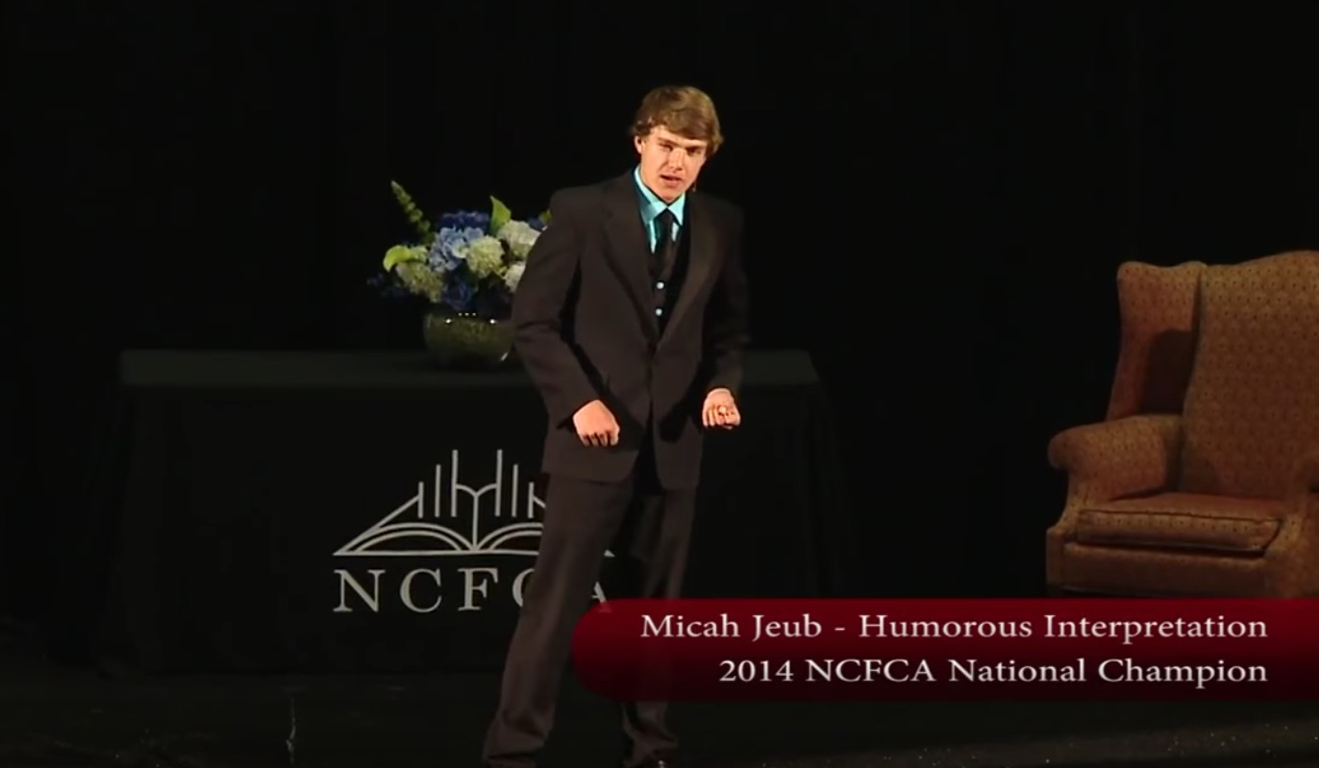
August 19, 2019
This speech was performed by Micah Jeub in Season 14 (2013-2014). He took 1st place for both Stoa’s National Invitational Tournament of Champions and NCFCA National Tournament. He has the honor of being the first student to win both national titles in the same event in one year.
The NCFCA eliminated Humorous Interpretation as an event, but they may be run in Open Interpretation instead. Stoa explains HI in this way on their website StoaUSA.org/events/humorous-interpretation:
In Humorous Interpretation the competitor creates an amusing, original rendition from a single piece of literature which captivates and entertains the audience. Stand-up comedy, or telling a series of jokes without a corresponding plot, is not Humorous Interpretation. Speakers select and analyze literature, then bring it to life through the creative use of voice, movement, and facial expression.
Directions: Use this source material to enhance your understanding of expos. This speech is an excellent example of champion speaking. You may want to consider doing this event in Season 20.
Meanwhile, Back at the Ranch
by Micah Jeub
You can watch the entire speech at:
https://youtu.be/k_mNqxlsiD0
I want to be a standup comedian someday, so I set out to be the funniest guy in the country. This is a big reason why I am involved in speech, especially the category of Humorous Interp. I’ve always done well with it, especially with storybooks that I used to have read to me as a kid. In 2013 I chose Meanwhile, Back at the Ranch by Trinka Hakes Noble.
The story compares and contrasts the day Mr. and Mrs. Hicks have apart from one another: Rancher Hicks in Sleepy Gulch and Elna Hicks back at the ranch. Sleepy Gulch is so boring and flat that you could watch our dog run away for two days. In fact, this is what I said in the introduction:
Do you ever feel like your life is moving so slowly that nothing ever happens? Like Sleepy Gulch: it was the kind of place you could watch your dog run away for two days. Or, do you ever feel like your life is moving so fast like instead of putting water in the coffee maker you put a Red Bull through the coffeemaker and then get half way to work and realize you forgot your car? Or do you ever feel like a box of Cracker Jacks and all you ever get are the lick-n-stick tattoos? Maybe it’s all the commotion that happens that makes us not think of all the wonderful little things that are happening. Let’s take a little more time and think about the little things that can make our lives better.”
Let me compare two scenes, one in Sleepy Gulch and the other back at the Ranch. The most exciting thing that happened in Sleepy Gulch was a turtle crossing Main Street. The book says the Mayor came out and declared it a town holiday:
Meanwhile...back in Sleepy Gulch...
Rancher Hicks started to cross Main Street when he saw it!
“Amazing,” he gasped.
Folks ran to see it.
“Incredible,” they said.
A crowd gathered.
“This is big news, really big,” said the newspaper editor.
“We’d better wake up the mayor,” said the sheriff.
The mayor came. “Why I’ve never seen anything like it!” said the mayor. So he declared it a town holiday.
The whole town watched it for hours and hours until finally...a turtle crossed Main Street!!
I’d say this was sort-of funny, but not hilarious. Here’s how I built this up for the judges. I made it seem so cool and fun before I told my judges what exactly was going on. I imagined the turtle crossing Main Street and everyone staring at the ground watching. I even waited for several seconds expecting the judges to watch what I was pointing at. That made a not-so-funny scene to be very funny.
Then I would, of course, snap right to “meanwhile, back at the ranch…”
All the horses had colts when the President’s helicopter landed in Elna’s yard. “Elna hicks,” he said, “you’ve got the finest horses west of Washington. I’m making you a diplomat. Please deliver two of your finest horses to the Queen of England!”
The president paid Elna for the horses and gave her a diplomat’s diploma and an autographed picture of himself. “Don’t forget to vote for me!”
This was a pretty lame part of the book, not much funny at all. I made it seem spectacular by swinging around in a circle like a landing helicopter, clicking open the door, and actually acting like the president at the time, Barack Obama. To make this a stitcher, I needed to sound as close to Obama as I possibly could. I watched YouTube videos of him and got it down pat. I said the same lines as from the book, but I imitated the real President of the United States. When I performed this in Virginia for the NCFCA Showcase, Michael Farris was sitting in the front row. I had him in tears.
Those are two parts that people loved to laugh at. On the surface, they weren’t particularly funny, but after I got done with them, the judges were in stitches.

Why I considered dual affiliating
Soon after taking my first 1st place trophy at a larger tournament during the speech season, I visited SpeechRanks.com to see how I would measure up with the other HI competitors. I ranked 3rd in the nation, not an easy task, but I was surprised when I had never heard of the two interpers ahead of me.
Who were Micah Bock and Christopher Roberts??? They had a boatload of points, and I had just won at the largest tournament that I knew of. “Who are these cheaters?” I thought. So I started stalking them.
I soon found out that they were in the NCFCA. I brought this news to my Wise Pop, and to my surprise, he wasn’t surprised. “NCFCA has more HI competitors than Stoa,” he said. “So, Micah, there is no way you’re going to get 1st place in the nation.” He paused, I wept, and then he said: “Unless the Lord opens up an opportunity to compete in NCFCA.”
Just then, my mom walked in and said she had been given two standby airline tickets to Minnesota. The National Open, an NCFCA event, was going to be in St. Paul in two weeks. My dad sent the league president an email asking to get in, and she let me. These mountains were moving fast, and before we knew it, I was in Minnesota competing in my first-ever NCFCA tournament.
I had to make a lot of changes to abide by the rules at that time, but let me just say this: I started this journey thinking only of how to get the best competitive advantage and be #1 on SpeechRanks. I ended up becoming friends with at least a hundred amazing people who I didn’t even know were out there. Yes, I did win that tournament and qualify straight to Nationals; but, more importantly, I ended up having a lot of FUN. And that, to me, is more important.

What I discovered when dual affiliating
I’ve been competing in Stoa my whole life, and I always thought, “Stoa...you’re heaven.” And I thought, “NCFCA...you’re [not heaven].” But I don’t know what I was thinking. I had straw-man images of the other league, and my own interpretation of Stoa was reflective of my own experiences.
I’m so glad my dad encouraged me to become dual affiliated. Not because I won another national tournament (though that was awesome), but because I was a lone kid entering an atmosphere where I knew no one but had the chance to make friends. I love opportunities like that!
This leads me to three thoughts: opportunities, friends and potatoes.
1. Opportunities. During this experience, I got to travel more (California, Minnesota and Virginia were awesome). I loved meeting new people (like my Region 3 peeps and my adopted Region 6 parents). More importantly, though, I got to sharpen my speaking skills and become better and better at comedic timing. Remember, my ambition is to be a standup comedian, so this opportunity was all I could ever ask for.
2. Friends. I love making new friends! The reality is that I could spend time with other funny kids all day, and I found amazing people in both leagues. Which leads me to my third thought:
3. Potatoes. Rancher Hicks thought life was dandy in Sleepy Gulch, and Elna thought in the end, “Shoot! I miss everything.” Lots of NCFCAers dish on Stoa, and lots of Stoaites dish on NCFCA. But you know what? Both leagues are there to dig potatoes. They’re there to speak and debate, that’s what they both provide environments for, and they’re both great to be a part of.
Who knows? Maybe you will dual affiliate this year and learn so much that you will win both National Tournaments, too! But whatever happens, know this: You will be a better competitor if you stretch yourself and give it your all in both leagues.
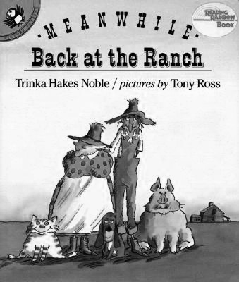
Meanwhile, Back at the Ranch is a storybook by Trinka Hakes Noble.
(Puffin, ISBN 978-0140545647, September 1, 1992).

