The Book of Awesome
Source Material of a Champion Duo Interpretation
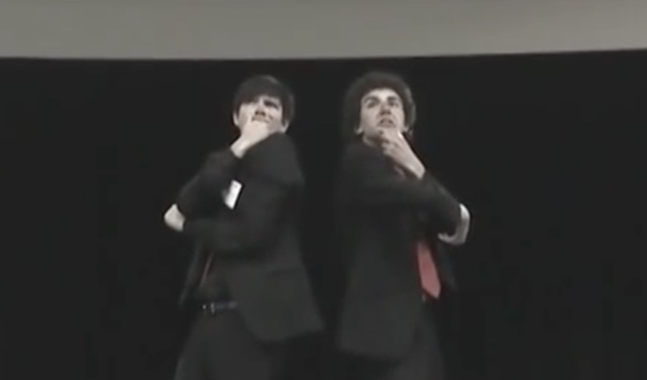
August 26, 2019

This unforgettable speech was performed by Kasey Leander and Benjamin Griffith, Stoa’s Hall of Fame Duo Champions in 2011. They won the National Invitational Tournament of Champions in San Diego with this Duo Interp on “The Book of Awesome” by Neil Pasricha. They ended the season ranked 2nd in Duo Interp on SpeechRanks.com for the 2010-2011 season.
Stoa explains Duo Interpretation in this way on their website (http://stoausa.org/wp-content/uploads/2017/07/Duo-Interpretation-Rules-2017-2018.pdf)
Description: In Duo Interpretation, two competitors create an original rendition of a story from one or more selection(s) of literature which captivates and moves the audience.

Goal: To select and analyze literature, bringing it to life through creative use of voice, facial expression, and movement without interacting face-to-face.

Directions: Use this source material to enhance your understanding of Duo. This speech is an excellent example of champion speaking. You may want to consider doing this event in Season 20.
The Book of Awesome
by Benjamin Griffith and Kasey Leander
You can watch the entire final round at:
https://www.youtube.com/watch?v=4LI5DgbOtzk&t=3s

Introduction to Piece
“Polar icecaps are melting, hurricanes swirl in the seas, wars are heating up around the world, and the job market is in a deep freeze.” This book is awesome. Literally.
In 2008, Neil Pasricha was juggling the continual bombardment of depressing news in the world along with his own personal struggles. He had just experienced a painful divorce and was overwhelmed when he heard that one of his closest friends had committed suicide. At this point in Pasricha’s life, there seemed to be nothing that could bring him comfort.
In the midst of all his pain and frustration, he challenged himself to stay positive by focusing on the little joys in life. He created a blog called “100 Awesome Things.” Every day he would write a short essay about something Awesome. To his surprise, his blog went viral. Not long after he created the site, his webpage had millions of hits from around the world. Encouraged by people’s interest in his simple writings, Pasricha decided to compile a large selection of his “awesome things” and publish The Book of Awesome in 2010.
We heard about this book through a friend who introduced us to the “100 Awesome Things” webpage. But finding such a bodacious piece was not as easy as 123 (nor ABC for that matter). We spent a good amount of our precious time at our local library, reading through countless books (23, to be exact) in order to find the perfect selection. After shedding blood, sweat and tears at the library, we trekked through the wilderness for miles and miles (2, to be exact), enduring scorching heat and other hardships until we collapsed at Kasey’s doorstep. We still had not found a winning piece. At our next meeting, while eating lots of delicious guacamole, we dissected the pages of several other books, still without success. It was not until much later that we discovered The Book of Awesome. The moral of this epic tale is to choose your piece wisely. You do not want to be stuck the whole year with a boring selection. Make sure your piece is PERFECT for you and your partner’s personalities. The Book of Awesome worked like magic for us.
Speaking of partners, be sure you pick a suitable partner. You want to choose someone whose acting style will compliment your own. In our Duo, Kasey’s wide variety of hysterical vocal characteristics mixed well with Benjamin’s collection of comical facial expressions. This is not to mention the fact that we are basically non-biological bros with indescribable chemistry. Be sure that you and your partner are equally committed and 100 percent compatible.
We put this selection in Emerald Book in order to demonstrate the diversity of literature genres in interpretive events. We enjoyed The Book of Awesome because it was completely unique. It was nothing like your classic Shakespeare play or Dickens novel. It is simply a collection of optimistic ideas and thoughts coming straight from the heart of an ordinary man in our modern world. Because there was little actual dialogue in the cutting, it challenged us to create the conversations for ourselves and to incorporate captivating motions and entertaining synchronized blocking throughout the entire performance. The most important thing to remember when competing in an interpretive event is that you are showing the audience your interpretation. The best interps are those that engage the crowd with unique and fresh ideas inspired by the speaker’s own creativity and thought.

Interesting Things to Know
When we settled on it, this humorous piece ended up fitting us perfectly for us for a few reasons:
- It is relatable. As you will see later in excerpts from our script, Neil Pasricha is a brilliant author who is able to take mundane, simple things and create a masterpiece of humor, wit and readability. In all honesty, this is one of the only things that protected us from the “quality literature monster” –– that one judge who, no matter how cool your interp is, will pick on you for not interping Shakespeare. While The Book of Awesome is not “classic literature” by any stretch of the imagination, most––if not all––of our judges could totally relate to the awesome things we acted out.
- It is flexible. “Dude, I've totally lost interest in my piece.” Ever heard that before? Maybe you have even said it! The Book of Awesome afforded us a unique opportunity–– the ability to swap stories out when they got stale from overuse. While not the only way to spice up a flagging piece, the flexibility of what we could include as the year progressed helped us to continue laughing at our own interp (and if you are laughing and confident in your piece, the judges will usually be kind enough to reciprocate).
- It is meaningful. At first, we needed a little help on this one. We would consistently go right after dramatic Duos who would slap our audience with a paradigm of morbidity (e.g., judges would ask themselves “How can I possibly laugh at Finding your Keys after Looking Forever when I just watched Sydney Carton die via la guillotine?”). However, after investigating the author further, we found that his appreciation for the little things in life developed after a difficult time in his own. With some help from our 120-word introduction and the last chapter of the book (where he makes some searching observations), we were able to incorporate meaning into what could have been a shallow piece.
- It is awesome. By awesome, we mean that there was so much we could do with it. Because of the book’s structure and content, the blocking possibilities were endless. Add a dash of creativity (provided by our friends and siblings), some difficult but worthwhile synchronization and pump-up sessions, and we had us a championship Duo.
Here are a few comments we received from judges on our ballots:
"Awesome creativity & humor!"
"You two were... awesome!"
"There was a part of me that just wanted to write ‘Awesome’ all over this ballot :)"

Into the Interp
This book does not have a lot of dialogue, so we had to be creative with how we worked out most of our scenes. For instance, Awesome Thing Number 3– “Finding your Keys after looking forever” …
Benjamin: Panic sets in very slowly. It is early in the morning. You’re heading out for work. You casually tap your pockets and find them, surprisingly dentless.
Kasey: "No big deal, probably left them on the kitchen counter.”
Benjamin: So, you swing by the kitchen, only to find no dice, man. No dice at all. You double check your pants, flip through your purse
Kasey: “Purse?”
Benjamin: and pause for a split second to stare at the microwave clock while doing some math. You suddenly ditch your jacket on the floor and go perform the classic key hunting play in three acts.
We filled “Finding Your Keys” ––a scene with little workable dialogue––by first re-designating some narration (everything in quotation marks we turned into dialogue), and second by adding some creative blocking. As Benjamin played the stoic narrator, Kasey ran around the room acting out everything he said. This worked well as Benjamin’s dry humor contrasted with the whirlwind of activity that swarmed around him like a rock among rapids. Comedic timing was everything during this scene. We did not always nail it (the repeat “purse” line and the sentence thereafter had a tricky, split second “sweet spot” that we only consistently hit at nationals). The great key-hunting play crescendo’d in
Kasey: ACT III: THE FLOURISH
Benjamin: Nearly in tears and on the brink of madness, sweat drips down your face as you swing open the door with full force and then you spot them- hanging in the lock. The Audience leaps to their feet and erupts, filling the theater with booming applause, loud whistles and screams from the balcony. Trumpets blast from the pit band, the standing ovation continues, and big bouquets of bright red roses are tossed onstage as the great play ends with a flourish.
We had put about two minutes (which is an eternity in interp time) into building the tension in this scene, so when Kasey finally spots the keys and lifts them in a triumphant haze of glory, the energy level was enormous.
Some of the scenes in the book are crazy long, and some short enough to play a munchkin in The Wizard of Oz. Here is a teeny tiny scene that helped add variety to the flow of the piece:
Kasey: Number 4– Picking the Perfect Nacho
Benjamin: off of someone else’s plate. AWESOME!
Kasey narrates the first half of the sentence a la suave Spanish accent; Benjamin leans over and interrupts by picking the perfect nacho of his plate. Pretty straight forward.
“When you actually remember the name of someone you met earlier” (which we ran as Awesome Thing Number Eight), struck such a chord with our audience. We had to pause for laughter most of the time. Here is Neil Pastricha’s writ (words in quotations, once again, are lines we designated as dialogue):
Benjamin: I have a problem. Within seconds of meeting somebody, I completely forget their name. I introduce myself, shake hands, and jump right into conversation. But I cannot fully concentrate, because I realize their name has immediately disappeared from my memory. So I smile and nod along, but inside, I am frustrated. And it is even worse when they use my name right away.
Kasey: “So Neil, where ya from, Neil? Neil!”
Benjamin: It is at these desperate times that I use one of the name teasing techniques that I’ve learned over the years.
We had a lot of fun with this one. Benjamin’s discomfort at forgetting the name (we have all been there) is multiplied by the fact that his Duo partner is pretending to be a girl (hopefully... we have not all been there.) In the first “name teasing technique,” Benjamin introduces his friend Chad –– who sounds suspiciously like the Old Spice Man.
Benjamin: “Oh, have you met Chad?”
Kasey (is Chad): “Nice to meet you. Sorry, what was your name?”
Benjamin: If Chad nails it, I give him a high five later. If he does not, I throw a cup of punch in his face so he gets it right next time.
Alas, when poor Chad fails to get the name, he gets a nicely synchronized cup of punch thrown in his face. For technique two, the spell check, Benjamin asks the lady to spell her name. We used a few of our added words to make the dialogue make sense.
Kasey: TWO: SPELL CHECK
Benjamin: “Hey, could you spell that for me?”
Kasey: “P-A-R-D-E-E-P”
Benjamin: “I am all aces. (Quick scene change) Hey, could you spell that for me?”
Kasey: “P-A-M”
Benjamin: “I am an idiot.”
When her name is Pardeep, she is sweet and a little ditzy. When her name is Pam, she is a cantankerous, middle aged Southern woman whose pleasant demeanor evaporates rapidly when she recognizes Neil’s cheap trick. So, she slaps him.
Benjamin: Let’s be honest. It is much more satisfying to actually remember and drop their name right at the beginning of a sentence, with confidence, like you have been old friends for years. Nice move, you.
Both: AWESOME!
This scene marked our humorous climax, but we had to end on a much more serious note. To exclude the final awesome thing, “Remembering how Blessed we are to be right here right now,” would have meant suicide when we went up against some of the extremely talented dramatic Duo teams we encountered that year. Neil Pasricha ends with a pretty cool analogy of the Solar System, relating our planet to peppercorn sitting on the vast sidewalk of the universe:
Kasey: You got it. That peppercorn is Earth. Our giant planet is just a tiny speck in the middle of nowhere.
Benjamin: But here’s the thing-
Kasey: here’s the big thing-
Benjamin: here’s the biggest thing of all. Of the millions of places we’ve ever seen, Earth is the only place that can support life.
Kasey: The only place.
Benjamin: If you feel that sense of wonder and beauty in all the tiny joys in life, then you’re part of an international band of old souls and optimists smiling on sidewalks, dancing at weddings,
Kasey (totally interrupting): or throwing a little celebration after finding money in your coat pocket!
Benjamin: Let’s all high five and keep thinking wild thoughts, dreaming big dreams, and laughing loud laughs.
Both: Thank you for being AWESOME!
Did we beat dramatic Duos in terms of weighty concepts? Not really... but we did feel that this last chapter tied the Duo to the ground and made the judges feel a little less guilty about voting against Hamlet and Les Misérables.
It is our hope that this article has given you a better understanding of the piece-picking-process and some of the work involved in Duo and interpretive events. When choosing your selection, remember to find something that (a) never bores you to tears, (b) compliments your personality, and (c) holds great potential for unique and original interpretation through a variety of voices, facial expressions and actions. Now jump in your car and drive down to your local library. Let the searching begin. We hope you are able to find a piece that is entirely... absolutely... inconceivably... undoubtedly... indisputably... quintessentially... well, AWESOME!

