“Ferdinand the Bull” by Stephen Roe
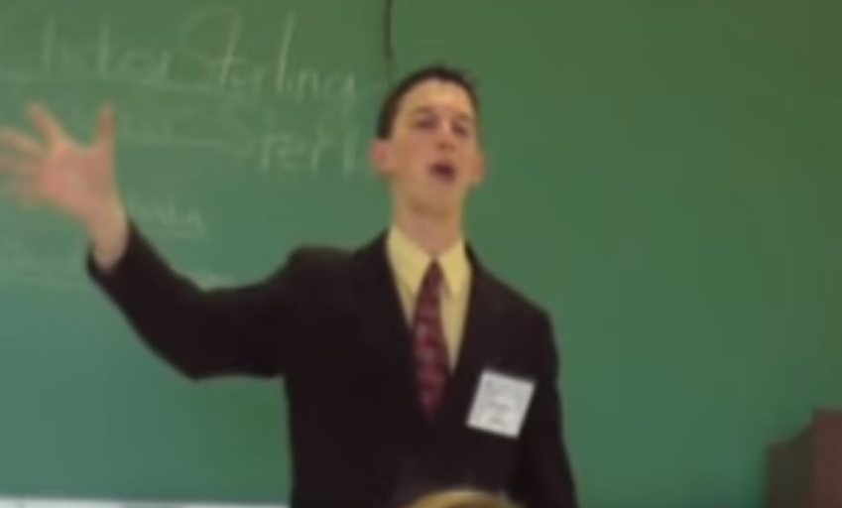
This is an Open Interpretation performed by Stephen Roe during the 2009-2010 season. He won 1st Place, 2010 Stoa National Invitational Tournament of Champions.
Per Stoa rules, you can add as many words as you like (as was done in this Interp). The NCFCA rules specify only 150 words can be changed.
“Ferdinand the Bull” by Stephen Roe
You can watch the piece of YouTube here:
https://www.youtube.com/watch?v=QpykzxbuoVY

Introduction to Piece
The most unique thing about this piece is that about one-fifth of the script is entirely Spanish. Nearly all of the humor in the piece comes from either acting in-between lines or Spanish translations (while the book is certainly lighthearted, there are no real “jokes”). Another aspect that set it apart from most other pieces was the lack of complex dialogue. In the original work, there are two lines of dialogue I subsequently cut because neither of them really pertained to the story. To replace this, I added some simple dialogue of my own. I pride myself in probably being the only competitor the entire year whose main character said literally two words in the entire piece –– and in a foreign language, to boot!
I had loved the Story of Ferdinand since I was a toddler, but the idea of doing it as an OI never occurred to me until a week after the first tournament. The true credit goes to my siblings. They thought of performing the story, which takes place in Spain, with a touch of Spanish added in. Within 15 minutes, we had nearly the entire plot summary worked out.

Interesting Things to Know
Though I competed in four other speech events and debate the year I did this piece, it remained my favorite for the entire season. I preferred it because it was my funniest speech, and other people seemed to enjoy it for the same reason.
Finally, the piece has a lot of significance to me. Not only is the book one of my all-time favorites, but the Spanish was a lot of fun. Our family resides a few miles south of the border in Tijuana, Mexico, where we serve as missionaries. I consider Spanish a fairly important part of who I am, and getting to use it in a speech was something I had wanted to do for a while.
The primary reason for the success of my piece was that my love of it showed through. Many judges commented that they could see I enjoyed giving the speech (which was true), they could see I loved the book (which was true), and that I was a perfect bull (which I hoped was not true). Another primary factor in its success was the fact that––as far as I am aware––there were no other pieces with significant non-English portions at the tournaments I attended.
The original piece could be summed up in a few sentences: The bulls who live with Ferdinand fight each other to prepare for the bull fights, but Ferdinand likes to sit under a tree and smell the flowers. One day, men come to pick out the bull for the bullfights. When Ferdinand sits down to smell the flowers he sits on a bumblebee and appears so fierce the men pick him. At the bullfight, he smells the flowers in the women’s hair instead of fighting, so they have to send him home. The story is cute, but rather two-dimensional. In order to bring a little bit of life into it, I changed a few different parts of the piece.
One of the first was to give it a purpose. I did some research on the author and the book and discovered that it was published nine months before the outbreak of the violent Spanish Civil War. I wrote a 50-word introduction detailing this significance, and changed the last phrase from “happily ever after” to “peacefully ever after.” A simple childish story took on a new meaning.
The second change was to bring out the personalities of the characters. Considering the lack of dialogue in my original cut, this was more difficult than I expected. I compensated by adding dialogue for 10 characters that were not distinguished in the original book, in addition to the ones that were (the narrator and Ferdinand). While that seems like a tremendous amount, they only spoke a few words each and were essentially separate caricatures of the “character groups” in the book. There were three other bulls, three men who came to pick out the fiercest bull, three bullfighters, and a woman invented to fill a weak point in the plot––instead of Ferdinand smelling the flowers in the women’s hair, I had one woman throw a flower into the ring.
Third, I had to convey the feeling that the viewer was truly “in Spain.” I used a multitude of ways to do this, the most obvious being the use of Spanish. This presented a slight difficulty: either every character (excluding the narrator) spoke Spanish, or none of them did. The inconsistency was glaring otherwise. I decided to have the narrator translate nearly every word, with bilingual humor to break up the tediousness. I also added references to castanets and siestas, hummed segments of Latin music, gave the female character a fan and the name of María Catelina Margarita Teresa Velázquez Domínguez de Ramos, cried ¡Olé! and ¡Arriba! a few times, and bestowed upon the three bullfighters three different kinds of mustaches. There were a few stereotypes I just could not resist.
Finally, I had to develop more emotion into the piece. While I did it on a small scale early on, I developed it even more before the national tournament at the suggestion of an alumnus in our club. The main way I did this was having the other bulls tease Ferdinand, who then responds with a silent tear. It is one of the very few lines in the piece without any humor, and it was extremely effective. I received more positive comments on this change than any other.

Into the Interp
The clincher for this piece was the opening line. It established the piece in a few short sentences.
NARRATOR: En España, había una vez un torito que se llamaba Ferdinando—¡ay caramba! ¡Son gringos! Ah... hello! Perhaps you would like that I translate this story from the Spanish to the English, ¿sí? A ver, pues. Once upon a time in Spain there was a little bull and his name was Ferdinand...
The opening of the Spanish translation generally wakes up most judges! The line that follows give the narrator a personality and the Spanish-speaking judges a laugh––the narrator expresses his surprise at realizing that the audience are not native Spanish speakers, using animated gestures and the term “gringo.” Then he continues in English peppered with Spanish words and grammar, all with a primarily Mexican accent. Though technically incorrect, this was a deliberate choice to avoid confusion––Spanish from Spain has a distinct lisp-like sound on various “S” sounds, creating an accent unfamiliar to Americans (“Perhapth you would like that I tranthlate thith thtory from the Thpanith...”). Mexican Spanish has no such sound, so it was used for the characters in the piece.
The narrator continues with a teaser, telling us that Ferdinand is not like the other bulls. The final portion of the teaser is Ferdinand––whom I portrayed with a short neck, shoulders pulled tightly together, and knuckle “hoofs” as hands––reaching down, plucking a flower (with a quick tearing sound), bringing it to his nose, throwing his head back and smelling it with his eyes closed, then bringing his head back down and opening his eyes with a high-pitched sigh. That little action usually produced laughs, endeared Ferdinand to the audience, and gave timers something to mime throughout the tournament.
Then the history behind the piece is told and the sources are related. The narrator then describes the activities of the other bulls, culminating in the emotional climax of the piece. After speaking of the other bulls for a few lines, he says:
NARRATOR: What they wanted most of all was to be picked to fight at the bull fights in Madrid. But not Ferdinand—he still liked to sit just quietly under the tree and smell the flowers. The other bulls would ask him why he did this.
BULL #1: Oye, Ferdinando, ¿por qué haces esto?
NARRATOR: Why do you do this?
FERDINAND: P-p-porque quiero.
NARRATOR: Because I want to.
BULL #1: Nosotros somos los toros más grandes y más fuertes—tenemos toda la fuerza y el poder y las vaquitas. Y ¿qué tienes tú? ¿las flores?
NARRATOR: You do not expect me to translate this, do you? No? Good. They would laugh at him...
BULL #1: (High pitched) Hee, hee, hee!
BULL #2: (Low-pitched) Ho, ho, ho!
BULL #3: (Inhaling, saw-like laugh) A-hyuh, a-hyuh, a-hyuh!
NARRATOR: ...and call him names.
BULL #1: ¡Eres endeble!
BULL #2: ¡Eres blandengue!
BULL #3: ¡Eres debiluchito!
NARRATOR: You are a sissy, you are a sissy, you are a little sissy. Ferdinand did not like it when they said things like this, but he did not want to get into a fight with the other bulls or hurt their feelings, so he stayed to himself under his tree.
A typical narrator-introduction/character-line/narrator-translation format is followed here and throughout much of the piece. Some of the bilingual humor (“Why he did this... why do you do this?,” “You do not expect me to translate this, do you?,” and “You are a sissy, you are a sissy, you are a little sissy”) is included here, as well as Ferdinand’s only two words. After the last line (“...stayed to himself under the tree”), Ferdinand pulls a flower from the ground and wipes a tear from his eye. We learn that this continues day after day, until the three men come to select a bull for the fight. In the original work, there are five men, but three was more manageable for a 10-minute piece. When Ferdinand sits on the bee and acts “as if he were... how you say? ...crazy!,” we see a similar sequence repeated, with the standard joke for these bullfight-picking folks at the end.
NARRATOR: The three men saw him and they all shouted with joy.
MAN #1: (short, high voice) ¡Qué violente!
NARRATOR: How violent!
MAN #2: (tall, with lisp) ¡Qué furiotho!
NARRATOR: How furious!
MAN #3: (hunched, with repetitive hand motion) ¡Es el más grandísimo, el más fuertísimo, y el más machísimo que todos los demás!
NARRATOR: Wow.
These three fellows demonstrate every one of the founding principles of this piece: the Rule of Threes. Nearly everything is delivered in a sequence of three: there are three other bulls, three adjectives used by the third man to describe Ferdinand, three examples in this list, etc.
Creative blocking formed the transition into the bullfight. Ferdinand walks through a 180-degree turn with a clip-clop to his gait. When his back is turned, the sound becomes slightly higher, and when I complete the turn, voilá! It is the narrator playing the castanets.
NARRATOR: What a day it was! Castanets were playing, flags were flying, people were cheering
RANDOM PERSON: ¡Arriba!
NARRATOR:...and all the lovely ladies had flowers in their hair. They had a parade into the bull ring. First came the Picadores, who had long pointed spears and long pointed mustaches. Next came the Banderilleros, with sharp curved swords and sharp curved mustaches. Then came the Matador, the proudest of all, with an elegant drooping red cape and an elegant drooping mustache.
MATADOR: ¡Olé!
There are four fast switches to generic characters at the beginning––a castanet player, a flag (my hand, mostly), a cheering person with a one-word line, and a lovely lady with a flower in her hair (MCMTVDR, as I have abbreviated the name of the flower-throwing woman at the end). These happen fairly quickly at the end of their respective lines.
Then we meet the bullfighters. After each segment describing them, I portray them for a few seconds holding their weapon and stroking their mustache––be it long and pointed, sharp and curved, or elegant and drooping––while humming a background musical piece (for the sake of you musical aficionados, it was Rimsky-Korsakov’s Capriccio Espagnol for the picadores and banderilleros, and the Zorro theme for the matador). The matador gets the privilege of arrogantly blowing kisses to the audience, donning a cocky expression and pronouncing an exclamation in Spanish. Along the same lines as my Mexican narrator, I’ve taken some artistic liberties with the bullfighting roles. Picadores are traditionally mounted on horses, and banderillos technically use barbed sticks (banderillas), not swords. And none of them are required to have mustaches.
Our unknowing MCMTVDR promptly spoils the day, and despite the poking and prodding of the picadores and banderillos and a lengthy Spanish rant from the matador, Ferdinand remains in the middle of the ring, smelling the flower. The picadores get mad, the banderilleros get madder, and the matador get so mad he cries, wiping the tears with his cape, and finishes out his part in the story with a pitiful kiss-blowing and passionless “Olé.”
Ferdinand is sent home, and the rest of the story ties up all of the remaining threads, finishing with a Spanish phrase equivalent to our “happily ever after”:
NARRATOR: So they had to take Ferdinand home. And for all I know he is sitting there still, under his favorite tree, smelling the flowers. He is very happy. Y colorín colorado, este cuento se ha acabado. Or, as you say it: he lived—peacefully—ever after. The end.
And it is a peaceful end indeed.

