The Bridge to Terabithia
Source Material of a Champion Dramatic Interpretation
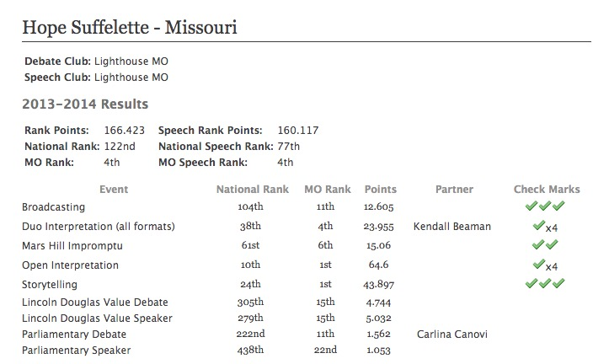
December 3, 2018
This speech was performed by Hope Suffelette in Season 14 (2013-2014). She took 1st place three in state competitions, one first place slot at an out of state tournament and 2nd at the St. Louis Gateway Classic and was ranked 1st in OI in Montana at the end of the season.
The NCFCA eliminated Dramatic Interpretation as an event, but they may be run in Open Interpretation instead. Stoa explains DI in this way on their website http://stoausa.org/wp-content/uploads/2018/06/Dramatic-Interpretation-Rules-2018-19.pdf:
In Dramatic Interpretation the competitor creates an original rendition of a relatable story from a single published work of literature with a focus on plot and character development which captivates and moves the audience
Directions: Use this source material to enhance your understanding of dramatic. This speech is an excellent example of champion speaking. You may want to consider doing this event in Season 19.
The Bridge to Terabithia
by Hope Suffelette

Getting Started:
I invite you to join me in learning from everything I’ve gained in my two years of competing in the OI category; particularly, my 2014 speech – The Bridge to Terabithia by Katherine Paterson. No matter why you’re reading this, I would like to first and foremost wish you the best of luck in the upcoming competition season.
Next, here are a few rules to live by when searching for a good script that fits your personality and level of experience:

Don’t Force It
If you’re searching for a good piece to perform, don’t look too hard. I know it’s hard not to settle for the first script you lay your eyes on. As strange as it may sound, you have to let the script find you. Wait it out for the perfect script idea to come to you instead of deciding the category of speech you want to participate in prior to having a good script idea. Never force a script that doesn’t work well as an open interpretation.

If at First You Don’t Enjoy It…It’s Not Worth Your Time
Love your piece. When performing The Bridge to Terabithia this year, I showed emotion because I loved my characters and the story they portrayed. Love it, and you’ll succeed. This applies to speech and debate, as it does to almost every other aspect of life.

Challenge Yourself
My OI was neither easy to perform, nor was it easy to cut/write. I would not have asked for it any other way. I challenged myself to not shy away from the parts of the piece that were too sad or unpleasant to perform. In the script, one of the main characters dies toward the end. It would have been easier to cut that part out; but truth be told, that part of the piece was the main reason I had a successful season.
The Script
When cutting the script, I tried to understand the concept of the piece. It’s important to have a grasp on the patterns and the meaning of the document. With only 10 minutes to tell a story, you should comprehend the overall message and magnify it. There are a couple of different methods I’ve used to do this.

Cutting
Magnify the most important parts of your piece by strategically cutting it. Start by reading it from cover to cover, then repeat. After you’ve read it twice, pick out the most important moment of the piece, and then build your script using the parts of the story leading up to that scene.

Writing
Re-write the piece. It’s easier to understand the message of the story and make it your own. Regardless of how a script is developed, the most important thing is to choose one vital part of the original story and focus on it. Let everything build to that moment.

The Performance
Think back to the last time you felt your entire body cringe while watching someone attempt to speak in public. Your discomfort wasn’t due to ad libbing or rephrasing of a sentence or two; in fact, you probably didn’t notice those things. You sympathized with the speaker because you knew just how awkward and nervous, they felt themselves. We all know someone who would rather remove his fingernails individually with pliers than give a speech. That mentality comes from believing that you’re not good at giving speeches. Some advice that transformed my speech career from a psychologically devastating and humiliating experience into the hobby that mothered my greatest high school memories was simply remembering that I know how to speak. We’ve been doing it for years. Most of us mastered the art by the time we were five. Why is it that people forget about their deeply-engrained ability to speak as soon as they stand in front of a crowd?
Whether you’re speaking on a stage or just in casual conversation, remember you’re just talking. What reason does speaking have to make you so nervous? None. Public speaking or speaking in general should not have the power to make someone feel uncomfortable. When you perform an interp, ditch the nerves at the door. I can’t tell you how many positive ballots I’ve received simply from pretending to know what I’m doing. Going into a room confidently is the most important part of giving a speech. I have always relied heavily on that premise.
Along with being confident, don’t forget to have tons of fun. No judge will be entertained if you’re not entertaining yourself. At times I have fallen under the monotonous spell where I forget to love what I perform. This was agonizing, and those rounds were by far the worst of my speech career.

Deeper into the Piece
I started Bridge to Terabithia the same way I start all of my other pieces throughout the years: with humor. It began with a high energy, pre-introduction scene intended for the sole purpose of grasping the attention of the judge and introducing the main characters. Even if a piece is not necessarily intrinsically humorous, it’s nice to open it in a light-hearted manner. There’s no need to overwhelm an audience by jumping straight into the heaviest aspects of the speech. Humor and the introduction of the main characters is a straight forward, classic way to start an interp.
From the introduction on, the piece started building. As you progress from the beginning to the end, don’t perform with a monotonous state of emotion that stays constant throughout. There must be some form of an emotional build in order for the speech to capture the audience. For Bridge, the build was the pieces being put in place for the most impactful part of the speech.
The most important part of the piece is what happens in the last three minutes, which is what will be left in the judges’ minds after you leave – so make it good! I picked my book for its ending. Making it emotional was not an unreasonable stretch of the script. I got off lucky. Not everyone will choose a script that has such a strong finish. For those who do not have that luxury, pick a part of the script to be the climax and save your best acting for that part of the speech. The last few minutes are vital in wowing the audience.

The Result
When it was all said and done, I was very pleased with this piece. I had a wonderful time performing and learned a lot in the process. I encourage you to pick speeches that mean something to you, that you enjoy, that challenges you on different levels. Take time to prepare your script in a way that makes you proud. Enjoy each and every round you walk into, knowing that, sooner than you imagine, you will perform your speech for the last time. Be confident, do your best, entertain your judges and you will go far!
Putting together a speech is not easy. There are times of stress and anxiety. Frankly, sometimes preparing a speech isn’t fun at all – but the outcome is spectacular. In the beginning, Bridge seemed like more work than I wanted; but eventually, it paid off. Work hard on a speech, give it your all, and finish the season strong. You will not regret it. There is nothing more satisfying than knowing that you gave your all to a speech. Competing in the open category was a wonderful experience for me, and I pray that it will be just as fruitful for all of you. Good luck in all of your speech and debate endeavors.

