Fantastic Mr. Fox
Source Material of a Champion Duo Interpretation
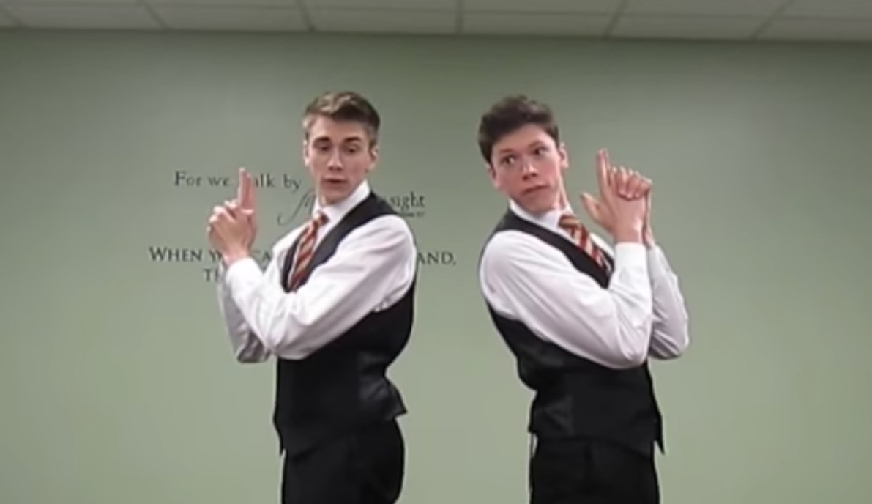
This speech was performed by Christopher and Shane Roberts in Season 14 (2013-2014). They consistently took the top two places in National Opens around the nation. They won the Regional tournament and took runner up at the NCFCA National Tournament. They ended the season by being ranked 1st in their state and 2nd in the country.
All speech and debate leagues: Stoa, NFHS and NCFCA offer this speech event.
NCFCA Explains Duo this way on their website: https://www.ncfca.org/speech/interpretation-speeches/
“Duo is an interpretation speech in which two speakers explore a published literature selection and develop a unique, original performance.”
Directions: Use this source material to enhance your understanding of Duo. This speech is an excellent example of champion speaking. You may want to consider doing this event in Season 19.
Fantastic Mr. Fox
by Christopher and Shane Roberts
Watch their speech on YouTube here: https://www.youtube.com/watch?v=Yyt55iZ5P7A&t=115s

“Hi there, my name is Shane Roberts.”
“And my name is Christopher Roberts.”
“We are the Duo team Roberts/Roberts.”
If you had walked in on one of our final rounds of the speech season, you would’ve seen a polished speech, performed seamlessly. And, indeed, we could perform our piece forward and backward. But before we reached this point, there were several hours of sweat and brainpower that we diligently poured into our duo. We found ourselves constantly seeking new inspiration for ideas and added motivation. We repeatedly asked ourselves how to set our crazy piece apart from the rest. Before each tournament, we would mull it over: “How can we do even better?” The outcome of this constant work was one successful season.
Before we dive into the tips and tricks we learned along the way, we want to clarify that our duo interpretation was humorous, meaning that some of this advice may not be applicable for the more dramatic interpretations. The reason for our choice of humor over drama stemmed from our personalities and the universal appeal that humor provides. This may differ per partnership and that’s okay! In the end, a good partnership will foster the perfect piece for your duo season, bringing us to the first part of our journey.
The Partnership
Firstly, in the development of a successful pairing, we can testify to the importance of you and your partner staying on the same page throughout the creation of your duo. This may be a lot harder than it sounds, so we’ve come up with some general rules/advice when crafting a dual collaboration:
No. 1: Realize your need for a partner.
No. 2: Select somebody that works well with you.
No. 3: Be open to each other’s advice.
No. 4: DO NOT try to carry the piece by yourself.
No. 5: Identify each other’s strengths and weaknesses.
If you start off your season and partnership tucking these rules neatly away in the back of your mind, the rest of your season should be nothing but smooth sailing (or at least smoother sailing).
There are two things specifically that made our partnership successful. Firstly, we’re brothers. We realize this may not be a possibility for every duo team, but we credit much of the success of our duo with the fact that we live together, which makes practicing easy and efficient. So we suggest you partner with someone who lives near you for the sole sake of convenience, as the time needed to make a duo great will require a lot of time working together.
Secondly, as partners we had incredible compatibility. Whether in a round or generating the next blocking sequence, we literally knew each other’s thoughts and ideas before they were verbalized. It’s essential to have that kind of intuitive chemistry between partners because it translates into a noticeable difference during an actual competition round. It leads to an “edge” over the large majority of opponents because it ultimately makes a duo tighter, which we’ll talk in a little bit.
The Piece
We’re not going to lie; we aren’t one of those teams that have their piece picked out years in advance. Nope. That’s not us. Our season started the week before the Idaho National Open. That’s right, a week. It might seem improbable that any beneficial advice could come of this, but hear us out. The reason for our success doesn’t stem from crazy magic powers of spontaneity and last-minute preparation. Our ability to be successful comes from how we utilize the same 24 hours a day that everybody’s been given. So let’s hit rewind… back to the week before our first tournament.
The plane tickets had been booked, and we didn’t even have a piece. That’s something we like to call “the point of no return” – A.K.A. Panic Mode. We couldn’t find the perfect piece and were about to freak out. We had poured through literally dozens of books, asking ourselves what kinds of books are fun, entertaining, and appealing to all. At long last, we landed on a book by Roald Dahl that we really enjoyed reading: Fantastic Mr. Fox. (Rule of thumb: If you aren’t entertained when reading a book, do NOT choose that as your piece.) We were relieved; and along with choosing a piece we loved, we had picked up some useful tips for selecting the “perfect piece.”
Tip One: Be Original
Chances are, if a piece has been successful in the past, many judges in the speech and debate community have seen it performed before. So if you decide to use a previously popular duo, not only do you lose originality points, but you can lose the ability to insert your own creativity and instead are stuck within the bounds of someone else’s ideas and thought processes.
Tip Two: Take recommendations
Our piece, Fantastic Mr. Fox, was actually our aunt’s recommendation. Since she’s a 4th grade teacher at a public school, she has read this book to her students countless times and has grown to love it herself. Sometimes, getting a fresh opinion on different pieces is what’s needed to kick start a duo.
Tip Three: Sweet, blessed childhood memories
Think back to what you read as a kid. If you remember it fondly, think about why you liked it, and then splice it and dice it like a minced onion to see if you could do it as a piece. The lone fact that you loved it means that other people may feel the same way. Taking it back a few years, for our 2012-2013 season, we performed The Wonderful Tar-Baby Story by Joel Chandler Harris. It was a classic, and the judges seemed to agree. It served us well, garnering us 5th place in the 2013 national tournament.
Tip Four: Keep it short
We’ve found it very beneficial to keep the storyline somewhat simple, and the script short. When cutting the piece, shoot for about 1100 words. We know that seems short, but once you add the appropriate amount of blocking, different characters, and pauses here and there, it will be hitting the 10-minute mark. Start short and then add words. Don’t start with 2000 words and try to cut the night before competition. Pick a piece that is conducive to this goal.
Now that you’ve had a peek into our mysterious piece-picking ways, let’s move on to the reason you are probably reading this: finding ways to give your duo a dose of awesome ingenuity!
Use life as inspiration
You know that friend that talks with a unique accent or the mailman with a strange gait? Put them in your duo. One of Christopher’s characters, Farmer Bean, walked with a dead leg, had a funny voice, and a hilarious expression. The inspiration? A combination of our next-door neighbor, Forrest Gump, and a picture taken on Snapchat. So the next time you see someone or something funny in your life, make a mental note of it. It will not fail you when it comes to adding an interesting enhancement to your duo.
Be All In
The first thing we tell a team we’re coaching is that you have to be fully committed to your character and your piece. You’re going to look crazy, weird, and funny at times. You have to get over how you look, because then your creative mind has a medium through which it can express all its over-the-top ideas and truly bring the judges into the world you’ve created in your interpretation.
Know No Blocking Limits
You can’t touch each other. You can’t look at each other. You must keep it under 10 minutes. That’s it. Those are the only rules you have to keep in mind when creating your piece. While this might seem to constrain the artistic flow of your natural talents, please realize that the door is still open for amazing creativity with the blocking of your piece.
The quality of the blocking can either make the duo or break it. This is the single greatest opportunity for you to convey your interpretation to your audience. Make it count. Know no limits. Think outside the box and be anything but normal. This is one of the best opportunities to separate yourself from your competitors. Push the envelope of excellence.
In blocking Fantastic Mr. Fox, we had a few of our favorite techniques. First, transitions added that extra ounce of flair to the beginning or end of a scene and to the overall effect of your piece. They are NOT meant to be disruptive or distracting; instead, they are supposed to enhance the switch between two scenes so that the audience is clearly and quickly reminded of where they are in the storyline and what characters are involved in a particular sequence. Our favorite transitions were as we made the change between our fox and farmer characters. When making the shift, both of us would bend down and, using appropriate sound effects, act as though we were each pumping a pump-action shotgun, then jump up a few inches and land in the new characters. When we went from farmers to foxes we would again jump up, do a fox trot mid-air, and land in our “fox pose” to begin that certain scene. Our posture, facial expression, and sound effects during these transitions immediately conveyed to the audience that the scene was changing and quickly reminded them of who and what they were watching.
Next, synchronization kept us in “sync” with each other. You’ll know the importance of this immediately if you’ve ever been to a bad dance recital. It makes a difference, so put in the time until you know each other’s every move. Keep track of one another through the corner of your eye to catch the exact moment to pop off the next move. If you’re in a position where it’s impossible to see your partner, use specific words as signals. Realize though, there are times that the best blocking is done in complete silence and this requires an extra level of chemistry to get both of you off on the right beat. For this, listen to each other’s breathing pattern. Feel the natural rhythm of the piece and play off each other.
Finally, keep it tight. Every move, every word, every sound effect must come across as crisp and precise because the overall tightness of the piece often determines your final ranking. The bottom line is this: the judge should forget about all the rules (i.e. eye contact, physical contact, time, etc…) because you and your partner perform so confidently that the piece looks and feels like a 10-minute professional production.
Not-So-Secret Tips
The Fan Phenomenon
If you have a great partner, piece, and presentation, there’s not a reason in the world you shouldn’t be proud of it. This translates into wanting a full room, even asking friends and family to come and watch. A good duo team feeds off the audience and brings the room alive with their interpretation of a literary work. The judges can feel this captivating effect. Put together a great piece, get a following, and transform the audience. It’s a lot easier to pull this off with a room full of fans than it is to entertain three judges who have already watched five speeches of the same genre.
Before the Timer Starts
Your performance starts the minute you walk in the door and ends only after you’ve exited the room. The judges are already gathering notions and ideas about you as you walk in front of them and introduce yourselves. Realize that everything you do within your judges’ line of sight affects the outcome of your ranking, so make it count. Have a planned introduction for you and your partner. It doesn’t have to be canned, but you should have a calm confidence about yourselves that shows the judges you’re in it to win it.
Every Round Matters
This is something that we personally struggled with this year. We did very well in each of the eight tournaments we attended except for one regional qualifier, where we didn’t even make it to finals. We had already pre-qualified three times at this point, but this accomplishment unfortunately went to our heads and the only round we cared about was the final one… Turns out you have to make it to finals to do well in finals. We were crushed when we didn’t hear our names during break announcements, and we learned this lesson the hard way: EVERY ROUND MATTERS. We cannot stress this enough. The best way to ensure that you’re performing at your peak throughout the entirety of a tournament is to remember the reason you’re doing your duo. Every piece has a message to share with every judging panel. Even if your piece is simply humorous, don’t worry – your goal may just be to give those judges a break from the daily grind to forget about their worries and their strife. Every duo makes a point, so let that come across each time you’re on stage.
Practice, Practice, Practice
Practicing is a pretty obvious rule on the road to success, but not every team makes the best use of their practice time. Realize that duo practices are to be very experimental. Your ideas probably won’t work the first time but give them a chance. Secondly, while working on your piece, practice the parts that are hard and complex first, then work to incorporate the scenes before and after the complex sequence so that it flows smoothly. Lastly, set short-term goals for your practice sessions so that you feel accomplished after the session has expired.
Final Thoughts
As a duo team, we’ve always had a “knack” for this type of interpretation because it brought us closer together in a fun, lighthearted manner that taught us what it meant to work together effectively. In closing, remember that there are many things in life that are serious to a fault and duo shouldn’t be one of those things. Allow this speech to build bonds as a team. Use this as an opportunity to take risks, be funny, and put your creative ideas to the test. There will be a lot of trials that work and many that flop, and through it all just remember that there are no wrong ideas. This is your interpretation, so make it fun and entertaining, not solely for the audience, but for you and your partner as well.

