Introduction to Policy Debate
for Season 21
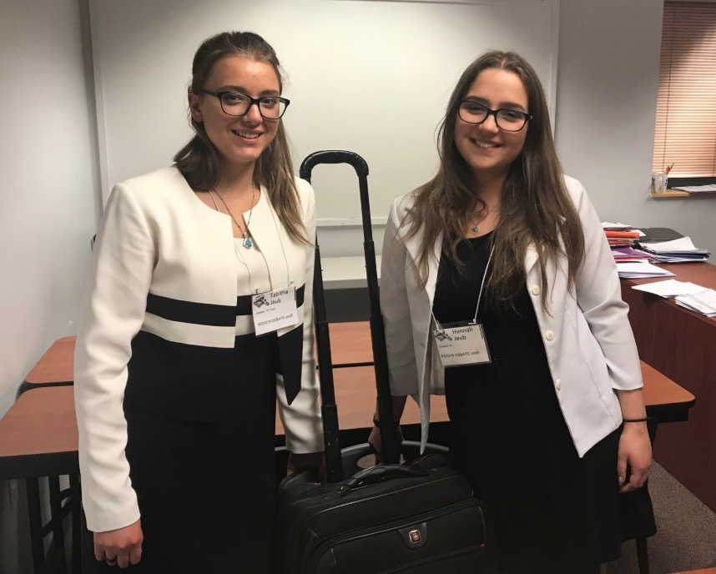
Policy debate is the oldest format of high school debate, its origins dating back to the 1930s. Depending on the league or region you are competing, this format is referred to as team-policy, cross-examination debate, CX, or (as Monument prefers to call it) just plain policy. This introduction to the world of policy debate digs into the details and gives a roadmap of what is to come for Season 21.
Policy debate consists of two debaters on each team, essentially a 2-on-2 scrimmage, who enter a room of a tournament to debate for a judge. The students have prepared materials and timed speeches to deliver, and the judge assesses the debaters and renders a balloted decision. The resolution addresses a political topic of some sort that the league sets forth for everyone competing in the event. To prepare for tournaments, debaters write affirmative cases (arguing for the resolution) as well as prepare negative briefs (getting ready to argue against cases).

Reasons for Policy Debate
Those who witness policy debates can’t help but be impressed. A common reaction from people who observe policy debate: “Wow!” The kids speak quickly, they exchange evidence and briefs, they give arguments swiftly and respond to them just as fast. Sometimes they make an observer’s head spin! But they always impress.
Policy debate brings incredible opportunities to students. The thinking and research skills necessary to succeed are second-to-none. Colleges and businesses know this. They’re able to pick a former debater out from the crowd any day. If you’re a parent, you know exactly why you’re here: You want your kid to be as impressive as those policy debaters!

The Structure of Policy Debate
It is helpful to understand the “team” and “policy” elements of policy debate. Both have structural elements to them that will help you prepare for a successful year of competition.
“Team” means that debate teams consist of two debaters each. The debaters enter the room of a tournament knowing which speeches they will run and will have trained for a division of labor between them. Here is a rundown of responsibilities between the two sides, and an explanation of the duties for each speech:
- First Affirmative Constructive (1AC) - 8 min.
The 1A gives a prepared eight-minute speech presenting his case to the judge. This is followed with a three-minute cross-examination by the 2N.
- First Negative Constructive (1NC) - 8 min.
The 1N addresses much of the 1A’s case within the eight-minute timeframe. This is followed with a three-minute cross-examination by the 1A.
- Second Affirmative Constructive (2AC) - 8 min.
The 2A refutes the 1N’s speech within eight minutes. This is followed with a three-minute cross-examination by the 1N.
- Second Negative Constructive (2NC) - 8 min.
The 2N runs various arguments against the affirmative case. This is followed with a three-minute cross-examination by the 2A.
- First Negative Rebuttal (1NR) - 5 min.
The 1N gives a five-minute rebuttal primarily to the 2AC.
- First Affirmative Rebuttal (1AR) - 5 min.
The 1A gives a five-minute rebuttal to the two previous negative speeches.
- Second Negative Rebuttal (2NR) - 5 min.
The 2N sums up the round and urges a negative ballot.
- Second Affirmative Rebuttal (2AR) - 5 min.
The 2A sums up the round and urges an affirmative ballot.
It may seem complicated, but that stress will melt away when you watch it work and get used to the even exchange of ideas. There are some basic understandings in policy debate that will help you grasp the competitive nature of this event. Notice the following in a typical 90-minute debate round:
- The affirmative team speaks first and last. This is because the affirmative team has what’s called the “burden of proof.” They must convince the judge to change the status quo. The negative team rests with “presumption,” meaning that if the affirmative fails to uphold their burden of proof, the negative should win. Of course, this is debate theory (there is no rule that states this must exist in every round), but it helps us understand why the affirmative has the first and last word in the round.
- The negative team has 13 minutes of speaking time in the middle (speeches 4 and 5), right next to each other. This is called the “negative block,” and it is a strategy for negative debaters to split the responsibilities between the two speeches.
- The debate round is divided into two parts: the constructives and the rebuttals. The names reflect what happens. The constructive speeches build arguments, and the rebuttals refute what the constructives bring up. New arguments should not appear in the rebuttals.
- The cross-examinations, also called CX or cross-ex, are timed exchanges between the debaters. Every debater is allowed three minutes to ask questions of an opponent, and another three minutes to answer questions delivered to him or her. Debaters should not make arguments in CX, but should carry any admissions in the CX into their speeches.
Policy resolutions are political in nature. Every year various leagues announce either foreign or domestic topics to debate. Leagues typically set forth one resolution per year, though there are some unique policy debate formats that allow for more.
Monument will be covering two resolutions throughout Season 21 with weekly releases of cases and briefs all the way to Nationals. As a member, you will receive downloads for the following resolutions in both the NCFCA and Stoa leagues, respectively:
- Resolved: The European Union should substantially reform its immigration policy.
- Resolved: The USFG should considerably decrease its military commitments.

Example of Policy Debate
Policy resolutions are written to call on an actor — usually the U.S. government — to change a problem in the status quo. Take, for example, a resolution from above: “The USFG should considerably decrease its military commitments." The “USFG” stands for the United States Federal Government, and this is the “actor.”
Debaters will start the year off with research. What exactly are the United States’ military commitments? When that is answered, what exactly is wrong with them? These fundamental questions are answered early in the year.
Debaters will prepare affirmative cases that “affirm” the resolution. They will enter a tournament with a debate case that calls for the judge to pass the policy that the debaters put forth. The case will typically present a problem in the status quo, explain a solution for the problem, and explain why the proposed solution will solve the problem.
The negative will try to convince the judge that the affirmative failed in some way that calls for the presumption to keep things the way they are. They often do this by proving one of four arguments called “stock issues.” These include:
- Topicality. The negative may claim that the affirmative team failed to uphold the resolution. The affirmative team would show how it did.
- Significance. The negative may claim that the problem isn’t significant enough to justify the new policy. The affirmative would show that it is.
- Inherency. The negative may claim that the problems presented will be solved without changing anything. The affirmative would show that their plan is needed for change.
- Solvency. The negative may claim that the presented problems will not be solved by the presented plan. The affirmative would show how all the cited problems would be solved with their plan.
The exchange will go on between the four debaters for the entire hour-and-a-half. Evidence will be exchanged and arguments will flow through the round. In the end, the judge or judge panel will decide whether to “pass” the affirmative’s plan or let the status quo remain as it is.

Release Schedule for Season 21
At the time of this introductory download (July 20, 2020), the two resolutions stated above have been released to NCFCA and Stoa students and Monument writers have busily been writing cases and briefs. Here is an explanation of what will be coming for policy debaters:
- July 20, 2020 – The “Introduction to Policy Debate for Season 21” releases.
- August 3-10, 2020 – Two installments release for NCFCA and Stoa, the first introducing debaters to the year’s policy topic, the second a list of status quo problems to solve.
- August 17 through Christmas – All foundational cases and briefs will be released in weekly installments. Students should download them every Monday and make the habit of studying them throughout the early season of preparation.
- January 1 through Nationals – As competition revs up, Monument will release downloads on an as-needed basis. Members are encouraged to send us flows from debate rounds for our writers to develop materials to help them win.
- Stoa’s National Invitational Tournament of Champions takes place at Concordia University in Irvine, California, May 23-29, 2021.
- NCFCA’s National Tournament has not been announced as of July 20, 2020, but most likely will take place at Northwestern College in St. Paul, Minnesota. This was the venue intended for 2020, cancelled due to the coronavirus shutdown.

