Season 23
—
Debating the 2022-2023 NCFCA Policy Resolution
By “Coach Vance” Trefethen
Resolved: The United States Federal Government should significantly reform its import and/or export policy within the bounds of international trade
Table of Contents
Current Issues in U.S. Trade Policies 2
The World Trade Organization 2
Free Trade Agreements & GSPs 4
Product Tariffs 5
Nuclear Technology 6
Trade Sanctions 7
Export Controls 12
Arms Sales 12
Generic Briefing Issues 13
Summary & Conclusions 14

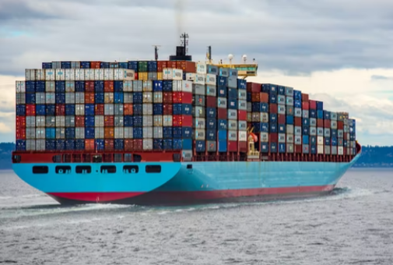
Current Issues in U.S. Trade Policies

NCFCA 2022-2023 Policy Resolution
Resolved: The United States Federal Government should significantly reform its import and/or export policy
In this article, we will outline a few of the more prominent areas of public policy debate regarding issues in US foreign trade.

The World Trade Organization
As we noted in the previous article, the US is a member of the WTO, which provides a wide ranging framework for much of the trade that occurs globally today. It requires its members to follow rules that generally lower trade barriers and tariffs, and provides for retaliation and sanctions when countries don’t follow the rules. It also has an arbitration and appeal process to judge disputes among nations and authorize sanctions against the offender.
Some believe WTO is essential to preserving the benefits of widespread free/freer trade that exists among most nations today. Some might agree but argue that membership has been extended too easily to countries that do not actually have market economies (like China), and therefore do not trade “fairly” with other nations, since their governments subsidize or even completely own the businesses in their country, allowing them to export at costs below what markets would otherwise provide.
Others believe the WTO represents too much of a commitment to globalization of US trade policy and forfeits too much US sovereignty. Rep. Peter DeFazio (D-Oregon) in 2020 introduced legislation in Congress to have the US withdraw from the WTO.
“For the first time since 2005, lawmakers from both parties and both houses of Congress are pushing to pull the United States out of the trading body it helped create and which was the culmination of decades of postwar efforts to boost free trade and economic integration. By law, the United States has a chance to vote every five years on staying inside the WTO, but staying on board was such a no-brainer in recent years that no such resolution was even presented. But this year—powered by a rise in economic nationalism, growing concern about China, and frustration with two decades of paralysis at the WTO—the knives on Capitol Hill are out, to the delight of some of the trade hard-liners in the White House. “The WTO has been a disaster for the United States,” said Rep. Peter DeFazio, an Oregon Democrat, who introduced House legislation to withdraw this month.”
Short of dropping out of the WTO, the US also has another issue with that organization that has been brewing since the Trump administration. The US has been blocking appointment of members to vacancies on the “Appellate Body” that adjudicates disputes, which has seriously crippled the functionality of the WTO – some would say effectively abolishing it in spirit even if not in letter.
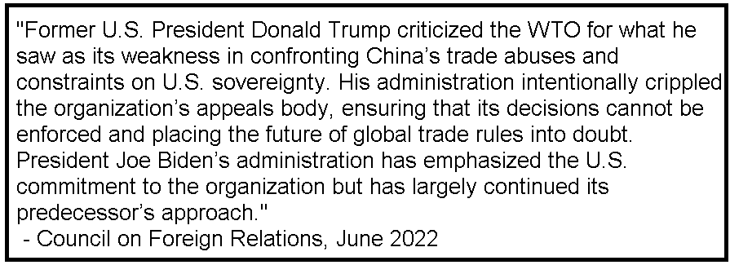
“Mexico, speaking on behalf of 123 members, introduced for the 52nd time the group's proposal to start the selection processes for filling vacancies on the Appellate Body. The extensive number of members submitting the proposal reflects a common concern over the current situation in the Appellate Body which is seriously affecting the overall WTO dispute settlement system against the best interest of members, Mexico said for the group. The United States reiterated it was not in a position to support the proposed decision. The US continues to have systemic concerns with the Appellate Body, which it has explained and raised over the past 16 years and across multiple administrations. The US said it believes that WTO members must undertake fundamental reform if the dispute settlement system is to remain viable and credible.”

Free Trade Agreements & GSPs
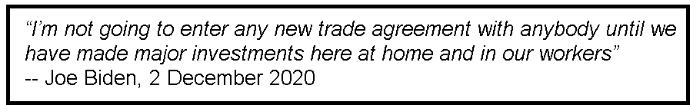
A number of possible options for the US to join or offer Free Trade Agreements have been suggested recently.

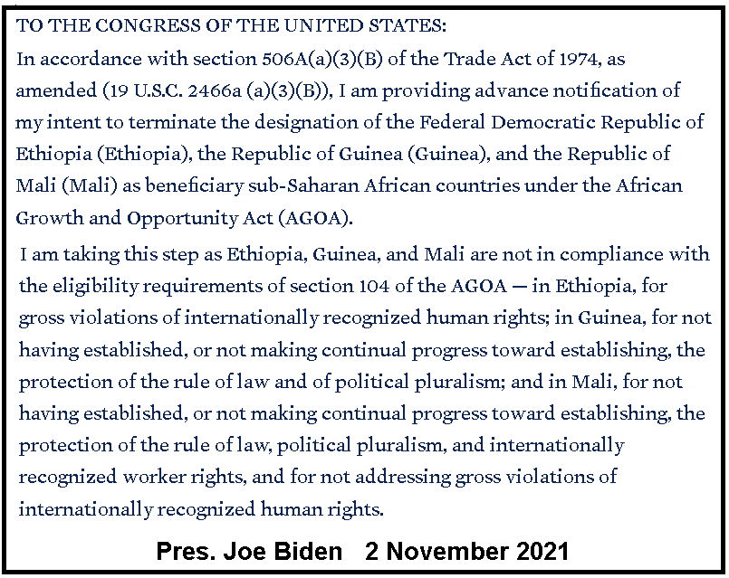
“The Trump Administration began negotiations on two new FTAs, one with the United Kingdom and the other with Kenya. The shared history of the US and the UK and the latter’s departure from the EU may give impetus to that negotiation. Picking up the negotiation with Kenya would signal that the US has continued interests in improving its economic relations with Africa. Among other possible FTAs, the return of the United States to the CPTPP looms large, but it would be difficult to agree on labor provisions comparable to those in the USMCA with some of the current members of the CPTPP, a task that would be much more difficult (if not impossible) if China joined the CPTPP. An FTA with the EU, while desirable, does not appear to be a feasible near-term objective, although there is Congressional interest in a US-EU deal. The United States and Japan may strengthen their bilateral commercial ties without commencing an FTA negotiation. If the United States were to negotiate FTAs with those potential partners, it would take a significant step toward improving the degree of preferential market access enjoyed by US firms and workers. For example, a trade agreement with the European Union would cover 17% of total US exports. An FTA with the United Kingdom would cover 4% of total US exports, and joining the CPTPP would cover 5% of US exports, through the addition of Japan, Vietnam, and New Zealand to the list of US FTA partner nations.”
Other countries that have been proposed for FTA’s include Switzerland and Georgia.
Generalized Systems of Preferences (GSP) give special trade benefits to lesser developed countries to allow their exports to come to the US at even lower tariff rates, while not requiring the same concessions for those countries to reduce barriers to US exports to them. Examples of these include The African Growth and Opportunity Act (AGOA), the Caribbean Basin Trade Partnership Act (CBTPA) and the Andean Trade Preferences Act.
Policy changes for GSPs might include removing certain countries from eligibility, as Pres. Biden did recently with several countries in AGOA. In addition, AGOA is set to expire in 2025, which means it may need to be renewed (and reformed?) before then. Some argue that it isn’t accomplishing much as currently designed, but could be improved.

Product Tariffs

The Trump Trade War
There are numerous specific products that Affirmative teams may find as opportunities for policy change. All the more so now than in prior years, since Pres. Trump implemented a number of additional or higher tariffs, particularly on China, some of which have not (yet) been reversed by the Biden administration. Debaters in past seasons have run cases on removing tariffs on Chinese products like solar panels and tires.
“The February 14, 2020 implementation of the phase one agreement between the Trump administration and China established new US tariffs on imports from China for the foreseeable future. Average US tariffs on Chinese exports remain elevated at 19.3 percent. These tariffs are more than six times higher than before the trade war began in 2018. These tariffs cover 66.4 percent of US imports from China, or roughly $335 billion of trade (measured in terms of 2017 import levels). … Overall, the trade war proceeded in five stages between 2018 and 2022. The first six months of 2018 featured only a moderate increase in tariffs. The months of July through September 2018 resulted in a sharp tariff increase on both sides: US average tariffs increased from 3.8 percent to 12.0 percent, and China's average tariffs increased from 7.2 percent to 18.3 percent. In stage three, there was an 8-month period (September 25, 2018, through June 2019) of little change in tariffs. From June to September 2019, another set of tariff increases kicked in. In the current stage five, and despite the phase one agreement, tariffs between the two countries remain elevated and are the new normal.”
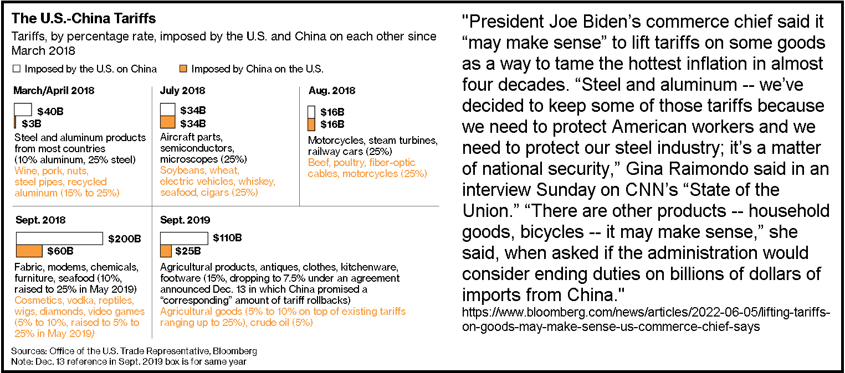

Section 301
“Section 301” is the law that authorized Pres. Trump to impose the tariffs mentioned in the paragraph above. When the President believes a foreign trade partner is engaged in improper trade practices, he can impose tariffs as a remedy. Section 301 is often invoked due to the belief that a foreign country’s government is subsidizing (giving free government money) to its manufacturers in order to allow their exports to undercut the price of competing products manufactured in the United States. Tariffs might be imposed on those goods when they arrive in the U.S. to raise their price back up to what they would have been if their government had not artificially lowered their price.
“Section 301 of the Trade Act of 1974 grants the Office of the United States Trade Representative (USTR) a range of responsibilities and authorities to investigate and take action to enforce U.S. rights under trade agreements and respond to certain foreign trade practices. … Title III of the Trade Act of 1974 (Sections 301 through 310, 19 U.S.C. §§2411-2420), titled “Relief from Unfair Trade Practices,” is often collectively referred to as “Section 301.” Section 301 provides a statutory means by which the United States imposes trade sanctions on foreign countries that violate U.S. trade agreements or engage in acts that are “unjustifiable” or “unreasonable” and burden U.S. commerce.”
Of course, if goods come into the U.S. priced cheaper than they “should be,” thanks to the generosity of the taxpayers of China, for example, why shouldn’t American consumers be allowed to accept this free gift?

Nuclear Technology
Federal law (Section 123 of the US Atomic Energy Act) requires an agreement between the US government and a foreign government in order to allow the export of materials related to nuclear energy and nuclear technology. The agreements, known as “123 Agreements,” contain standards and restrictions to create safeguards against the diversion of nuclear materials to places or countries we don’t want to have them, or to prevent the recipient country from diverting them into a nuclear weapons program. As of 31 December 2021, the US has 23 of these agreements in effect.
Renewal of these agreements, or entry into new ones, requires policy decisions that might be areas of policy debate for Affirmatives to consider. They might be good opportunities to expand good job-creating industries in the US nuclear energy sector. Or, they might be dangerous deals that lead to nuclear proliferation, increasing global risk of horrific outcomes if nuclear weapons spread and are more likely to be used in a conflict.
“Over the course of the Biden administration’s first term, the United States will have to decide not only whether to re-enter a nuclear agreement with Iran, but also whether to renew or amend U.S. civilian nuclear cooperation agreements with Egypt (2021), Morocco (2021), South Korea (2021) and Turkey (2023), enter into an agreement with Saudi Arabia, and resume or expand nuclear cooperation with Russia and China.”

Trade Sanctions
Trade sanctions (denial of imports, exports, or other business transactions involving a target country's government or businesses operating there) are a frequently used tool of US foreign policy. There are always questions about how effective they are, whether they hurt the common people more than the “bad guys," or simply harden the resolve of the target country to resist outside pressure. Here are a few of the more prominent country sanctions that Affirmatives might want to reform.

Iran
The US has been sanctioning Iran for over 40 years following the attack and takeover of our embassy in Teheran in 1979. Oil is the most obvious trade product that comprises much of Iran’s economy, but US sanctions are broader. In addition to Iranian support for terrorist groups, there are also concerns about Iran’s efforts to possibly process nuclear materials into an atomic bomb. The U.S. engaged in negotiations with Iran and other nations to work out an agreement in 2015 (known as the “Joint Comprehensive Plan of Action” or JCPOA or “the Iran nuclear deal”) to suspend many sanctions in exchange for suspending Iran’s nuclear program. Pres. Donald Trump, viewing other non-nuclear problems with Iran’s foreign policy (like terrorism and human rights violations), elected in 2018 to drop out of the JCPOA and reimpose sanctions. Pres. Biden campaigned for office in 2020 on a platform of rejoining the nuclear deal, but thus far (as of 23 June 2022) he has not done so.
Russia
The Russian invasion of Ukraine is at the top of today's headlines and along with it are US and allied nations' trade and financial sanctions against Russia. There's a fair amount of question as to whether the sanctions will accomplish anything, or whether they may even backfire and increase Russia's financial position. After all, sanctions disrupt the global economy and make commodity prices rise. Since Russia is a big exporter of certain commodities (oil, natural gas, wheat), if those prices go up, Russia gets more revenue selling to the remaining countries that haven't sanctioned them (which are significant). And what are the chances Russian Pres. Vladimir Putin is going to wake up one day and admit that he's canceling the invasion because we sanctioned him? He won't be losing any meals, even if the Russian economy were completely wrecked.
North Korea
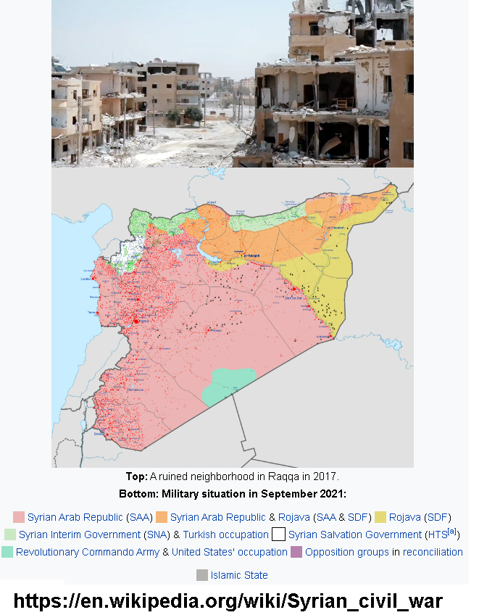
The U.S. has been sanctioning North Korea for decades. Just about every time they do something we don't like, the President in office at the time always announces "more sanctions." One would wonder what in the world there is remaining unsanctioned. N. Korea's economy has been isolated from the rest of the world for a long while, partly because of sanctions but also because of their secretive communist government. Its mismanagement has wrecked their economy so badly that they have little to trade with the rest of the world. Sanctions cannot further impoverish the people, because they are already dirt poor. They cannot create pressure on the regime to change, because they are a brutal dictatorship that is not accountable to the people and do not hold elections.
Syria
Syria has been embroiled in a nasty and bloody civil war since 2011, when there began a widespread movement against the government of evil dictator Bashar al Assad. There are numerous factions involved in the conflict, and their positions and stories are complex. As of now, the tide has turned back in favor of Assad, but there is still death and destruction ongoing. Over the years, many have advocated regime change in Syria to remove Assad because of his poor human rights record, and the US has applied sanctions on his regime, most notably the “Caesar Syria Civilian Protection Act of 2019.” It is controversial because it may be punishing the common people rather than the regime. And, in the very unlikely even that it succeeded at removing Assad, the alternatives to his bad rule would probably be even worse.

Cuba
Cuba was a flashpoint of conflict during the height of the Cold War. Following a communist revolution in 1959, the U.S. sponsored an unsuccessful invasion to overthrow the regime in 1961 (the Bay of Pigs). And the Soviet Union for a time deployed nuclear missiles to the island aimed at the U.S. homeland (1962). But now we're long past the days when Cuba was considered a major threat to the US homeland, or the US was considered a threat to invade Cuba.
If ever US economic sanctions were going to work, they should have worked in Cuba by now. The US began an economic embargo on Cuba during the administration of Pres. John F. Kennedy. Yet 60 years of sanctions later, Cuba still has a one-party dictatorship run by the Communist Party. Many believe removing or relaxing the Cuba embargo would open up Cuban society by exposure to US tourists, trade and ideas, and possibly spur governmental reform more effectively than the embargo has done. Political pressure by Cuban exiles who fled the island in generations past, particularly on their members of Congress from Florida, are about the only reason they haven't been lifted yet. Pres. Obama began relaxing them during his term of office, but Pres. Trump reversed that policy.
Venezuela
Rich in petroleum resources, Venezuela had the highest standard of living in Latin America in the 1980’s. But in the years that followed, with the decline of world oil prices, their economy began to falter. The election in 1998 of leftist president Hugo Chavez pushed things further downhill. Oil revenues kept his government afloat for a while, but his socialist policies damaged the economy, and things went from bad to worse. Chavez died in 2013, and his successor, Nicolas Maduro, has continued Chavez’s policies. In the course of attempting to maintain power, Maduro has wrecked democratic institutions and ruled by force, using the military to crush opposition. Millions of Venezuelans have left the nation as refugees and the country remains in turmoil.
Unsurprisingly, the US has slapped economic sanctions on Venezuela in the hope that further damaging their collapsed economy will motivate Maduro to reform, start respecting human rights, and restore democratic elections. Recently (May 2022) the federal government has relaxed a few sanctions on Venezuela to encourage negotiations between Maduro’s government and the US-backed opposition. But most sanctions continue to apply.
Hong Kong
The Chinese city of Hong Kong was ruled as a British colony from the late 1800s until 1997. As such, it did not participate in the communist revolution that created the People’s Republic of China in 1949. This was fortunate for them, since communism stunted the economy and erased the freedoms of the hundreds of millions of Chinese trapped in it. Hong Kong became wealthy under its free market economy, far wealthier than their brethren on the other side of the border. When Britain handed jurisdiction over Hong Kong back to China in 1997, there was an agreement that life would go on under the framework of “one country, two systems.” In other words, the Communist Party would go on oppressing the rest of mainland China, but would leave Hong Kong’s freedoms and human rights untouched.
Or so we all thought. Slowly, China has been eroding these freedoms, and recently the oppression has sped up, with radical new steps taken to clamp down on Hong Kong more dramatically. The U.S. federal government has responded with new sanctions on China in response.
Around the globe, the US has a wide variety of sanctions on numerous countries related to various issues like human trafficking, sponsoring terrorism, organized crime, child soldiers, and slavery. They are all certainly debatable as to their effectiveness and utility, and many will appear in debate rounds this year.

The Full List
Here’s a list of all the US foreign trade sanctions currently in effect, according to the Dept. of the Treasury’s Office of Foreign Assets Control (OFAC), which administers US trade sanctions. This list could provide numerous Affirmative case ideas.
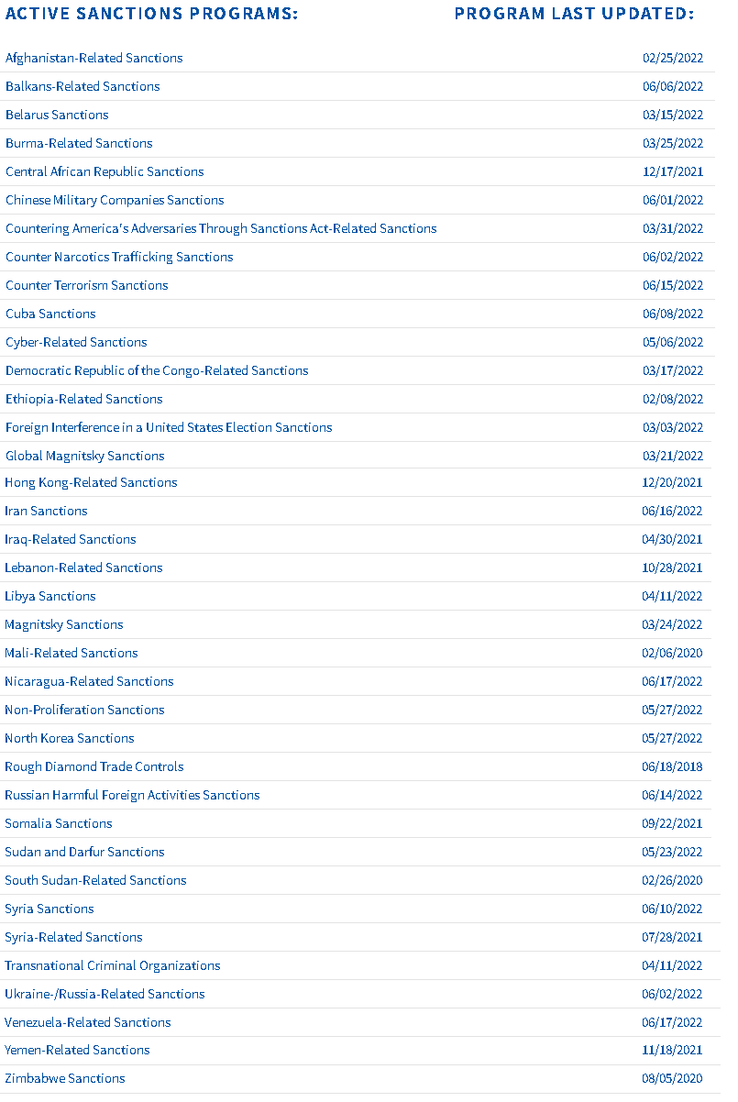

Export Controls
Export controls are a little-known aspect of US trade policy, but play a very important part of the everyday concerns of many US corporations in their daily activities.
“The term export controls includes the laws and regulations that govern the export of any item or technology from the United States to a foreign country or to non-U.S. persons.”
Export controls are designed to deny technologies that could aid a foreign hostile power from improving its military capabilities and possibly using those technologies or capabilities against us. The list of countries is somewhat complicated as to exactly what restrictions apply to which countries for what reasons, but you can reference them online.
There are two possible directions reform of export controls could take. It’s possible that current export controls are too lax, and that the US should add more countries, or add more technologies, to the export control list. It’s also possible that US export controls are useless impediments to American corporations that could be employing workers and making money on products that foreign importers will simply get from someone else if not from us.

Arms Sales
As mentioned in the previous article, arms sales are always a fertile ground for debaters whenever a trade resolution is active in a policy debate season. The US is by far the largest exporter of weapons worldwide, so there are dozens of possible cases that Affirmatives could run. The typical issues that come up in debates about arms sales are:
Human rights – Do US arms exports to countries with bad human rights policies make the US complicit in those policies, or make these countries’ behavior worse by strengthening their oppressive leadership? Or do they give the US influence for change that might make things better in the long run?
Substitution – If US suppliers are banned from selling arms to any country, how hard or easy is it for the target country to simply buy weapons from Russia, France or China instead?
Hegemony – US world leadership may depend on its influence with other nations, which may depend on being seen as a dependable military supplier. If US hegemony is weakened, particularly if substitution takes place, “bad guys” like Russia and China gain world influence and maybe the world becomes a much worse place.
Jobs – The defense contracting industry in the U.S. provides a lot of good paying jobs. Canceling defense sales potentially eliminates jobs and gives them to companies in Russia, France or China instead.
Among the dozens of possible countries that Affirmatives could target for arms sales policy changes are these:
Taiwan – Arms sales to Taiwan are always controversial because mainland China views them as a rebellious province in defiance of their authority (even though Taiwan has never been part of the People’s Republic). If China wanted to invade and take over Taiwan, would US weapons really be enough to stop them? The Taiwan Relations Act requires the US to provide weapons needed for Taiwan’s defense. Is it worth the tension in US/China relations to sell arms to them if they have no hope of maintaining their de facto independence anyway?
Saudi Arabia – It’s a country with a terrible human rights record, both internally and in its prosecution of a horrific war in Yemen, and a sponsor of terrorism. It’s also sitting on the biggest reserves of oil in the world and an ally of the United States in opposing the influence and activities of Iran in the Middle East. Arms sales to Saudi Arabia are always controversial.
Egypt – It’s one of the biggest export destinations of US weapons, much of it through military aid we provide as an unwritten part of the Egypt-Israeli peace settlement (often called the “Camp David” treaty). But Egypt has human rights problems and lacks any real attempt at a functional democratic form of government. The weapons we send them may or may not be used to fight terrorism, as they claim, or they may just be toys for the generals to play with, while the real security issues go unresolved.
Israel – With Egypt, it’s also one of the biggest recipient of US weapons, and many question whether it should be, given its problem with human rights in the occupation of Palestinian territories.

Generic Briefing Issues
Here are some generic issues debaters may want to have briefed in preparation for Negative rounds against plans for which they have no on-case evidence. Evidence for all of these positions can be found with some diligent research:
Human Rights – should not be a major consideration in our foreign policy (we should be more concerned about national security) – could be a prepared response to numerous AFF cases that will argue we should change trade policy to uphold human rights in other nations.
Trade Sanctions – are doomed to fail; they merely harm the common people and never persuade target country leaders to change their bad behavior.
Trade Significance – foreign trade is so small a force in our economy and doesn’t really make much difference or long term benefit.
Trade Liberalization – reduction of trade barriers and freer trade don’t benefit anyone
Trade Deficits – don’t really matter, because the money all circulates back into the economy anyway, and a trade deficit is merely another name for a capital surplus.
Free Trade Agreements – don’t work, historically haven’t benefited the US or other countries with which we have signed them.
Hegemony – anything that reduces US influence in the world is bad because it leads to a more chaotic and poorer world led by bad guys like Russia and China.

Summary & Conclusions
This article merely scratches the surface of the topics that will likely be raised in this year’s debates. You will need to do a lot of research for this very broad resolution. You should also be constantly staying up to date with the news in order to learn about updates that may affect either your Affirmative case or provide material to use when going Negative against other teams’ cases.

https://foreignpolicy.com/2020/05/27/world-trade-organization-united-states-departure-china/
WTO March 2022 https://www.wto.org/english/news_e/news22_e/dsb_28mar22_e.htm
Guy Erg and Scott Sommers 2021 https://www.wita.org/blogs/bidens-trade-policy/
https://www.brookings.edu/blog/africa-in-focus/2021/11/15/how-the-biden-administration-can-make-agoa-more-effective/
Peterson Institute for International Economics, April 2022 https://www.piie.com/research/piie-charts/us-china-trade-war-tariffs-date-chart
Congressional Research Service 26 May 2022 https://crsreports.congress.gov/product/pdf/IF/IF11346
https://www.energy.gov/nnsa/123-agreements-peaceful-cooperation#:~:text=Section%20123%20of%20the%20U.S.,equipment%20from%20the%20United%20States.
https://www.brookings.edu/research/the-export-and-proliferation-of-nuclear-technology/
Sanctions on Iran started when Coach Vance was a policy debater. Sanctions on Cuba started before Coach Vance was born. We're still waiting for both policies to produce any positive results.
Britain had obtained Hong Kong with a 99-year lease in 1898, so it had no choice but to turn it back over to China in 1997.
https://home.treasury.gov/policy-issues/financial-sanctions/sanctions-programs-and-country-information
https://orpa.princeton.edu/export-controls
https://doresearch.stanford.edu/topics/export-controlled-or-sanctioned-countries-entities-and-persons

