Negative: Belarus Aid Cancel
By “Coach Vance” Trefethen
The AFF case claims that the us gives over $1 billion in aid to Belarus, which is bad because they are an ally of Russia and helping with the war on Ukraine. AFF plan cancels all non-humanitarian aid to Belarus. The "billion dollars" is likely the sum of all US aid given since 1992, not what we give every year. The yearly total is only a few million.
Negative: Belarus Aid Cancel 2
TOPICALITY 2
1. Not significant reform 2
Affirmative plan sounds a lot like Status Quo policy: Congress already blocks aid to the Belarus government and only allows it for private sector and humanitarian needs 2
Violation: Endorsing the Status Quo isn't a valid Affirmative position 2
Impact: Negative ballot 2
INHERENCY 2
1. Belarus canceled US aid in 2021 2
Belarus closed all US Agency for International Development (USAID) programs in 2021 and fired all the local staff 2
2. Status Quo effectively opposes Belarus government 2
Belarus bad guys are sanctioned 2
Anything that could help Belarus military is sanctioned already 3
US sanctions block Belarus from getting any technology or equipment that could aid its military 3
HARMS / SIGNIFICANCE 3
1. Reverse advocacy: Opponents of the regime say we should aid Belarus to help the opposition 3
Opponent of the regime says we need US aid to Belarus because helps the opposition fight oppression 3
Opposition leader requests US aid because it helps the opposition work to build a new Belarus 4
2. The aid we were giving wasn't helping the government 4
US Agency for International Development (USAID) work was private sector business development 4
US foreign assistance in Belarus goes to protestors and opponents of the regime 4
3. Zero military aid 4
US aid to Belarus is zero percent military 4
DISADVANTAGES 6
1. Sets back the cause of freedom 6
Link: AFF plan cancels "all" non-humanitarian aid to Belarus 6
Impact: Sets back the cause of freedom. Freedom in Belarus and Ukraine depend on outside aid to the opposition 6
2. Loss of exposure to outside influence 6
Link: US aid would (if we could do it) bring Belarus professionals to the US to learn our ideals and apply them at home 6
Impact: Reduced influence for democracy and reform. Exchange programs can be a powerful influence for good 7
3. Punish the innocent with the guilty 7
Lots of Belarus citizens oppose the war in Ukraine. AFF fails to separate policy towards the evil government from policy towards the citizens, who are victims themselves 7
It's wrong and counterproductive to blame or sanction all Belarusians for the actions of their leader, whom many do not support 7
Negative: Belarus Aid Cancel
TOPICALITY
1. Not significant reform
Affirmative plan sounds a lot like Status Quo policy: Congress already blocks aid to the Belarus government and only allows it for private sector and humanitarian needs
Congressional Research Service 2021. (non-partisan research agency of Congress) last updated 5 May 2021 "Belarus: An Overview" (accessed 16 Feb 2023) https://crsreports.congress.gov/product/pdf/IF/IF10814/13
In recent years, U.S. assistance to Belarus has focused on independent media and civil society, private sector development, and vulnerable populations. From FY2015 to FY2019, the United States provided a total of about $49 million in obligated foreign assistance to Belarus. For FY2020, the State Department allocated $9.67 million in aid to Belarus. The Belarus Democracy, Human Rights, and Sovereignty Act of 2020 expresses the sense of Congress that foreign aid to Belarusian civil society “should be reevaluated and increased” and the U.S. Agency for Global Media should boost U.S. broadcasting to Belarus.
Violation: Endorsing the Status Quo isn't a valid Affirmative position
They're not endorsing the resolution when they simply agree with what the Status Quo already did,
Impact: Negative ballot
If the Affirmative won't uphold the resolution calling for significant reform, then no matter what other arguments they win or lose in the round, you should vote Negative.
INHERENCY
1. Belarus canceled US aid in 2021
Belarus closed all US Agency for International Development (USAID) programs in 2021 and fired all the local staff
Associated Press 2021. 29 Oct 2021 "Belarus forces U.S. to close public diplomacy, USAID offices" (accessed 15 Feb 2023) https://www.pbs.org/newshour/world/belarus-forces-u-s-to-close-public-diplomacy-usaid-offices
Belarus has forced the closure of the U.S. Embassy’s Public Diplomacy and USAID offices in a move that comes amid the tensions with the U.S. and its allies over Belarusian authorities’ crackdown on protests. Samantha Power, the U.S. Agency for International Development administrator, said Friday that the Belarusian authorities aim to “severely disrupt U.S. development assistance and public diplomacy in Belarus by forcing the closure of facilities that house key U.S. Government operations, and by ending employment of all of USAID’s local staff and Department of State public diplomacy staff.”
2. Status Quo effectively opposes Belarus government
Belarus bad guys are sanctioned
Secretary of State Antony J. Blinken 2023. "Responding to Continued Repression by the Lukashenka Regime in Belarus" 17 Jan 2023 (accessed 16 Feb 2023) https://www.state.gov/responding-to-continued-repression-by-the-lukashenka-regime-in-belarus/
Including today’s announcement, the State Department has taken steps to impose visa restrictions on 322 individuals for undermining democracy in Belarus since the fraudulent 2020 presidential election. We will continue to use all appropriate tools to hold to account those in Belarus standing in the way of their fellow citizens’ democratic aspirations.
Anything that could help Belarus military is sanctioned already
White House Press Release 2022. 2 March 2022 (accessed 16 Feb 2023) https://www.whitehouse.gov/briefing-room/statements-releases/2022/03/02/fact-sheet-the-united-states-continues-to-impose-costs-on-russia-and-belarus-for-putins-war-of-choice/
Sweeping restrictions on Belarus to choke off its import of technological goods in response to its support of Putin’s war of choice. The Department of Commerce will extend the stringent export control policies put in place for Russia to Belarus. This action will help prevent diversion of items, technologies, and software through Belarus to Russia and will significantly degrade both countries’ ability to sustain their military aggression and project power. This will severely limit the ability of Russia and Belarus to obtain the materials they need to support their military aggression against Ukraine, project power in ways that threaten regional stability and undermine global peace and security.
US sanctions block Belarus from getting any technology or equipment that could aid its military
White House Press Release 2022. 2 March 2022 (accessed 16 Feb 2023) https://www.whitehouse.gov/briefing-room/statements-releases/2022/03/02/fact-sheet-the-united-states-continues-to-impose-costs-on-russia-and-belarus-for-putins-war-of-choice/
Targeting Entities Supporting the Russian and Belarusian Military. The Commerce Department, in coordination with its interagency partners, will add entities that have been involved in, contributed to, or otherwise supported the Russian and Belarusian security services, military and defense sectors, and/or military and defense research and development efforts to the Entity List. These actions will ensure that the military as well as the aerospace, maritime and high-technology sectors do not obtain U.S. technology goods and technology that can be used to support Russian technical maintenance and innovation.

HARMS / SIGNIFICANCE
1. Reverse advocacy: Opponents of the regime say we should aid Belarus to help the opposition
Opponent of the regime says we need US aid to Belarus because helps the opposition fight oppression
Svyatlana Tsikhanouskaya 2022 (was elected President of Belarus in 2020, but the evil dictator voided the results and declared himself the winner, so she is not currently able to take office) 24 June 2022 "Administrator Samantha Power at USAID 2022 Democracy, Human Rights,and Governance Conference" (accessed 15 Feb 2023) https://www.usaid.gov/news-information/speeches/jun-24-2022-administrator-samantha-power-usaid-2022-democracy-human-rights
You know, when this war had started, about 80 acts of sabotage by the Belarusian partisans took place in order to slow down Russian troops from moving to Ukraine. Belarusian people sent information about Russian troops to Ukrainian army for them to be prepared for bombings and Belarusian men are fighting on the side of Ukrainian army. So we are – on our side, we want to support this brave courage, Ukrainian people, as much as possible. And of course, it's very important to explain crucial role of Belarus in our region, because while regime is in the power and while regime, like, is the friend to Russia's regime, you know, there will be constant threat and not only for Europe, but also for Poland, Latvia, Lithuania and other neighboring countries. So Belarus is a part of the problem, of the crisis, and this crisis has to be solved like in complex. You can't solve Ukrainian issue without changes in Belarus. So people in Belarus are fighting as brave we can in these circumstances under huge repressions in Belarus. But we for sure, we need support and assistance of democratic countries, the U.S.A., Canada and all European ones.
Opposition leader requests US aid because it helps the opposition work to build a new Belarus
Associated Press 2021. 29 Oct 2021 "Belarus forces U.S. to close public diplomacy, USAID offices" (accessed 15 Feb 2023) https://www.pbs.org/newshour/world/belarus-forces-u-s-to-close-public-diplomacy-usaid-offices
Sviatlana Tsikhanouskaya, the main opposition candidate in the country’s disputed August 2020 presidential vote, was forced to leave Belarus under official pressure. She expressed gratitude Friday to the U.S. Embassy Public Diplomacy and USAID offices. “They will return to new Belarus,” Tsikhanouskaya said on Twitter. “I ask them to continue work for Belarusians — we see and value this consistent support.”
2. The aid we were giving wasn't helping the government
US Agency for International Development (USAID) work was private sector business development
US Agency for International Development 2021. (agency of the US State Department) Ethical disclosure: The article is undated but references events that took place on Dec 20, 2015. "Belarus" (accessed 15 Feb 2023) https://www.usaid.gov/belarus
The United States seeks to promote the emergence of a democratic and market-oriented Belarus that respects human rights. USAID works with a cross-section of the population to stimulate the country’s transition to a market-based economy through programs that support citizen engagement in decision-making, encourage growth and competitiveness of private business, and improve social and health services’ delivery.
US foreign assistance in Belarus goes to protestors and opponents of the regime
US State Department 2021. " Foreign Assistance Fact Sheet - Belarus" June 2021 (accessed 15 Feb 2023) https://www.state.gov/wp-content/uploads/2021/08/Belarus_FY-2020-Country-Assistance-Fact-Sheet.pdf
U.S. foreign assistance coordinated by the Office of the Coordinator of U.S. Assistance to Europe, Eurasia, and Central Asia (ACE) supports the U.S. government’s (USG) commitment to a sovereign and independent Belarus, respectful of human rights and committed to countering Russian malign influence. In the wake of Belarus’s fraudulent August 2020 presidential election, U.S. assistance has prioritized providing support to activists and protesters fleeing persecution from the Lukashenka regime, independent media and journalists, and capacity building for civil society.
3. Zero military aid
US aid to Belarus is zero percent military
US State Department 2023. "US Foreign Assistance By Country" - Belarus https://www.foreignassistance.gov/cd/belarus/2022/disbursements/1
It's a chart documenting US foreign aid to Belarus. We can't hold up the chart, but we can read the words at the bottom, where it says QUOTE: "Military vs. Economic. 0% Military 100% Economic" END QUOTE.
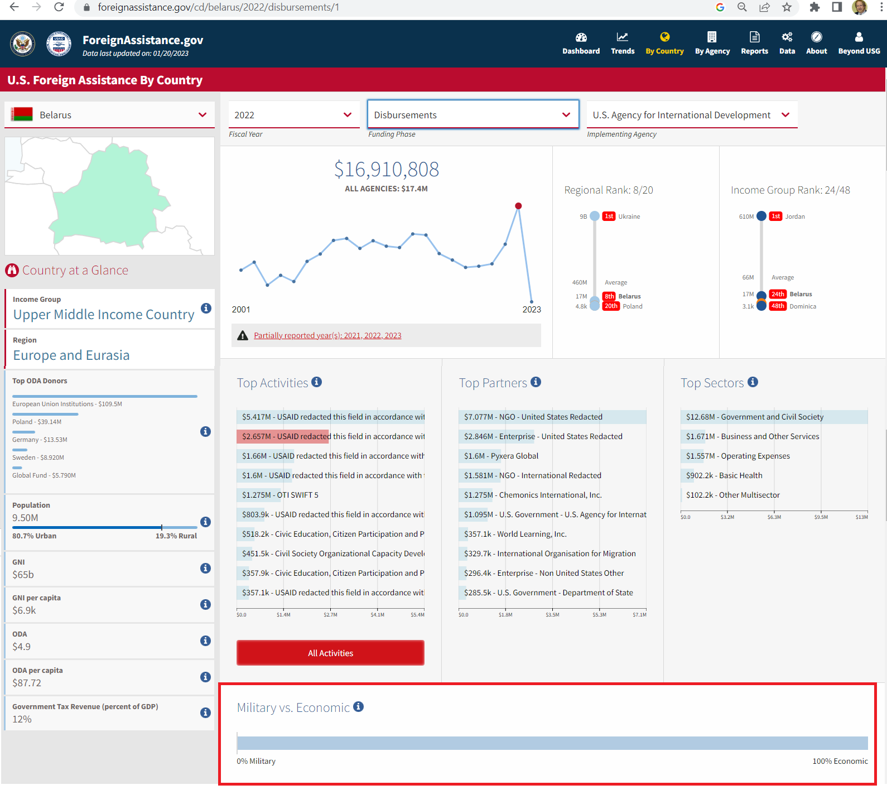

DISADVANTAGES
1. Sets back the cause of freedom
Link: AFF plan cancels "all" non-humanitarian aid to Belarus
The only ones left who benefit from US aid to Belarus are the opposition movements and private businesses we're helping, so that must be who gets cut under their plan.
Impact: Sets back the cause of freedom. Freedom in Belarus and Ukraine depend on outside aid to the opposition
Ceclia Smitt Meyer and Dr Anders Olofsgard 2023. (Meyer - M.Sc. Research Assistant, Stockholm Institute of Transition Economics. Olofsgard - PhD; Deputy Director at the Stockholm Institute of Transition Economics) 9 Jan 2023 "How to Sustain Support for Ukraine and Overcome Financial and Political Challenges | SITE Development Day 2022" (accessed 16 Feb 2023) https://freepolicybriefs.org/2023/01/09/site-development-day-2022-support-ukraine/ (brackets added)
Amidst the fight for Ukraine, we must also fight for a free Belarus, [opposition leader Svyetlana Tsikhanouskaya] added. Not only Belarusians fighting alongside Ukrainians against Russia in Ukraine, but also other parts of the Belarusian opposition need support from the free and democratic world and the EU. The massive crackdowns on opponents of the Belarusian regime today and the war on Ukraine are not only acts of violence, but they are also acts against democracy and freedom. The world must therefore continue to give support to those fighting in both Belarus and Ukraine. Ukraine will never be free unless Belarus is free, Tsikhanouskaya concluded.
2. Loss of exposure to outside influence
Link: US aid would (if we could do it) bring Belarus professionals to the US to learn our ideals and apply them at home
Tanner Helem 2018. (writes for The Borgen Project, an international humanitarian organization. He has a BA from the University of Washington in Political Science: International Security. He is a Legal Assistant at a law firm in Bellevue, WA) 7 Nov 2018 " US FOREIGN AID TO BELARUS: THE GATEWAY TO THE EAST" (accessed 16 Feb 2023) https://borgenproject.org/u-s-foreign-aid-to-belarus-the-gateway-to-the-east/
The second focus of USAID is to create a stronger civil society in order for a freer form of government to flourish. Civil society organizations (CSOs) are an essential part of this plan. CSOs are meant to increase the involvement of the general public in policy-making decisions. As of 2016, 140 CSOS had been trained and funded, totaling more than 8,000 hours. Each year, more than 60 Belarusian professionals from different sectors (business, law, education, government and civil society) are selected for exchange programs in The U.S. These professionals are exposed to the innovations of U.S. nongovernmental organizations and how to apply these innovations in Belarus.
Impact: Reduced influence for democracy and reform. Exchange programs can be a powerful influence for good
Helena Kane Finn 2002 (State Department public diplomacy officer) 2 Apr 2022 Public Diplomacy: Promoting a Culture of Tolerance (accessed 16 Feb 2023) https://www.washingtoninstitute.org/policy-analysis/public-diplomacy-effective-strategies-future-importance-academic-and-cultural
The principal goal of the United States must be the universal promotion of democracy. America must encourage open media, universal literacy, and study of the English language. A command of English allows one to access the immense world of information available on the internet, international television, and radio. Academic exchange programs such as Fulbright can help to develop a country's intellectual infrastructure by training the best and the brightest at institutions in the United States. Professional exchange programs like Humphrey and Eisenhower can give policy planners in education, economics, and social sciences a firsthand exposure to American research. Youth exchange programs enable young people to spend a year with an American host family while attending an American high school. Programs such as these leave a lifelong imprint. How do we measure the success of exchanges? Large numbers of exchange program alumni take important positions as heads of state, cabinet ministers, governors, influential journalists, and respected academics.
3. Punish the innocent with the guilty
Lots of Belarus citizens oppose the war in Ukraine. AFF fails to separate policy towards the evil government from policy towards the citizens, who are victims themselves
Anais Marin 2022 (Research Fellow with the Center for French Culture, Univ. of Warsaw) 31 Oct 2022 " Belarusians during the war on Ukraine: caught between a rock and a hard place" (accessed 16 Feb 2023) https://theconversation.com/belarusians-during-the-war-on-ukraine-caught-between-a-rock-and-a-hard-place-193133
Hundreds of Belarusians have joined international battalions in Ukraine, and so are literally risking their lives in the defense of Ukraine. If taken prisoner by the Russian armed forces and returned to Belarus, they could face harsh punishment.In diplomatic settings, the Belarusian democratic opposition in exile tirelessly advocates for decoupling civil population from the country’s leadership – widely recognised as illegitimate. It also argues that Belarus too could be considered a Russia-occupied territory. Without prejudice to the validity of such claims, it would be fair to remember that Belarusians are double hostages in this deadly conflict.
It's wrong and counterproductive to blame or sanction all Belarusians for the actions of their leader, whom many do not support
Prof. David R. Maples and Katsiaryna Lozka 2022 (Maples - Distinguished University Professor of Russian and East European History, University of Alberta, Canada. Lozka - doctoral research fellow, affiliated with Ghent University and UNU-CRIS, specializing in Eastern Europe and the South Caucasus. She holds a Master's degree in EU International Relations and Diplomacy Studies from the College of Europe in Bruges, and a Master's degree in European Studies from Comenius University in Slovakia) 26 Oct 2022 "Belarusians are facing discrimination and blame for Russia’s war in Ukraine" (accessed 16 Feb 2023) https://theconversation.com/belarusians-are-facing-discrimination-and-blame-for-russias-war-in-ukraine-192828
The Lukashenko regime has supported Russia, resulting in European states lumping all Belarusians together with Russians as co-aggressors. But that’s both misinformed and counterproductive. Two years ago, 250,000 people gathered in the streets of Minsk, the Belarusian capital. They protested the fabricated results of the presidential elections and Lukashenko’s brutal crackdown against his own citizens. It was the largest single demonstration in the history of the independent state. Protests were held even in villages and small towns in every region of the country.

