Key to Success: The Case for the Keystone XL Pipeline
By Joseph “Coach Graham”
Resolved: The United States Federal Government (USFG) should significantly reform its domestic transportation policy implemented by the Department of Transportation (DOT).
The Keystone XL pipeline extension was designed to transport tar sands oil from the Athabascan Reserve in Alberta, Canada (Canada ranks #4 in proven reserves worldwide with 95% of proven reserves in Alberta). It is expected to increase transport of 830,000 barrels (35 million gallons) of tar sands oil per day to the Gulf Coast of Texas. Gulf Coast refineries are specifically designed to process “heavy” oil like the kind from Canada. Regardless of whether Canadian tar sands oil gets to these refineries someone will be sending heavy oil to be processed there. In the status quo that means Latin American oil or others if there are delays from Canada. The KXL project has undergone back and forth approval and cancellations since originally proposed in 2008. Pres. Obama cancelled it. Pres. Trump un-canceled and approved it. Now Pres. Biden has canceled it again. The pipeline was just getting started (it has never been close to completion), but it requires permission from the US State Department to be built, and then falls under the jurisdiction of the US Dept of Transportation as all US oil pipelines do. The environmental impact is officially negligible, even according to the US government, but that didn’t stop environmentalists from vehement opposition. It was most recently canceled on President Biden’s first day in office, by canceling the cross-border permit. The oil continues to be transported to Gulf refineries via other means primarily rail or truck (there is no boat option for landlocked Alberta). This case emphasizes the low environmental impact of Keystone XL as an insufficient justification for cancellation and rather leverages the benefits to the North American economy and energy security as reasons to approve the pipeline.
OBSERVATION 1. DEFINITIONS 4
Significant 4
Policy 4
Implement 4
The Pipelines & Hazardous Materials Safety Administration. It's an agency of the US Dept of Transportation that implements policies on oil pipelines 4
OBSERVATION 2. INHERENCY, or background facts about the Status Quo 5
FACT 1: Pipeline canceled 5
On his first day in office, Pres. Biden canceled the Keystone XL pipeline. 5
FACT 2: Trucks and trains 5
Without Keystone XL pipeline, Canadian oil will be transported across the US by rail or truck 5
OBSERVATION 3. The PLAN 5
OBSERVATION 4. The JUSTIFICATIONS 6
JUSTIFICATION 1: The Environment 6
SUBPOINT A: No Climate Impact. XL up and running would have no impact on Climate 6
SUBPOINT B: Pipelines are safer than alternative modes of transportation. Pipelines are the most environmentally friendly way to carry oil: 6
JUSTIFICATION 2: Economic Benefits 7
Keystone XL would create thousands of jobs and billions of dollars in economic benefits 7
JUSTIFICATION 3: Energy Security 7
Canceling XL helps our enemies. Approving XL leads to global economic and national security benefits 7
2A Evidence: Keystone XL 8
OVERVIEW 8
Biden "virtue signaling" over Keystone XL: It sounds good but doesn’t actually help the environment because alternatives are worse 8
DEFINITIONS & TOPICALITY 8
Argumentation about policy change actor versus implementation actor 8
Text of the entire bill 8
Pipeline & Hazardous Materials Safety Administration has regulatory authority over interstate pipelines 9
PHMSA is part of Department of Transportation 9
PHMSA establishes national policy over pipelines 9
INHERENCY & BACKGROUND 10
Canadian Oil Fields 10
170 Billion Barrels of Oil in Alberta, Canada oil sands 10
Alberta Landlocked 10
Keystone XL Status 10
XL was close to completion when Biden canceled it 10
Keystone XL Map, Accessed in 2023 11
TC Energy seeking $15 Billion over cancelation 11
U.S. Oil Imports 12
Latin America 12
OPEC+ Cuts Trigger More Latin America Oil 12
A/T “Don’t need XL” – Infrastructure needed 12
Boom outpaced current pipelines before XL 12
Canada held hostage with pipeline ceiling 12
HARMS/SIGNIFICANCE 13
The Globe DEPENDS on Fossil Fuels—85% 13
A/T “Rate of Extraction Increased”—U.S. Environmental Impact Study says rate of extraction not affected 13
J1 - Environmental Impact 14
No climate worries: Canada has environmental safeguards and the source of the oil is irrelevant to climate impact anyway 14
Pipeline opponents concede XL climate impact is close to zero 14
No climate impact to Alberta oils sands production and use 14
Burning the entire Alberta oil sands reserve would lead to global warming of 0.03 degrees Celsius 14
Pipeline runs on net-zero emissions 15
Pipelines Safer / Alternatives Worse 15
Keystone Oil ends up being transported in less safe and efficient means 15
Pipelines are far safer than the alternatives - trucks and rail 15
XL would have $50 billion/year in transportation cost savings—Pressures rail toward bigger cars and worse wrecks 16
Pipeline spills = Less human death 16
Pipeline spills cause less human death than the alternatives 16
Pipelines are the safest way to transport oil—No pipeline fatalities since 1999 17
A/T "Climate change impacts of fossil fuels / XL Pipeline" 17
Climate Sensitivity to CO2 is Modest 17
Science Not Settled—Climate Sensitivity 17
Science Not Settled—Could Could Could 18
J2 - Economic Benefits 18
Jobs 18
Cancelation Devastating to Communities 18
Ended 1,000 union jobs and 10,000 others 18
A/T "They were only 'temporary' jobs lost" - Insulting to construction workers. ALL construction jobs are temporary, yet important 19
Canada agrees canceling costs jobs and energy security 19
Business Stability 19
Economic Uncertainty Hurts GDP and Lowers Living Standards 19
Project cancellations leads to fewer investments 19
Investors worry about cancelations after approval 20
Example: Canceled tar sands project due to uncertainty 20
Stable Business Investments - when we quit approving and canceling pipelines back and forth (see section 2 of the AFF bill) 20
IMPACT: Billions in losses 21
J3 – Energy Security 21
Decreases Middle Eastern Dependency 21
Fossil fuel projects improve foreign policy leverage 21
Cancellation Harms Energy Economy 21
Keystone XL displaces heavy crude oil from OPEC+ and Mexico 22
A/T “Unknown Number of Jobs”—Not an argument against energy resource development 22
SOLVENCY / ADVOCACY 22
PHMSA inspecting pipelines 22
Fully Funded 23
Canada Still Supports: Moving forward makes for a strong North American economy, Biden decision should be reversed 23
XL Opponents' position based on ideology, not actual data 23
DISADVANTAGE RESPONSES 23
A/T "Oil Spills" 23
Pipeline spills infrequent based on risk assessment 23
Rail Alternative Worse Than Pipeline 24
[STUDY] Rail Riskier 24
Example: Rail Tragedy in Quebec 24
Example: Rail Spill—13 Killed v. Pipeline Spill—0 Dead [Rail travels through towns, pipelines do not] 24
A/T “Higher Oil Prices" 25
Oil prices depend entirely on world prices and world events, not domestic markets 25
Global oil prices determine US gasoline prices because oil is a globally traded commodity 25
Climate Impacts 25
Advocate for climate change concern, IPCC, admits total impact of the entire industrial revolution from 1850 to 2019 is 1.07 degrees Celsius. Not much 25

Key To Success: The Case for the Keystone XL Pipeline
Virtue signaling is a modern phenomenon where someone takes a symbolic action that doesn't actually accomplish anything for their righteous cause, but makes it look like they care. Pres. Biden did that on the first day of his presidency by canceling the Keystone XL Pipeline. His actions not only didn't advance his cause of protecting the environment, it made the environment and a lot of other things worse off. That's why my partner and I are affirming that: The United States Federal Government should significantly reform its domestic transportation policy implemented by the Department of Transportation.
OBSERVATION 1. DEFINITIONS
Significant
Merriam Webster Online Dictionary copyright 2023. https://www.merriam-webster.com/dictionary/significant (accessed 4 July, 2023)
2a: having or likely to have influence or effect : IMPORTANT
Policy
Merriam Webster Online Dictionary copyright 2023. https://www.merriam-webster.com/dictionary/policy (accessed 4 July 2023)
a high-level overall plan embracing the general goals and acceptable procedures especially of a governmental body
Implement
Merriam Webster Online Dictionary copyright 2023. https://www.merriam-webster.com/dictionary/implemented (accessed 4 July 2023)
Carry out, accomplish
The Pipelines & Hazardous Materials Safety Administration. It's an agency of the US Dept of Transportation that implements policies on oil pipelines
US State Dept. 2012. Final Supplemental Environmental Impact Statement - Keystone XL Project (accessed 6 July 2023) https://2012-keystonepipeline-xl.state.gov/documents/organization/221143.pdf
The Department’s jurisdiction to issue a Presidential Permit includes only the border crossing and the associated facilities at the border, although the analysis included in this Final Supplemental Environmental Impact Statement (Final Supplemental EIS) discloses potential impacts of the proposed Project along its entire route in the United States. The Department’s authority over the border crossing does not include the legal authority to regulate petroleum pipelines within the United States. The Department of Transportation’s Pipelines and Hazardous Materials Safety Administration is responsible for promulgating regulations regarding petroleum pipeline construction, operation, and maintenance.
OBSERVATION 2. INHERENCY, or background facts about the Status Quo

FACT 1: Pipeline canceled

On his first day in office, Pres. Biden canceled the Keystone XL pipeline.
Kristie Pladson, 2021 (journalist with Deutsche Welle, German news agency) “Biden cancels Keystone XL pipeline”. Deutsche Welle. January 21, 2021. (Accessed 1 July, 2023) https://www.nationalreview.com/2023/01/the-u-s-should-privatize-air-traffic-control/
Within hours of taking his oath of office, Joe Biden, the 46th president of the United States, had signed over a dozen executive orders, among them one canceling the permit for the Keystone XL oil and gas pipeline. The pipeline was to carry millions of gallons of oil from Canada to refineries in the US. Along with the project cancellation, the executive order revokes oil and gas development at national wildlife monuments. Conceived over 10 years ago, the $8 billion (€6.6 billion) pipeline has been fraught with controversy from the beginning. What is the Keystone XL pipeline project? The completed segment of pipeline was to cover a 1,179-mile (1,897-kilometer) route from the province of Alberta, Canada, to Nebraska where it would have connected with the existing pipelines leading to the coast. It would have transported up to 830,000 barrels of heavy crude oil a day, replacing production from Latin American countries. The pipeline is owned by energy company TC Energy and the government of Alberta.

FACT 2: Trucks and trains
Without Keystone XL pipeline, Canadian oil will be transported across the US by rail or truck
Benjamin Zycher 2021 (senior fellow at the American Enterprise Institute, where he works on energy and environmental policy) “The Shallowness of Opposing The Keystone XL Pipeline” Climate Change Dispatch. January 26, 2021. (Accessed 3 July, 2023) https://climatechangedispatch.com/the-shallowness-of-opposing-the-keystone-xl-pipeline/
Accordingly, without Keystone XL, the heavy oil will be produced but transported by rail or truck, to be refined in northern or eastern refineries. Lighter oil from U.S. hydraulic fracturing operations will be sent to the Gulf Coast refineries despite the fact that those facilities are optimized for heavier crudes. So, the net effect of stopping Keystone XL will be an inefficient allocation of crude oil geographically. In short: Without the pipeline, railroad capacity will grow, overall safety will decline, and economic costs will be higher. Who would benefit from that outcome?
END QUOTE. And that's exactly why we offer:
OBSERVATION 3. The PLAN
1. Congress enacts H.R. 684, a bill proposed in 2021 but never enacted, which approves the Keystone XL pipeline, and repeals the need for Presidential approval so that it cannot be canceled again by any future President.
2. Agency and Enforcement through the Dept of Transportation’s Pipeline and Hazardous Materials Safety Administration, the federal courts, and any other necessary federal agencies.
3. Plan takes effect the day after an Affirmative ballot.
4. Funding from existing budgets of existing agencies, no additional funding required.
5. All Affirmative speeches may clarify

Our plan is warranted based on several important reasons as we see in

OBSERVATION 4. The JUSTIFICATIONS

JUSTIFICATION 1: The Environment
The environmental impact of NOT doing the Keystone XL pipeline would be worse than the possible impacts of doing it. Stopping the XL pipeline for environmental reasons means the Status Quo has it exactly backwards, as we see in two subpoints:
SUBPOINT A: No Climate Impact. XL up and running would have no impact on Climate
Paul C. Knappenberger, 2017. (Paul C. Knappenberger is the Former Assistant Director, Center for the Study of Science) “Keystone XL Approved at Last, Now Let’s Move On” CATO Institute, January 24, 2017 (accessed July 3, 2023) https://www.cato.org/blog/keystone-xl-approved-last-now-lets-move
But from the federal government standpoint, this shouldn’t matter. If private monies want to take the risk, the federal government should not stand in the way. After all, the Keystone XL pipeline passed each and every environmental impact/​safety assessment along the way. Even the climate impact, much touted and hyped by the previous Administration and its supporters, was shown, dispassionately, to be inconsequential—a mere 1/100th of a degree of warming by century’s end (and that’s being generous).

END QUOTE. But this brings us to:
SUBPOINT B: Pipelines are safer than alternative modes of transportation. Pipelines are the most environmentally friendly way to carry oil:
Charlie Kirk, 2021. (Founder and President of Turning Point USA.) “Canceling Keystone Does More Environmental Harm than Good | Opinion”. Newsweek. February 11, 2021. (Accessed 2 July, 2023) https://www.newsweek.com/canceling-keystone-does-more-environmental-harm-good-opinion-1568680
Crude oil, or oil in its unrefined state, is toxic to humans and animals, and destructive to the environment when spilled on land or in bodies of water. After crude oil is obtained, it must be transported safely and carefully to refineries to be chemically processed so that it can be used. It can be easily transported in one of three ways: by truck, by train or by pipeline. Truck transportation accounts for just under 30 percent of transport emissions. It has a higher fatality rate than any other mode of transportation, and the average spill volume of petroleum shipped by trucks is 13,707 gallons per billion ton-miles. In 2013, the Association of American Railroads found that the rate of hazardous-material spills by railroad is about 2.7 times higher than by pipelines. That same year, an oil train from North Dakota derailed and exploded in Alabama, spilling an estimated 749,000 gallons onto land. That was just one of several rail incidents over the last decade. Though no mode of oil transport is perfect, pipelines have proven to be the safest and most environmentally friendly way to carry oil. More than 80 percent of pipeline accidents don't happen in the actual pipe, but in facilities. According to the Fraser Institute, from 2003 to 2013, 99 percent of such accidents did not damage the environment.
END QUOTE. But in addition to the environment, there are further positive reasons for supporting the pipeline which leads to:

JUSTIFICATION 2: Economic Benefits
Keystone XL would create thousands of jobs and billions of dollars in economic benefits
Sukhayl Niyazov, 2021. (a journalist for Human Events, an American conservative political news and analysis website) “Canceling the Keystone Pipeline Is a Mistake” Human Events January 23, 2021. (Accessed 2 July, 2023) https://humanevents.com/2021/01/23/canceling-the-keystone-pipeline-is-a-mistake/
Estimates for the number of temporary construction jobs the Keystone XL pipeline would have created range from 2,500 to 9,000. According to the Perryman Group, in the long run, the project would also create anywhere from 250,348 to 553,235 so-called “spin-off” jobs in related industries, such as manufacturing, transportation, and refining of petroleum. The total economic impact of the project over its service life would be “$20.931 billion in total spending, $9.605 billion in output, and 118,935 person-years of employment.”
JUSTIFICATION 3: Energy Security
Canceling XL helps our enemies. Approving XL leads to global economic and national security benefits
Gen. James L. Jones 2014 (retired US Marine Corps general; former Supreme Allied Commander in Europe; served as Special Envoy for Middle East Security and as the President's National Security Adviser) testimony before the Senate Foreign Relations Committee 13 Mar 2014 (accessed 7 July 2023) https://www.govinfo.gov/content/pkg/CHRG-113shrg93175/html/CHRG-113shrg93175.htm
Second, a more overarching but no less significant point-- and of this I am convinced--if America does not remain prosperous and strong, an imperative dependent on energy security, we will not be in a position to engineer the low-carbon energy solutions the world needs, nor will we be able to exercise the global leadership necessary to answer the climate challenge. The decision on the pipeline is a litmus test of whether America is serious about national, regional, and global energy security, and the world is watching. America's workers and consumers are watching. Investors and job-creators are watching. Our allies, who need a strong United States and a reliable energy partner, are watching. The developing world, which requires global energy abundance to lift hundreds of millions of people out of poverty, is watching. And the international bullies who wish to use energy scarcity as a weapon against us all are watching intently. So if we want to make Mr. Putin's day and strengthen his hand, we should reject Keystone. If we want to gain an important measure of national energy security, jobs, tax revenue, and prosperity to advance our work on the spectrum of energy solutions that do not rely on carbon, then it should be approved.
END QUOTE. We present all these reasons to reverse the cancellation of Keystone XL and return to common sense policy decisions. Thank you.
2A Evidence: Keystone XL
OVERVIEW
Biden "virtue signaling" over Keystone XL: It sounds good but doesn’t actually help the environment because alternatives are worse
Tim Murtaugh 2021 (visiting fellow at The Heritage Foundation) Biden Virtue Signaling on Keystone XL Pipeline Can Actually Harm Environment 4 Mar 2021 (accessed 7 July 2023) https://www.heritage.org/environment/commentary/biden-virtue-signaling-keystone-xl-pipeline-can-actually-harm-environment
On the campaign trail, then-presidential candidate Joe Biden promised to kill the Keystone XL pipeline, which would transport 830,000 barrels of crude oil each day from Alberta, Canada, to Nebraska, a pledge met with elation from environmental activists across the globe. So no one was surprised when, on his first day in office, Biden followed through by revoking the pipeline permit through executive order, again prompting applause from the green crowd. But even a cursory examination of the issue reveals Biden’s actions to be mere virtue signaling, which will not stop the oil from flowing into the United States, and could prove even more environmentally dangerous than the Keystone XL pipeline itself.
DEFINITIONS & TOPICALITY
Argumentation about policy change actor versus implementation actor
There are 2 agents named in the resolution. The actor of change is "The federal government" - which must include lots of things and people not in the DOT, else no plan could be enacted this year. Congress and the President are not part of DOT, so they would be ruled out if the "actor" or agent of change is limited to DOT only. The second agent, DOT, limits the "scope" of what the first actor is allowed to change. The "federal government" (in general, any part of it) can change any transportation policy as long as that policy is one that is "implemented by the DOT". In our case, the President (federal actor, but not DOT) is changing a policy (approving an oil pipeline) that is implemented by the DOT (because US oil pipelines are always implemented by the DOT). We have an authorized actor - the President - working within the limited scope of things implemented by DOT, so we are within the bounds of the resolution.
Text of the entire bill
Text of HR 684, written in 2021. “Keystone XL Pipeline Construction and Jobs Preservation Act” (accessed 6 July 2023) https://www.congress.gov/bill/117th-congress/house-bill/684/text
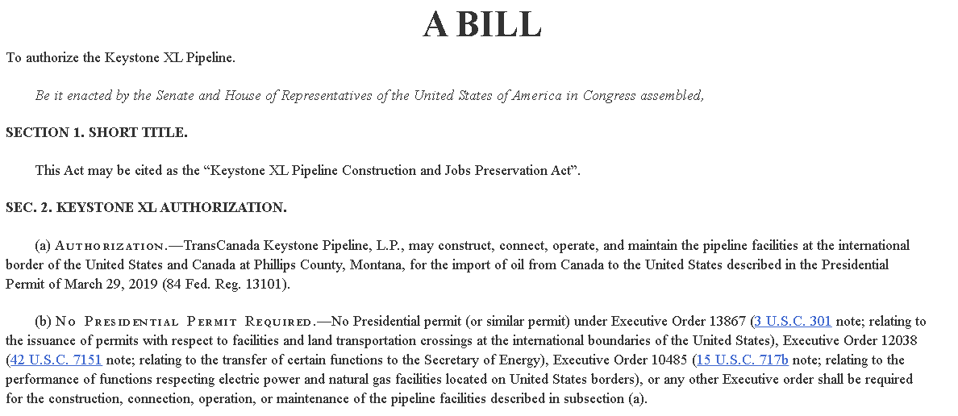
Pipeline & Hazardous Materials Safety Administration has regulatory authority over interstate pipelines
Government Accountability Office, 2021. (GAO, often called the "congressional watchdog," is an independent, non-partisan agency that works for Congress) “Pipeline Safety: Information on Keystone Accidents and DOT Oversight” Government Accountability Office. July 22, 2021. (Accessed 4 July, 2023) https://www.gao.gov/assets/gao-21-588.pdf
PHMSA’s oversight includes setting and enforcing the federal minimum pipeline safety standards for the construction, operation, maintenance, and inspection of interstate pipelines. Operators may apply for—and PHMSA has the authority to issue—special permits that waive compliance with one or more pipeline safety regulations if PHMSA determines that the permit is not inconsistent with pipeline safety.

PHMSA is part of Department of Transportation
US Department of Transportation, 2021. “U.S. Department of Transportation Administrations” Department of Transportation, Last Updated August 23, 2021 (Accessed July 4, 2023) https://www.transportation.gov/administrations
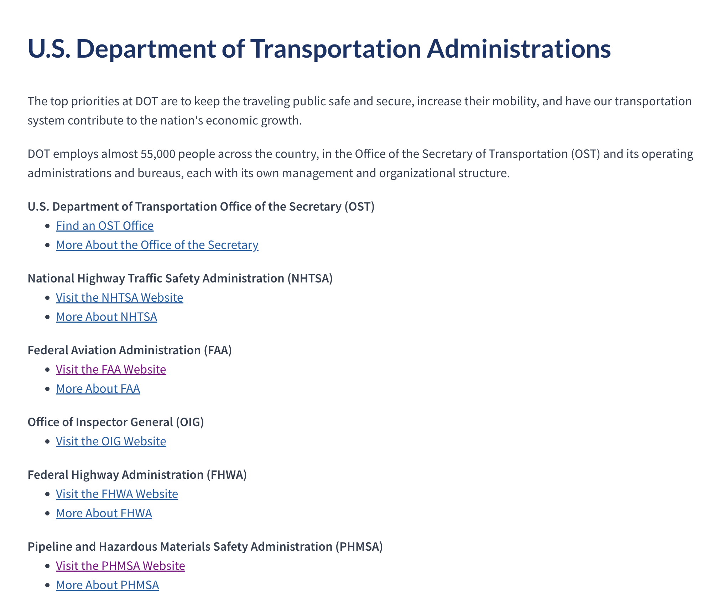

PHMSA establishes national policy over pipelines
Pipeline and Hazardous Materials Safety Administration, 2023. (regulatory agency within the US Dept of Transportation) “PHMSA’s Mission”. U.S. Department of Transportation, Pipeline and Hazardous Materials Safety Administration. January 25, 2023. (Accessed 4 July, 2023) https://www.phmsa.dot.gov/about-phmsa/phmsas-mission
PHMSA's mission is to protect people and the environment by advancing the safe transportation of energy and other hazardous materials that are essential to our daily lives. To do this, the agency establishes national policy, sets and enforces standards, educates, and conducts research to prevent incidents. We also prepare the public and first responders to reduce consequences if an incident does occur.
INHERENCY & BACKGROUND
Canadian Oil Fields
170 Billion Barrels of Oil in Alberta, Canada oil sands
Dr. Neil C. Swart and Dr. Andrew J. Weaver, 2012. (Dr. Neil Swart is a Research Scientist - Developing the physical and biogeochemical components of the Canadian Earth System Model and examining the role of the ocean in the climate system. Climatologist Dr. Andrew Weaver contributed to several UN IPCC reports; University of Victoria professor of Earth and Ocean Sciences) “The Alberta Oil Sands and Climate”. University of Victoria, British Columbia. Nature Clim Change 2, 134-136. 19 Feb 2012. Issued March 2012 (Accessed 2 July, 2023) https://climate.uvic.ca/people/nswart/Alberta_Oil_Sands_climate.html
Key Points. There are 1.8 trillion barrels of oil-in-place (OIP) in Alberta's oils sands; 170 billion of those are the 'economically viable proven reserve'. Burning the OIP would lead to a climate warming of 0.36°C (0.24-0.50°C, 5th-95th percentile). Burning the proven reserve would lead to a warming of 0.03°C (0.02-0.05).
Alberta Landlocked
BBC News, 2021. (British Broadcasting Corp., national broadcasting agency of the United Kingdom) “Keystone XL pipeline: Why is it so disputed?” BBC News 21 Jan 2021 (Accessed 3 July, 2023) https://www.bbc.com/news/world-us-canada-30103078
Canada already sends 550,000 barrels of oil per day to the US via the existing Keystone pipeline. The oil fields in Alberta are landlocked and as they are further developed require means of access to international markets. Many of North America's oil refineries are based in the Gulf Coast, and industry groups on both sides of the border want to benefit.
Keystone XL Status
XL was close to completion when Biden canceled it
Mark Green 2022. (journalism degree from the University of Oklahoma and master’s in journalism and public affairs from American Univ ; joined American Petroleum Institute after a career in newspaper journalism) “Misunderstood Keystone XL a Reminder of the Importance of Critical Infrastructure” American Petroleum Institute, March 11, 2022. (Accessed 3 July, 2023) https://www.api.org/news-policy-and-issues/blog/2022/03/11/misunderstood-keystone-xl-a-reminder-of-the-importance-of-critical-infrastructur
The Keystone Pipeline System was over half complete. At the time the presidential cross-border permit was revoked, construction of the 1,120-mile Keystone XL segment was on track to be completed in 2022, with operations starting in early 2023.

Keystone XL Map, Accessed in 2023
Keystone XL, Accessed 2023. (Keystone XL oversees the Keystone XL project) “Terminated pipeline route” Keystone XL, No Publication Date. Copyright 2023. (Accessed 4 July, 2023) https://www.keystonexl.com/maps/
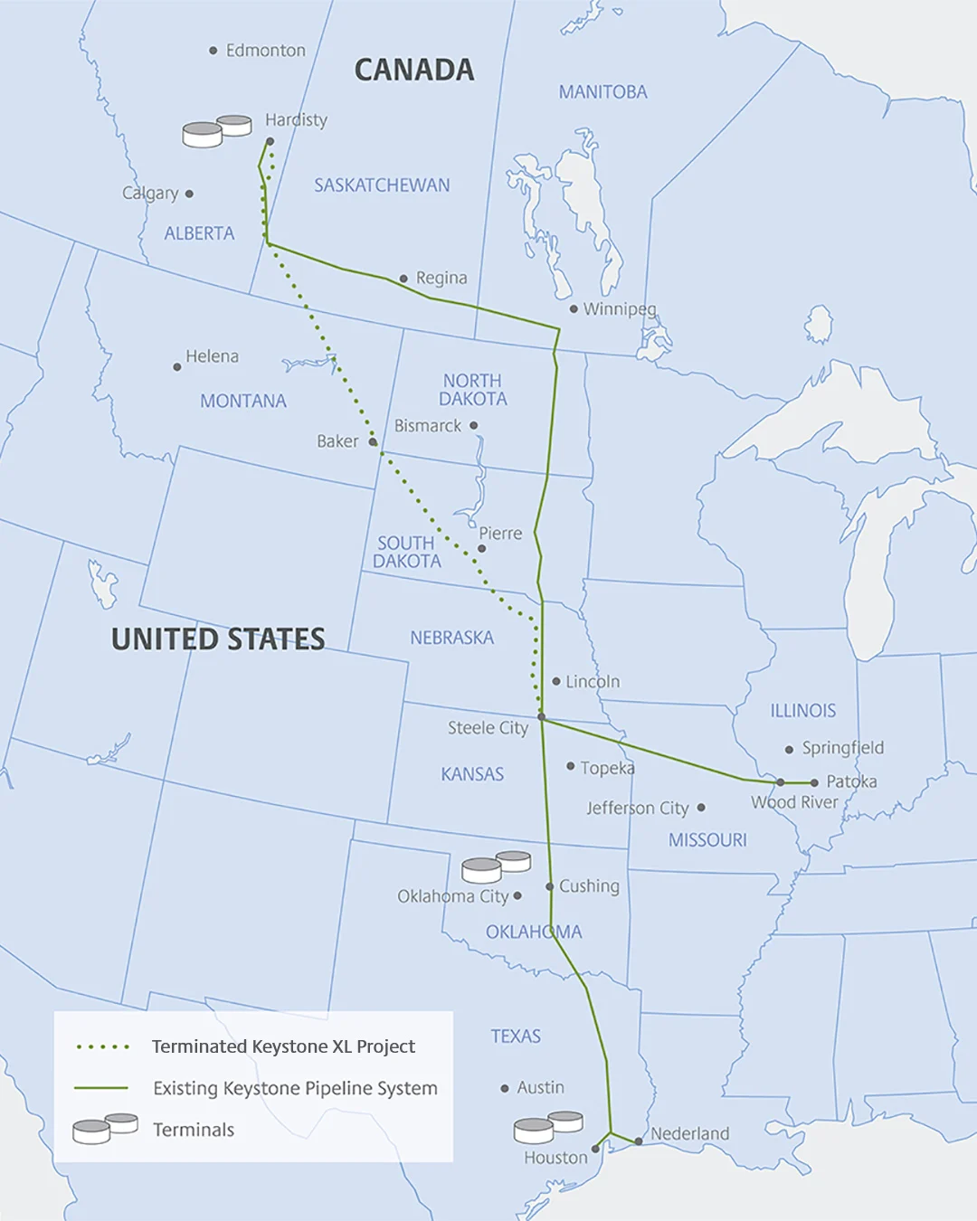[This is for background understanding of the AFF team. You cannot hold up a map during a team policy debate, it's not acceptable as valid evidence.]

TC Energy seeking $15 Billion over cancelation
Alex Durham and Sally King 2022. (journalists. Public Citizen is a nonprofit consumer advocacy organization that champions the public interest in the halls of power) “U.S. May Face $15 Billion Penalty for Rejection of Keystone XL Pipeline” Public Citizen, November/December, 2022 (Accessed July 3, 2023) https://www.citizen.org/news/u-s-may-face-15-billion-penalty-for-rejection-of-keystone-xl-pipeline/
Biden pulled the plug on the Keystone XL pipeline on his first day in office given longstanding climate, environmental, and health concerns of the crude oil project. TC Energy is now using a little-known provision in the North American Free Trade Agreement (NAFTA) to sue the U.S. government for $15 billion from U.S. taxpayers for “lost profits.” The Canadian company claims that blocking the construction of the pipeline violates its rights under NAFTA’s Investor-State Dispute Settlement (ISDS) provisions, even though the estimated cost of the project was to be $8 billion, and only $1.1 billion had been invested in the project. The ISDS case has recently progressed to a key step, in which the three arbitrators have been selected.

U.S. Oil Imports
Latin America
Josh Owens, 2022. (Content Director at Oilprice.com. An International Relations and Politics graduate from the University of Edinburgh, Josh specialized in Middle East and U.S. relations) “Latin America’s Crude Exports Drop In August” OilPrice.com, August 16, 2022 (Accessed July 3, 2023) https://oilprice.com/Latest-Energy-News/World-News/Latin-Americas-Oil-Export-Fall-As-Countries-Prioritize-Domestic-Energy-Needs.html
Although Latin American producers have boosted exports to Europe, the bulk of their crude continues to go to the United States. Crude exports to the U.S. averaged 1.4 million bpd in the first half of August, slightly down from the 1.5 million bpd high in July. Exports to Europe rose by 160,000 bpd from July to reach 730,000 bpd so far in August, Vortexa’s analysis showed.

OPEC+ Cuts Trigger More Latin America Oil
Sheela Tobben, 2023. (journalist for Bloomberg News) “OPEC+ cut set to trigger more competition for Latin America oil” American Journal of Transportation, April 4, 2023 (Accessed July 3, 2023) https://www.ajot.com/news/opec-cut-set-to-trigger-more-competition-for-latin-america-oil
“US buyers will fight to keep Latin American and Gulf of Mexico sour crudes at home, particularly as Middle East flows to the US continue to dry up,” said Matt Smith, lead Americas oil analyst for industry consultants Kpler. He added that Latin America exports more medium and heavy sour crude than the US produces in the Gulf of Mexico — making the South’s producers invaluable.

A/T “Don’t need XL” – Infrastructure needed
Boom outpaced current pipelines before XL
David Biello, 2018. (contributing editor) “Are Pipelines Safer Than Railroads for Carrying Oil?” Scientific American, July 10, 2018 (Accessed 4 July, 2023) https://blogs.scientificamerican.com/observations/are-pipelines-safer-than-railroads-for-carrying-oil/
But the boom in unconventional oil, from the tar sands of Alberta to the oil shale of North Dakota, has outpaced the growth of the pipeline infrastructure that would move those products. Efforts to build more pipelines, such as the Keystone XL project that would move oil from the tar sands to Texas's Gulf Coast, have faced significant political and environmental challenges. And, regardless of whether new pipelines are built, the glut of oil from new sources suggests that a variety of transport methods will be needed, in what might be dubbed an "all of the above" approach to energy transportation.

Canada held hostage with pipeline ceiling
Zainab Calcuttawala, 2018. (American journalist based in Morocco) “U.S. Regulators Keep Keystone Capacity Capped at 80 Percent” OilPrice.com, January 23, 2018 (Accessed 4 July, 2023) https://oilprice.com/Latest-Energy-News/World-News/US-Regulators-Keep-Keystone-Capacity-Capped-At-80-Percent.html
TransCanada says U.S. regulators are still requiring the Keystone pipeline to operate at 80 percent capacity after the key vein suffered a 5,000-barrel leak a couple of months ago, according to a new report by Reuters. Genscape said the pipeline averaged a 524,000-bpd flow rate last week. The reduced supply caused inventories at the Cushing, Oklahoma, site to decline as well, traders said. The U.S. Pipeline and Hazardous Materials Safety Administration (PHMSA) did not comment on when Keystone would be allowed to operate at full capacity again. Canada’s oil industry has also been unable to build new pipelines to get the landlocked oil from Alberta to market. Alberta oil producers are essentially hostage to their buyers in the U.S., with oil production now bumping up against a ceiling in terms of pipeline capacity.

HARMS/SIGNIFICANCE
The Globe DEPENDS on Fossil Fuels—85%
Dr. Hannah Ritchie and Dr. Max Roser in a graphic published by Our World in Data, 2022. (Dr. Hannah Ritchie is Deputy Editor and Science Outreach Lead for Our World in Data. Dr. Max Roser is the Founder and Director of Our World in Data. He is also Programme Director of the Oxford Martin Programme on Global Development at the Univ. of Oxford) “Overview of Global Energy” Our World in Data, April 7, 2023 (Accessed June 29, 2023) https://ourworldindata.org/energy-overview
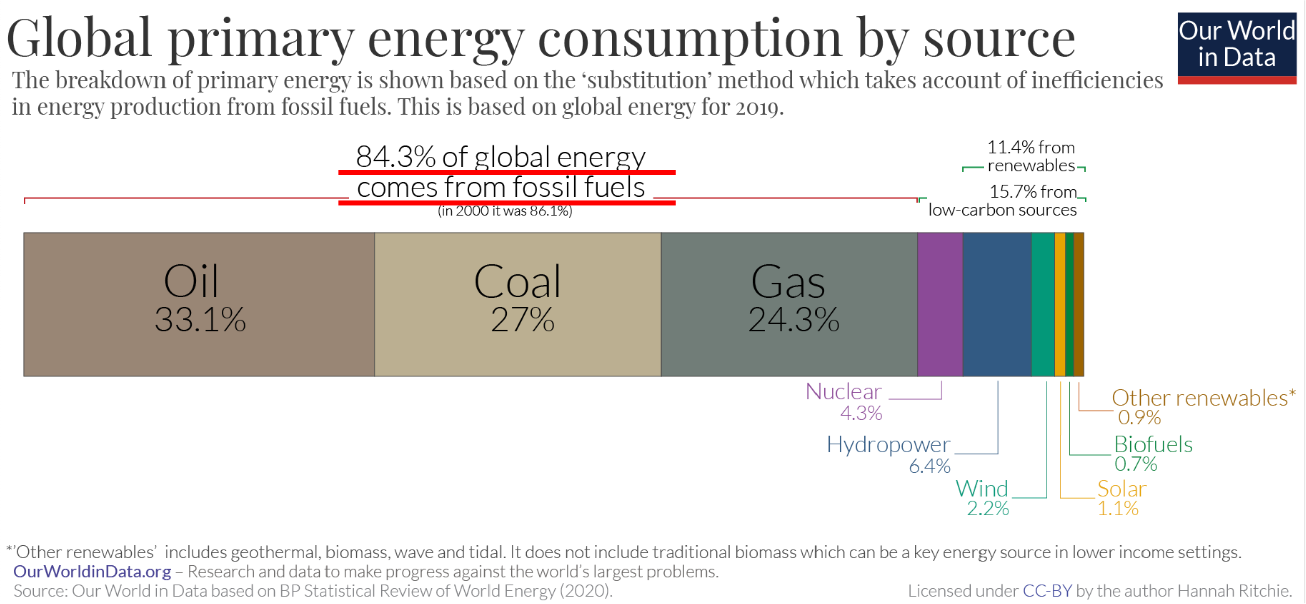

A/T “Rate of Extraction Increased”—U.S. Environmental Impact Study says rate of extraction not affected
Final Supplemental Environmental Impact Statement for the Keystone XL Project, 2014. (The Bureau of Oceans and International Environmental and Scientific Affairs is a functional bureau within the United States Department of State.) “Final Supplemental EIS for the Keystone XL Project” U.S. Department of State Bureau of Oceans and International Environmental and Scientific Affairs, January, 2014 (Accessed June 29, 2023) https://2012-keystonepipeline-xl.state.gov/documents/organization/221135.pdf
The above estimates represent the total incremental emissions associated with production and consumption of 830,000 bpd of oil sands crude compared to the reference crudes. These estimates represent the potential increase in emissions attributable to the proposed Project if one assumed that approval or denial of the proposed Project would directly result in a change in production of 830,000 bpd of oil sands crudes in Canada (See Section 4.14.4.2, Emissions and Impacts in Context, for additional information on emissions associated with increases in oil sands production). However, as set forth in Section 1.4, Market Analysis, such a change is not likely to occur under expected market conditions. Section 1.4 notes that approval or denial of any one crude oil transport project, including the proposed Project, is unlikely to significantly impact the rate of extraction in the oil sands or the continued demand for heavy crude oil at refineries in the United States based on expected oil prices, oil-sands supply costs, transport costs, and supply-demand scenarios.

J1 - Environmental Impact
No climate worries: Canada has environmental safeguards and the source of the oil is irrelevant to climate impact anyway
National Review, 2021. (National Review is an American conservative editorial magazine, focusing on news and commentary pieces on political, social, and cultural affairs.) “Biden’s Foolish Sabotage of the Keystone Pipeline” The Editors at National Review, January 19, 2021 (accessed July 3, 2023) https://www.nationalreview.com/2021/01/bidens-foolish-sabotage-of-the-keystone-pipeline/
The notional case against Keystone is environmental in the main part, and in the lesser part an issue of Indian lands and rights. The environmental case is unsound: Canada has ratified the Paris agreement and takes environmental issues relatively seriously. Innovation and technological improvements have substantially reduced the greenhouse-gas emissions associated with Canadian tar-sands productions — by 30 percent since the 1990s, as the Canadian government calculates. Of course, it matters relatively little whether a gallon of gasoline in the tank of a Cadillac Escalade in Houston is refined from Canadian tar-sands oil or from West Texas oil — the relevant emissions come overwhelmingly from the point of combustion.

Pipeline opponents concede XL climate impact is close to zero
Benjamin Zycher, 2021. (senior fellow at the American Enterprise Institute. Climate Change Dispatch (CCD) is a forum for the discussion of human-caused global warming) “The Shallowness of Opposing The Keystone XL Pipeline” Climate Change Dispatch. January 26, 2021. (Accessed 3 July, 2023) https://climatechangedispatch.com/the-shallowness-of-opposing-the-keystone-xl-pipeline/
The opponents of the pipeline occasionally concede that, yes, the climate impacts of stopping Keystone XL would be very close to zero, but that many such actions globally would add up to something significant.
No climate impact to Alberta oils sands production and use
Robert Rapier, 2014. (chemical engineer in the energy industry; 25 years of international engineering experience in the chemicals, oil and gas, and renewable energy industries) “Keystone XL’s Miniscule CO2 Impact and the Bigger Picture” OilPrice.com. February 12, 2014. (Accessed 2 July, 2023) https://oilprice.com/Energy/Energy-General/Keystone-XLs-Miniscule-CO2-Impact-and-the-Bigger-Picture.html
In 2012, Canada produced 3.74 million barrels per day (bpd) of oil. The oil industry there has been increasing production by 3.1% per year over the past decade. At that growth rate, Canada could reach Saudi Arabia’s production level in 2045. If we assume that level of production could be maintained, it would take until 2070 to produce the 170 billion barrel Athabasca oil sands reserve. At that point, the temperature impact is estimated to be 0.03°C — not even measurable against the background noise.
Burning the entire Alberta oil sands reserve would lead to global warming of 0.03 degrees Celsius
Dr. Neil C. Swart and Dr. Andrew J. Weaver, 2012. (Swart is a Research Scientist - Developing the physical and biogeochemical components of the Canadian Earth System Model and examining the role of the ocean in the climate system. Climatologist Dr. Andrew Weaver contributed to several UN IPCC reports. Univ. of Victoria professor of Earth and Ocean Sciences.) “The Alberta Oil Sands and Climate” Nature Clim Change 2, 134-136. February 19, 2012. Issued March 2012 (Accessed 2 July, 2023) https://climate.uvic.ca/people/nswart/Alberta_Oil_Sands_climate.html
Key Points. There are 1.8 trillion barrels of oil-in-place (OIP) in Alberta's oils sands; 170 billion of those are the 'economically viable proven reserve'. Burning the OIP would lead to a climate warming of 0.36°C (0.24-0.50°C, 5th-95th percentile). Burning the proven reserve would lead to a warming of 0.03°C (0.02-0.05).

Pipeline runs on net-zero emissions
Zachary Evans, 2021. (Zachary Evans is a news writer for National Review Online. Scott Moe is the Premier of Saskatchewan.) “Leader of Canadian Province Urges Biden Admin to Reconsider Keystone XL Pipeline” National Review. January 22, 2021. (Accessed 3 July, 2023) https://www.nationalreview.com/news/leader-of-canadian-province-urges-biden-admin-to-reconsider-keystone-xl-pipeline/ [brackets added; ellipses in original]
However, [Scott] Moe [Saskatchewan Premier] emphasized that the pipeline itself is unique in that it runs on net-zero carbon emissions, and TC Energy has stated the pipeline will be powered entirely by renewable energy by 2030. Additionally, energy producers in the west side of Saskatchewan have been able to reduce greenhouse gas emissions in each barrel of oil that they drill. “In this particular area…the greenhouse gas emissions in each barrel of oil has been reduced by 50 percent,” Moe said. “That is a comparatively sustainable energy that is going into the Keystone XL pipeline, down to the Gulf Coast…ultimately offsetting the need for a much dirtier energy source coming in from Venezuela or one of the OPEC nations.”

Pipelines Safer / Alternatives Worse
Keystone Oil ends up being transported in less safe and efficient means
Ben Lieberman, 2021 (senior fellow who specializes in environmental policy at the Competitive Enterprise Institute. Lieberman has returned to CEI after serving seven years as a senior counsel on the U.S. House Committee on Energy and Commerce.) “Lessons from the Demise of ANWR and Keystone XL” Competitive Enterprise Institute, June 23, 2023 (accessed July 1, 2023) https://cei.org/blog/lessons-from-the-demise-of-anwr-and-keystone-xl/ ("ANWR" refers to oil drilling in the Alaska National Wildlife Refuge)
If the goal is a wholesale shift away from gasoline-powered vehicles to electric vehicles (EVs) in order to reduce greenhouse gas emissions, killing off ANWR and Keystone XL won’t work. Only a dramatic improvement in the affordability and convenience of EVs can do that, and even then there are serious questions regarding where the necessary critical minerals will come from, not to mention the additional electricity. The only real change will be that the oil that would have been produced in ANWR will come from somewhere else, quite possibly nations that impose far less stringent environmental measures than the U.S. And the oil that would have traversed the Keystone XL pipeline will be transported instead by less safe and less energy efficient methods such as rail or through older pipelines much more susceptible to spills than new ones. These environmentally counterproductive impacts would only grow if other new projects are also blocked.

Pipelines are far safer than the alternatives - trucks and rail
Tim Murtaugh 2021 (visiting fellow at The Heritage Foundation) Biden Virtue Signaling on Keystone XL Pipeline Can Actually Harm Environment 4 Mar 2021 (accessed 7 July 2023) https://www.heritage.org/environment/commentary/biden-virtue-signaling-keystone-xl-pipeline-can-actually-harm-environment
About 70% of petroleum products in the United States are already transported by pipelines, with truck and train shipping combining for a mere 7%. One would then naturally expect that most accidents occur with pipelines, but one would be wrong. Though responsible for a tiny fraction of petroleum product transportation, road and rail methods are where a majority of mishaps occur. From 2005 to 2009, roadway transmission averaged 19.95 incidents per billion ton-miles each year, while railway accidents occurred at the rate of 2.08 accidents per year. In contrast, liquid pipelines produced only 0.58 incidents annually. The environmentalist specter of the pipeline as a leaking, polluting menace just does not hold up to the barest scrutiny.
XL would have $50 billion/year in transportation cost savings—Pressures rail toward bigger cars and worse wrecks
Dr. James Conca, 2018. (PhD in Geochemistry & Expert in Nuclear energy; former contributor to Forbes magazine. ) “Which Is Safer For Transporting Crude Oil: Rail, Truck, Pipeline Or Boat?” Forbes, October 11, 2018 (accessed July 1, 2023) https://www.forbes.com/sites/jamesconca/2018/10/11/which-is-safer-for-transporting-crude-oil-rail-truck-pipeline-or-boat/
Like always, it will probably come down to money. And it won’t be about jobs, regardless of which end of the spectrum you believe, because there just isn’t enough jobs to matter compared to the value of the oil itself and the refinery capacity and locations. It’s simply cheaper and quicker to transport by pipeline than by rail or by truck. The difference in cost is about $50 billion a year for shipping via the Keystone versus rail, totally eclipsing any economic effect of jobs in either direction. A rail tank car carries about 30,000 gallons (÷ 42 gallons/barrel = about 700 barrels). A train of 100 cars carries about 3 million gallons (70,000 barrels) and takes over 3 days to travel from Alberta to the Gulf Coast, about a million gallons per day. The Keystone will carry about 35 million gallons per day (830,000 barrels). This puts pressure on rail transport to get bigger and bigger, and include more cars per train, the very reason that crude oil train wrecks have dramatically increased lately.

Pipeline spills = Less human death
Dr. James Conca, 2018. (PhD in Geochemistry & Expert in Nuclear energy. He is a former contributor to Forbes magazine. ) “Which Is Safer For Transporting Crude Oil: Rail, Truck, Pipeline Or Boat?” Forbes, October 11, 2018 (accessed July 1, 2023) https://www.forbes.com/sites/jamesconca/2018/10/11/which-is-safer-for-transporting-crude-oil-rail-truck-pipeline-or-boat/
The question remains: which is safest and which should we invest in most? Take two spills for comparison. The Quebec oil train wreck killed 47 people and spilled 1.5 million gallons of crude onto land. The Enbridge pipeline rupture spilled over a million gallons of similar crude into the Kalamazoo River but did not kill anyone. Contamination of water is definitely worse for the environment than land and spreads quickly over more area and impacts more species and habitat, but killing people makes a big difference to the public. I don’t want to put a price tag on human life, but the Government has, and it’s about $8 million a person. So the Quebec train derailment cost over $400 million in human life, plus another $150 million for clean-up and repairing the town. The Enbridge pipeline cost no human lives but will cost about a billion dollars to clean-up, and, like the Exxon Valdez, will never really succeed.

Pipeline spills cause less human death than the alternatives
Benjamin Zycher, 2021. (senior fellow at the American Enterprise Institute. Climate Change Dispatch (CCD) is a forum for the discussion of human-caused global warming) “The Shallowness of Opposing The Keystone XL Pipeline” Climate Change Dispatch. January 26, 2021. (Accessed 3 July, 2023) https://climatechangedispatch.com/the-shallowness-of-opposing-the-keystone-xl-pipeline/
The opponents argue as well that the pipeline would create a danger of spills. But transport of oil by pipeline is substantially safer than transport by rail or truck, the real-world alternatives to Keystone XL. For crude oil and petroleum products in the U.S., pipelines carry about 70% of the ton-miles; the respective figures for water transport, trucking, and railroads are 23%, 4%, and 3%. If we ignore water transport (not relevant as an alternative for Keystone XL), the data on adverse incidents—explosions or fires, spills of five gallons or more, fatalities, personal injuries requiring hospitalization, or all-inclusive property damage exceeding $50,000–show that pipeline incidents per ton-mile are about a quarter of those for rail transport, and about 3% of those for truck transport. This vastly greater safety of Keystone XL over the alternatives is important because the heavy Canadian oil will be produced with or without the pipeline.
Pipelines are the safest way to transport oil—No pipeline fatalities since 1999
David Biello, 2018. (contributing editor) “Are Pipelines Safer Than Railroads for Carrying Oil?” Scientific American, July 10, 2018 (Accessed 4 July, 2023) https://blogs.scientificamerican.com/observations/are-pipelines-safer-than-railroads-for-carrying-oil/
As the Association of American Railroads points out, the volume of oil spilled by railcars is "less than 1 percent of the total pipeline spills." That's 2,268 barrels spilled by the railroads between 2002 and 2012, compared to 474,441 barrels spilled by pipeline operators over the same span, according to the Association's numbers. But there hasn't been a fatality from a petroleum-related pipeline accident since 1999, when a gasoline pipeline ruptured and the volatile fuel exploded, killing three young boys. Deadly accidents involving crude pipelines are even rarer. "Crude oil pipeline spills generally do not result in a fire or an explosion," says attorney Brigham McCown, the first administrator of the Pipeline and Hazardous Materials Safety Administration. "Pipelines transport the lion's share of crude oil because they are the safest, most environmentally friendly and least expensive way to transport large volumes of energy products."
A/T "Climate change impacts of fossil fuels / XL Pipeline"
Climate Sensitivity to CO2 is Modest
Matt Ridley, 2014. (author of “The Rational Optimist: How Prosperity Evolves” and a member of the British House of Lords.) “Fossil Fuels Will Save the World (Really)” Wall Street Journal, March 13, 2014. (Accessed 4 July, 2023) https://www.wsj.com/articles/fossil-fuels-will-save-the-world-really-1426282420
Only in the 1970s and 1980s did scientists begin to say that the mild warming expected as a direct result of burning fossil fuels—roughly a degree Celsius per doubling of carbon-dioxide concentrations in the atmosphere—might be greatly amplified by water vapor and result in dangerous warming of two to four degrees a century or more. That “feedback” assumption of high “sensitivity” remains in virtually all of the mathematical models used to this day by the U.N. Intergovernmental Panel on Climate Change, or IPCC. And yet it is increasingly possible that it is wrong. As Patrick Michaels of the libertarian Cato Institute has written, since 2000, 14 peer-reviewed papers, published by 42 authors, many of whom are key contributors to the reports of the IPCC, have concluded that climate sensitivity is low because net feedbacks are modest. They arrive at this conclusion based on observed temperature changes, ocean-heat uptake and the balance between warming and cooling emissions (mainly sulfate aerosols). On average, they find sensitivity to be 40% lower than the models on which the IPCC relies.
Science Not Settled—Climate Sensitivity
Massachusetts Institute of Technology, 2021. (The MIT Climate Portal is managed by the MIT Environmental Solutions Initiative, with support from the MIT Office of the Vice President for Research. This Explainer was adapted from “Explained: Climate Sensitivity” by David Chandler, which originally appeared in MIT News.) “Climate Sensitivity” Massachusetts Institue of Technology, Environmental Solutions Initiative, June 8, 2023 (accessed July 1, 2023) https://climate.mit.edu/explainers/climate-sensitivity
Climate sensitivity is a term used by the Intergovernmental Panel on Climate Change (IPCC) to describe to what extent rising levels of greenhouse gases affect the Earth’s temperature. Specifically, it describes how much warmer the planet will get if the amount of greenhouse gases in the atmosphere doubles. Although scientists don’t know exactly what Earth’s climate sensitivity is, it’s a useful concept for thinking about the range of risks we face from climate change: from slower and more manageable consequences if our climate sensitivity is low, to faster and more dire changes if it’s high. According to the most recent IPCC report, our climate sensitivity is very likely somewhere between 2 and 5 ℃ (between 3.6 and 9 ℉). Feedback Effects. If that range sounds pretty wide, that’s because there are many factors that can speed up or slow down the rise in atmospheric temperatures. The main ones are clouds, sea ice, and water vapor. Scientists call these factors “feedback effects,” and they can make predicting the planet’s future climate more complicated.

Science Not Settled—Could Could Could
Massachusetts Institute of Technology, 2021. (The MIT Climate Portal is managed by the MIT Environmental Solutions Initiative, with support from the MIT Office of the Vice President for Research. This Explainer was adapted from “Explained: Climate Sensitivity” by David Chandler, which originally appeared in MIT News.) “Climate Sensitivity” Massachusetts Institute of Technology, Environmental Solutions Initiative, June 8, 2023 (accessed July 1, 2023) https://climate.mit.edu/explainers/climate-sensitivity
Climate scientists agree that with no feedback effects at all, our climate sensitivity would be just 1 ℃. Many controversies in climate science hinge on just how strong the various feedbacks are, and whether scientists have accounted for all of them. Clouds are a good example. Clouds can warm or cool the planet, depending on how high they are and the size of their water droplets. Overall, most scientists expect changes in clouds to mostly warm the planet, but some say it’s hard to know. An Uncertain Future. While climate sensitivity can help us understand our climate risks today, we shouldn’t get too hung up on an exact number. The definition of climate sensitivity is based on doubling carbon dioxide and other greenhouse gases, compared with their levels in the atmosphere before humans started burning massive amounts of fossil fuels in the 1800s. If greenhouse gases more than double in the long run, the feedback effects could change and the Earth’s temperature could become more or less sensitive to extra emissions, causing global warming to speed up or slow down. Climate scientists also agree that it will take some time for the world’s climate to stabilize after emissions level off. So in the short run, even if we stop adding greenhouse gases to the atmosphere today, we should expect global warming to take a few years to catch up to our climate sensitivity.

J2 - Economic Benefits
Jobs
Cancelation Devastating to Communities
Ben Lieberman, 2021. (senior fellow who specializes in environmental policy at the Competitive Enterprise Institute; served seven years as a senior counsel on the House Committee on Energy and Commerce) “Lessons from the Demise of ANWR and Keystone XL” Competitive Enterprise Institute, June 23, 2023 (accessed July 1, 2023) https://cei.org/blog/lessons-from-the-demise-of-anwr-and-keystone-xl/
Lost Jobs and Revenues. Slanted media coverage aside, both projects enjoyed local support. In Alaska, enthusiasm for oil production is strong and is not even a partisan issue, except for the occasional Alaska Democrat who accuses his Republican opponent of not being pro-ANWR enough, and vice versa. And a clear majority of elected leaders along the path of Keystone XL—Senators, Representatives, and state and local officials—have been solidly pro-pipeline. Given the thousands of construction jobs created by such projects, the smaller but not insignificant number of permanent jobs thereafter, and the tax revenues that would fill state and local coffers, it is easy to see why the citizens most directly impacted support such projects. The cumulative impact of blocking these and similar projects will be particularly devastating for the many communities that depend on oil and gas production.

Ended 1,000 union jobs and 10,000 others
Christina Zhao, 2021. (Senior News Editor for Newsweek) “AFL-CIO President Richard Trumka Criticizes Joe Biden for Canceling Keystone XL” Newsweek, February 7, 2021 (accessed July 1, 2023) https://www.newsweek.com/afl-cio-president-richard-trumka-criticizes-joe-biden-canceling-keystone-xl-1567450
The president of one of the most prominent labor unions in the country has criticized President Joe Biden for canceling the Keystone XL pipeline project on his first day in the White House. AFL-CIO President Richard Trumka backed labor groups who have said that the president ended 1,000 existing union jobs and about 10,000 additional projected jobs with his decision during an interview with Axio on HBO, which aired Sunday evening.

A/T "They were only 'temporary' jobs lost" - Insulting to construction workers. ALL construction jobs are temporary, yet important
Tim Murtaugh 2021 (visiting fellow at The Heritage Foundation) Biden Virtue Signaling on Keystone XL Pipeline Can Actually Harm Environment 4 Mar 2021 (accessed 7 July 2023) https://www.heritage.org/environment/commentary/biden-virtue-signaling-keystone-xl-pipeline-can-actually-harm-environment
The 11,000 American workers who would have been employed through the Keystone XL pipeline are unlikely to offer Biden pats on the back for his preening for his environmental audience. About a thousand people were immediately laid off when the permit was pulled, 10,000 more jobs will now never exist, and $3.4 billion will never be added to the gross domestic product. To top it all off, the Biden administration and the media insult these hardworking Americans by dismissing these lost jobs as only “temporary” positions. This ignores the reality that construction jobs are temporary by nature, yet are key to supporting widespread employment, particularly when the country is attempting to emerge from an economic downturn.

Canada agrees canceling costs jobs and energy security
Zachary Evans, 2021. (news writer for National Review Online. Scott Moe is the Premier of Saskatchewan.) “Leader of Canadian Province Urges Biden Admin to Reconsider Keystone XL Pipeline” National Review. January 22, 2021. (Accessed 3 July, 2023) https://www.nationalreview.com/news/leader-of-canadian-province-urges-biden-admin-to-reconsider-keystone-xl-pipeline/ [brackets added; ellipses in original]
According to [Scott] Moe [Premier of Saskatchewan], the project’s cancelation would lead to the loss of “tens of thousands” of jobs both in Canada and the U.S. “My understanding is there are many union jobs” in the U.S., where a “unionized workforce is currently constructing this very integral piece of infrastructure. So those jobs will be gone, and gone immediately,” Moe said. “And it will provide us much less security in the jobs that are in the Gulf Coast, in the refineries…where this pipeline would ultimately secure those jobs for years to come.”

Business Stability
Economic Uncertainty Hurts GDP and Lowers Living Standards
Dr. Robert Krol 2018. (professor of economics at California State Univ-Northridge; a senior affiliated scholar for the Mercatus Center at George Mason University; and a member of the Heartland Institute’s Board of Policy Advisors; former economist at Security Pacific National Bank in Los Angeles and the Milken Institute in Santa Monica, California. PhD in economics from Southern Illinois University) “Does Uncertainty over Economic Policy Harm Trade, Foreign Investment, and Prosperity?” Mercatus Research, Mercatus Center at George Mason University, June 23, 2023 (accessed July 1, 2023) https://www.mercatus.org/publications/uncertainty-economic-policy-harm-trade-foreign-investment
The results reported in this paper and previous research suggest that economic and trade policy uncertainty negatively affects foreign direct investment inflows into the United States, as well as US imports and exports. When economic policy uncertainty is high, domestic and foreign businesses prefer to wait rather than expend the resources to invest and expand sales in the United States or abroad. Because more than one-half of US imports are intermediate goods, and because lower foreign investment limits capital formation, GDP falls, lowering living standards in the United States.
Project cancellations leads to fewer investments
Sukhayl Niyazov, 2021. (journalist for Human Events. Human Events is an American conservative political news and analysis website.) “Canceling the Keystone Pipeline Is a Mistake” Human Events January 23, 2021. (Accessed 2 July, 2023) https://humanevents.com/2021/01/23/canceling-the-keystone-pipeline-is-a-mistake/
Importantly, the cancellation of the project also makes America’s business environment more risky, unreliable, and uncertain for companies to operate: as National Review writes, “It is impossible for American businesses to make big, long-term investments in a political environment in which every project is up for renegotiation—or summary economic execution—every time the White House changes hands.” This could lead to fewer companies choosing to invest in the United States, especially in sectors vulnerable to volatility given turnover in the White House.
Investors worry about cancelations after approval
Ben Lieberman, 2021. (senior fellow who specializes in environmental policy at the Competitive Enterprise Institute; seven years as a senior counsel on the U.S. House Committee on Energy and Commerce) “Lessons from the Demise of ANWR and Keystone XL” Competitive Enterprise Institute, June 23, 2023 (accessed July 1, 2023) https://cei.org/blog/lessons-from-the-demise-of-anwr-and-keystone-xl/
Similarly, those investing in energy leases on federal lands—assuming such sales resume after the Biden administration’s suspension of them—must look at ANWR and wonder if the rug could be pulled from under them even after the lease sales are finalized.

Example: Canceled tar sands project due to uncertainty
Don Lindsey, President and CEO of Teck Resources Limited, 2022. (Teck is Canada's largest diversified mining company and is committed to responsible development. It has major business units focused on copper, metallurgical coal, zinc, gold and energy.) “RE: Notice of Withdrawl of the Fronteir Oil Sands Project Application Canadian Environmental Assessment Registry No. 65505” Teck Resources Limited, February 23, 2020 (accessed July 3, 2023) https://www.teck.com/media/Don-Lindsay-letter-to-Minister-Wilkinson.pdf
I am writing to advise that after careful consideration Teck has made the difficult decision to formally withdraw our regulatory application for the Frontier oil sands project from the federal environmental assessment process. [END QUOTE. He continues later to state QUOTE]
However, global capital markets are changing rapidly and investors and customers are increasingly looking for jurisdictions to have a framework in place that reconciles resource development and climate change, in order to produce the cleanest possible products. This does not yet exist here today and, unfortunately, the growing debate around this issue has placed Frontier and our company squarely at the nexus of much broader issues that need to be resolved. In that context, it is now evident that there is no constructive path forward for the project. Questions about the societal implications of energy development, climate change and Indigenous rights are critically important ones for Canada, its provinces and Indigenous governments to work through.

Stable Business Investments - when we quit approving and canceling pipelines back and forth (see section 2 of the AFF bill)
Ben Lieberman, 2021. (senior fellow who specializes in environmental policy at the Competitive Enterprise Institute; seven years as a senior counsel on the U.S. House Committee on Energy and Commerce.) “Lessons from the Demise of ANWR and Keystone XL” Competitive Enterprise Institute, June 23, 2023 (accessed July 1, 2023) https://cei.org/blog/lessons-from-the-demise-of-anwr-and-keystone-xl/
The federal government’s on-again, off-again process for evaluating Keystone XL has gone on for more than a decade. The project developers, TC Energy and the Government of Alberta, would have been better off had they gotten a timely rejection early on in the Obama administration rather than spending tens of millions of dollars across three administrations on an ultimately unsuccessful effort to secure approval—not to mention millions more on initial construction work when they thought the project had finally received a green light during the Trump administration. The lesson for other pipeline project developers is that they will face a long and costly permitting ordeal and that even approvals are subject to subsequent reversal.

IMPACT: Billions in losses
Dr. Robert Krol 2020. (professor of economics at California State University, Northridge; a senior affiliated scholar for the Mercatus Center at George Mason Univ.; member of the Heartland Institute’s Board of Policy Advisors. PhD in economics from Southern Illinois Univ-Carbondale) “If we want to boost the economy, create certainty about trade policy” Washington International Trade Association, July 6, 2020 (accessed July 4, 2023) https://www.wita.org/blogs/if-we-want-to-boost-the-economy-create-certainty-about-trade-policy/
Making matters worse, unpredictable economic and trade policies create powerful incentives for businesses to postpone investment and hiring. This is especially costly at a time of high unemployment when many businesses are struggling to survive.
[END QUOTE. He continues later to state QUOTE]
My estimates suggest that increased economic and trade policy uncertainty can be blamed for as much as $10.5 billion less in American imports and a $7.5 billion loss in U.S. exports per quarter. If these declines continued at the same level for a year, imports and exports would drop by about $40 billion and $30 billion, respectively.

J3 – Energy Security
Decreases Middle Eastern Dependency
BBC News, 2021. (British Broadcasting Corp., public broadcasting network of Great Britain) “Keystone XL pipeline: Why is it so disputed?”. BBC News. January 21 2021 (Accessed 3 July, 2023) https://www.bbc.com/news/world-us-canada-30103078
An increased supply of oil from Canada would mean a decreased dependency on Middle Eastern supplies. According to market principles, increased availability of oil means lower prices for consumers.
Fossil fuel projects improve foreign policy leverage
Representative Fred Keller, 2019. (Representative for the state of Pennsylvania.) “Biden’s plan to eliminate fossil fuels is bad for our national security, worse for our economy” The Hill. August 5, 2019. (Accessed 4 July, 2023) https://thehill.com/blogs/congress-blog/energy-environment/456198-bidens-plan-to-eliminate-fossil-fuels-is-bad-for-our/
However, the complete elimination of fossil fuels spells more pain than just massive tax increases for working families. It means weakening our national security by eliminating our ability to be energy independent, killing a thriving energy economy and the hundreds of thousands of jobs it supports, and stopping investment in rural America. The success of the natural gas industry in Pennsylvania and across the United States has completely shifted long-term thinking about American energy policy and our role in the global energy marketplace. Thanks in large part to our nation’s robust supply of natural gas, the United States is no longer energy dependent, relying on foreign adversaries to meet our energy needs. For the first time in six decades, the United States is a net natural gas exporter. We can now use our energy exports as leverage in our foreign policy, giving our allies flexibility, while diminishing the influence of unfriendly nations. One way to marginalize countries that do not like the United States is to bankrupt them.

Cancellation Harms Energy Economy
Zachary Evans, 2021. (news writer for National Review Online. Scott Moe is the Premier of Saskatchewan.) “Leader of Canadian Province Urges Biden Admin to Reconsider Keystone XL Pipeline” National Review. January 22, 2021. (Accessed 3 July, 2023) https://www.nationalreview.com/news/leader-of-canadian-province-urges-biden-admin-to-reconsider-keystone-xl-pipeline/ [brackets added]
Ultimately, [Scott] Moe [Saskatchewan Premier] warned that canceling the pipeline could harm not just Canada’s, but the entire North American energy economy. “We need to remember that we need a regulatory environment—not just in Canada, not just in the U.S., but across our border—to ensure that our integrated economy remains competitive,” Moe said.

Keystone XL displaces heavy crude oil from OPEC+ and Mexico
Mark Green, 2022. (Mark Green joined American Petroleum Institute after a career in newspaper journalism, including 16 years as national editorial writer for The Oklahoman in the paper’s Washington bureau; master’s in journalism and public affairs from American Univ.) “Misunderstood Keystone XL a Reminder of the Importance of Critical Infrastructure” American Petroleum Institute, March 11, 2022. (Accessed 3 July, 2023) https://www.api.org/news-policy-and-issues/blog/2022/03/11/misunderstood-keystone-xl-a-reminder-of-the-importance-of-critical-infrastructur
Exporting American energy to allies abroad is critical for U.S. interests, including national security and trade. Even so, during Keystone XL’s tortuous journey the past decade, its critics claimed the oil coming through the pipeline would be exported, denying Americans the oil’s energy benefits. Fact: KXL was planned to connect the world’s third-largest oil reserve in Canada with U.S. Gulf Coast refineries that were configured to process heavier grades of crude like those from Alberta. There’s no evidence KXL crude would have been exported. Fact: Those U.S. refineries on the Gulf that would have taken oil delivered by KXL still import waterborne heavy and medium crude to meet their demand requirements. KXL would have displaced other crudes imported from OPEC+ and Mexico. Analysis: KXL was a potential win-win for the U.S. and Canada. Certain U.S. refineries are set up to process heavier crudes, and Canada had ample supplies of it. The cross-border trade would have benefited both countries in terms of jobs and economic growth.

A/T “Unknown Number of Jobs”—Not an argument against energy resource development
Prof. Ellen R. Wald, 2013. (visiting assistant professor of history at Univ. of Georgia who specializes in the oil industry and the Middle East.) “Pipe Dreams: How Many Jobs Will Be Created by Keystone XL” Forbes, May 10, 2013 (accessed July 1, 2023) https://www.forbes.com/sites/energysource/2013/05/10/pipe-dreams-how-many-jobs-will-be-created-by-keystone-xl/
There is no way to accurately predict the number of short-term, ancillary, or spin-off jobs from any energy project. The number of jobs could exceed predictions, as construction jobs on the Trans-Alaska Pipeline exceeded most predictions. Alternatively, the number of jobs created could be far fewer, as was the case with spin-off jobs in Alaska. Regardless, uncertainty about the number of jobs which could be created is not an argument against energy resource development. Projects like the Keystone XL Pipeline will in fact create jobs (an unknown number), facilitate long term economic development, enhance state revenues, and bring the United States closer to energy security.

SOLVENCY / ADVOCACY
PHMSA inspecting pipelines
Government Accountability Office, 2021. (Government Accountability Office, official auditing agency of the federal government.) “Pipeline Safety: Information on Keystone Accidents and DOT Oversight” 22 July 2021. (Accessed 4 July, 2023) https://www.gao.gov/products/gao-21-588
In response to each of Keystone's four largest spills, PHMSA issued Corrective Action Orders requiring TC Energy to investigate the accidents' root causes and take necessary corrective actions. These investigations found that the four accidents were caused by issues related to the original design, manufacturing of the pipe, or construction of the pipeline. PHMSA also issued other enforcement actions and assessed civil penalties to TC Energy for deficiencies found during inspections, such as inadequate corrosion prevention and missing pipeline markers. Based in part on its experience overseeing Keystone, PHMSA officials said they have increased resources to conduct inspections during construction of other pipelines and are establishing a more formal process to document and track the compliance of all special permits, including Keystone's permit.
Fully Funded
Reuters, 2021. (Reuters is a news agency owned by Thomson Reuters Corporation.) “Fact Check-Through Keystone XL Pipeline has secured most of its funding, it was only 8% constructed” Reuters. March 12, 2021. (Accessed 4 July, 2023) https://www.reuters.com/article/factcheck-keystonepipelinexl-builtandpai-idUSL1N2LA2SQ
According to a March 2020 TC Energy press release, the estimated cost of the project was to be $8 billion (here). At the time of the press release, the Government of Alberta had invested $1.1 billion in the project, largely covering the cost of construction through the end of 2020, according to TC Energy. The press release also stated that the remaining $6.9 billion needed for construction was expected “to be largely made in 2021 and 2022 and funded through the combination of a US$4.2 billion project level credit facility to be fully guaranteed by the Government of Alberta and a US$2.7 billion investment by TC Energy.” In other words, 14% of the investment was made in 2020, with the remaining 86% secured and expected to be paid in 2021 and 2022.
Canada Still Supports: Moving forward makes for a strong North American economy, Biden decision should be reversed
Zachary Evans, 2021. (news writer for National Review Online.) “Leader of Canadian Province Urges Biden Admin to Reconsider Keystone XL Pipeline” National Review. January 22, 2021. (Accessed 3 July, 2023) https://www.nationalreview.com/news/leader-of-canadian-province-urges-biden-admin-to-reconsider-keystone-xl-pipeline/
The Biden administration should seriously reconsider the revocation of permits for the Keystone XL Pipeline, the head of the Canadian province of Saskatchewan told National Review. President Biden canceled the construction permit for the pipeline in one of his first executive orders following his inauguration. The pipeline, owned by TC Energy, was intended to transport oil from Canada’s oil sands in Alberta and Saskatchewan to Nebraska, where the oil would be rerouted to refineries on the Gulf of Mexico. Initially rejected by the Obama administration over environmental concerns, the Trump administration approved the project. Scott Moe, the Premier of Saskatchewan, urged the Biden administration to allow construction of the pipeline. “It’s a wonder to me why it’s not moving forward,” Moe told National Review. “We’d ask that both our national leaders engage on this project as well as on future projects so that we can keep being competitive and move forward as an integrated, competitive, and strong North American economy.”
XL Opponents' position based on ideology, not actual data
Benjamin Zycher, 2021. (senior fellow at the American Enterprise Institute, where he works on energy and environmental policy) “The Shallowness of Opposing The Keystone XL Pipeline” Climate Change Dispatch. January 26, 2021. (Accessed 3 July, 2023) https://climatechangedispatch.com/the-shallowness-of-opposing-the-keystone-xl-pipeline/
These realities demonstrate that the opposition to Keystone XL is almost wholly ideological, driven by a quasi-religious abhorrence of fossil fuels and the wealth, human wellbeing, and independence from government coercion that they facilitate.
DISADVANTAGE RESPONSES
A/T "Oil Spills"
Pipeline spills infrequent based on risk assessment
Michael Molitch-Hou, 2019. (Editor of Engineering.com’s 3D Printing Section) “Oil: By Pipe or by Rail, Which Is Less Likely to Fail?” Engineering.com. October 14, 2019. (Accessed 3 July, 2023) https://www.engineering.com/story/oil-by-pipe-or-by-rail-which-is-less-likely-to-fail
The 2,147-mile Keystone Pipeline had three major spills between the time it began operations in 2010 and 2017, including a massive 5,000-barrel spill in 2017 and two 400-barrel spills in both 2016 and 2011. However, the pipeline’s spill risk assessment suggested that the chance of a leak of more than 50 barrels would be “not more than once every seven to 11 years over the entire length of the pipeline in the United States.”
Rail Alternative Worse Than Pipeline
Michael Molitch-Hou, 2019. (Editor of Engineering.com’s 3D Printing Section) “Oil: By Pipe or by Rail, Which Is Less Likely to Fail?” Engineering.com. October 14, 2019. (Accessed 3 July, 2023) https://www.engineering.com/story/oil-by-pipe-or-by-rail-which-is-less-likely-to-fail
Though spills from pipelines may be more frequent than those from rail cars, that does not mean that oil transport by train is without its environmental and health impacts. In addition to the risk of derailment and spilling, diesel emissions from oil trains are significant. Karen Clay, a professor of economics and public policy at Carnegie Mellon University, found that the environmental costs of greenhouse gasses (GHG) released by oil trains leaving North Dakota in 2014 were twice the cost of any train accidents.
[STUDY] Rail Riskier
Charles F. Mason for IAEE Energy Forum, 2018. (H. A True Chair in Petroleum and Natural Gas Economics, Dept of Economics, and Associate Dean, College of Business, Univ of Wyoming) “A Comparison of the Risk of Transporting Crude Oil: Rail v. Pipeline” International Association for Energy Economics, Energy Forum. Second Quarter 2018 (Accessed 3 July, 2023) https://www.iaee.org/en/publications/newsletterdl.aspx?id=460
Taken together, these data indicate that the risk associated with shipping crude oil is noticeably larger for rail deliveries than for pipeline deliveries. The number of spills is a bit larger for pipelines, and medium size spills are somewhat more likely with pipelines, but the volume of spills associated with the largest spills is substantially larger for rail. Placing this information in the context of the magnitude of deliveries associated with the two transport modes, in conjunction with the geographic length of the delivery mode, adds further weight to the conclusion that rail is a riskier method for transporting crude oil than are pipelines.
Example: Rail Tragedy in Quebec
Marianne Lavelle, 2018. (journalist) “Oil Train Tragedy in Canada Spotlights Rising Crude Transport by Rail” National Geographic, July 8, 2018 (Accessed 4 July, 2023) https://www.nationalgeographic.com/science/article/130708-oil-train-tragedy-in-canada
The train had been parked for an overnight shift change four miles (7 kilometers) from the Canadian lakeside town when at about 1 a.m. Saturday, the 73 black tankers carrying pressurized containers of crude oil decoupled from their five locomotives for unknown reasons. They rolled downhill driverless into the town center, derailed, and set off a series of explosions and fire that raged for hours in the small community near the Maine border. "It looks like a war zone," Prime Minister Stephen Harper said after touring the scene Sunday, while authorities confirmed five deaths with dozens more missing.
Example: Rail Spill—13 Killed v. Pipeline Spill—0 Dead [Rail travels through towns, pipelines do not]
David Biello, 2018. (contributing editor) “Are Pipelines Safer Than Railroads for Carrying Oil?” Scientific American, July 10, 2018 (Accessed 4 July, 2023) https://blogs.scientificamerican.com/observations/are-pipelines-safer-than-railroads-for-carrying-oil/
The glut of new oil in North America has been accompanied by a boom in moving that petroleum by train. Railway traffic of crude oil in tankers has more than doubled in volume since 2011—and such transport led to tragedy in the early hours of July 6. At least 13 people were killed in the town of Lac-Megantic, Quebec, when 72 runaway railcars carrying crude oil derailed, crashed and exploded. Compare that with the leak of diluted bitumen from Alberta's tar sands in Mayflower, Ark., which left a mess but killed no one. The accidents highlight the differences between transporting oil by rail and pipeline. Train transport spills far fewer barrels of oil, but pipeline accidents tend to be more benign, if also more common.
A/T “Higher Oil Prices"
Oil prices depend entirely on world prices and world events, not domestic markets
Alan Reynolds 2022 (senior fellow at the Cato Institute and former vice president of the First National Bank of Chicago) 10 May 2022 "U.S. Gasoline Prices Depend on Global Oil Markets — Not “Independence”" (accessed 3 July 2023) https://www.cato.org/blog/us-gasoline-prices-depend-global-oil-markets-not-independence-1
U.S. gasoline prices follow gyrations in world oil markets, which depend on global (not domestic) supply and demand. What actually happened in 1978–80, an important German study from Bruegel reminds us, was the Iranian revolution and the Iran‐​Iraq War: “The 1978 Iranian revolution decreased global supply by 4 percent and led to a price increase of 57 percent. The 1980 Iran‐​Iraq war decreased global supply by 4 percent and led to a price increase of 45 percent.”

Global oil prices determine US gasoline prices because oil is a globally traded commodity
Katie Tubb 2021 (research fellow for energy and environmental issues at The Heritage Foundation) 29 Nov 2021 "Biden’s Strategic Petroleum Reserve Sale Is Shoddy Shortcut, Not Needed Course Correction" (accessed 3 July 2023) https://www.heritage.org/energy-economics/commentary/bidens-strategic-petroleum-reserve-sale-shoddy-shortcut-not-needed
Gasoline prices today are higher than they’ve been since September 2014. Some 90% of Americans’ transportation fuel need is met by oil. Oil is a globally traded commodity, such that Americans cannot totally insulate themselves from price increases.

Climate Impacts

Advocate for climate change concern, IPCC, admits total impact of the entire industrial revolution from 1850 to 2019 is 1.07 degrees Celsius. Not much
IPCC, 2023 (The Intergovernmental Panel on Climate Change is an intergovernmental body of the United Nations) “IPCC, 2023: Summary for Policymakers. In: Climate Change 2023: Synthesis Report. A Report of the Intergovernmental Panel on Climate Change.” Contribution of Working Groups I, II and III to the Sixth Assessment Report of the Intergovernmental Panel on Climate Change [Core Writing Team, H. Lee and J. Romero (eds.)]. IPCC, Geneva, Switzerland (Accessed 2 July, 2023) https://www.ipcc.ch/report/ar6/syr/downloads/report/IPCC_AR6_SYR_SPM.pdf
The likely range of total human-caused global surface temperature increase from 1850-1900 to 2010-2019 is 0.8°C to 1.3°C, with a best estimate of 1.07°C. Over this period, it is likely that well-mixed greenhouse gases (GHGs) contributed a warming of 1.0°C to 2.0°C, and other human drivers (principally aerosols) contributed a cooling of 0.0°C to 0.8°C, natural drivers changed global surface temperature by –0.1°C to +0.1°C, and internal variability changed it by –0.2°C to +0.2°C.

