Alexandria Ocasio-Cortez
by Mark Csoros
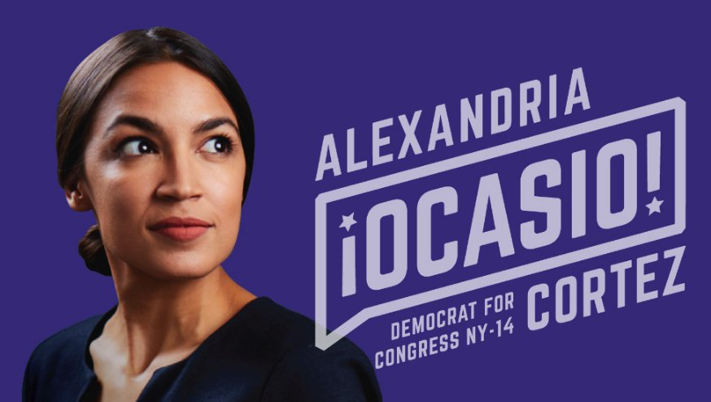
Alexandria Ocasio-Cortez, according to who you ask, is either the new face of the Democratic Party, or a political dilettante who has never held political office. She is either hailed as revolutionary light in darkness, or reviled as a representative of a massive threat to the American dream. In short, she is a polarizing and fascinating figure, and one who deserves at least a bit of applause for her win over long-time New York incumbent Joe Crowley.
Ocasio-Cortez is unapologetic about her progressive leanings and a member of the Democratic Socialists of America. She has defended her “Medicare for All” healthcare plan despite its estimated $40 trillion cost, referred to the Israeli “occupation” of Palestine, and barred the press from two town hall meetings to provide a “safe space” for attendees. Her platform includes the elimination of Immigration and Customs Enforcement and a federal jobs guarantee. To her credit, Ocasio-Cortez has managed to invigorate a seemingly stagnant Democratic Party by appealing to younger voters, and has been labeled the future of the party by the DNC chairman Tom Perez.
This week’s final round gives you a deep dive into one of America’s most ascendant and polarizing political figures, Alexandria Ocasio-Cortez. Other topics include international terrorism, the intersection of politics and economics, Myanmar’s continuing difficulties with reform, China’s Uighur minority, Mexico’s wildly popular new president, and more!
Extemp Prep
September 17, 2018
Directions: The following is a tournament worth of extemp questions. Take time to practice each, a simulation of current events at the time of this release, to keep you geared up for competition. Use the hyperlinks to read up on the latest for each topic.

Round 1 (Terrorism)
- Will ISIS compensate for its loss of territory with an increase in low-tech terrorism?
- Is Boko Haram more threatened by division than by counter-terrorism?
- Does Al-Qaeda’s current strength mean America should rethink its counter-terrorism strategy?

Round 2 (Africa)
- Will the South Sudanese peace deal last?
- Does the release of Victoire Ingabire represent a shift towards democracy in Rwanda?
- Will China seize Zambian national assets?

Round 3 (Politicized Business)
- Are there legitimate anti-trust concerns about T-Mobile’s proposed acquisition of Sprint?
- Has the Boring Company bitten off more than it can chew?
- Do recent boycotts mean that Israel is losing the PR battle to Palestine?

Semi-Finals (Diverse Selection)
- Will China’s treatment of the Uighur minority continue to worsen?
- Will Myanmar liberalize after international scrutiny of the abuse towards the Rohingya?
- Is Obrador a new kind of Mexican president?

Finals (Alexandria Ocasio-Cortez)
- Does Alexandria Ocasio-Cortez represent the future of the Democratic Party?
- Is Alexandria Ocasio-Cortez right about America’s treatment of Puerto Rico?
- Is Alexandria Ocasio-Cortez’s “Medicare for all” plan economically feasible?

