Fairtrade Does Good
Affirmative Brief by Nathaniel Arroyave
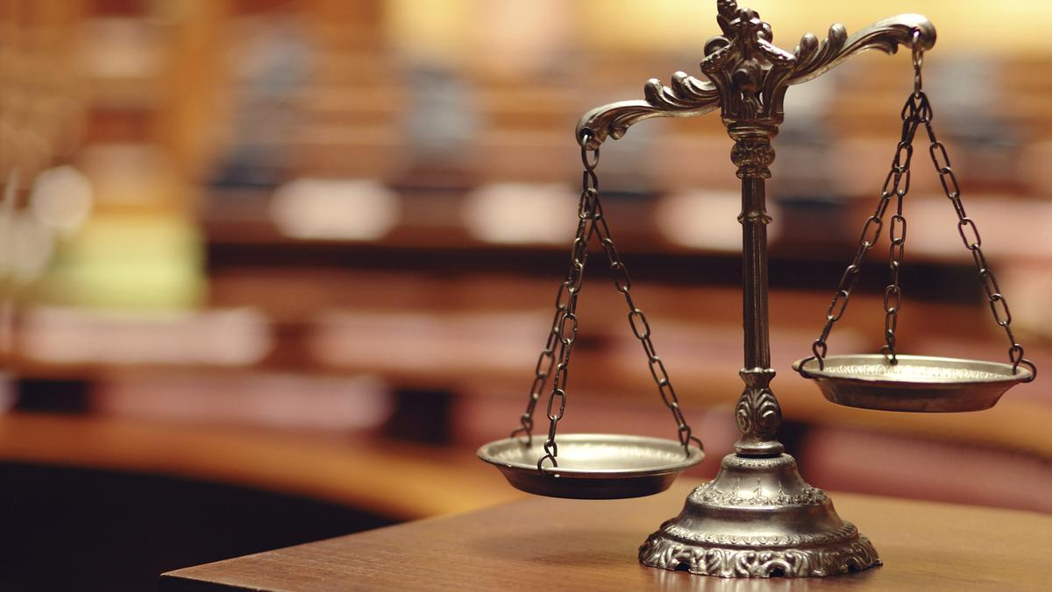
Fair Trade is based on the idea that farmers should be paid a wage proportional to the work and product they produce. One major sponsor of this on an international scale is the Fairtrade Foundation. In this brief, we’ll be discussing the benefits that Fairtrade incurs to the world at large as well as the farmers involved.

The tags used in this brief include:
- Fairtrade promotes gender equality
- Fairtrade protects workers’ rights
- Without Fairtrade, poorer countries become economically disadvantaged
- Fairtrade enables small-scale producers
- Fairtrade encourages social development
- Fairtrade certification promotes transparency
- Fairtrade process improves quality of life
- Fairtrade increases access to the open market
- Fairtrade’s system is thorough
- Fairtrade reduces damage to the environment
- Fairtrade enables a better future for impoverished children
- Fairtrade provides important economic benefits to farmers

Fairtrade promotes gender equality

“Why Choose Fairtrade.” Fairtrade Australia New Zealand, 2016, www.fairtrade.com.au/get%20involved/Our-Campaigns/Fairtrade-Fortnight/Why-Choose-Fairtrade.

Fairtrade believes the role of women in agriculture needs more visibility, recognition and value, and that gender equity is important to social sustainability. Currently, 350,000 women farmers and workers are part of Fairtrade, a quarter of the total.

Fairtrade protects workers’ rights

“Why Choose Fairtrade.” Fairtrade Australia New Zealand, 2016, www.fairtrade.com.au/get%20involved/Our-Campaigns/Fairtrade-Fortnight/Why-Choose-Fairtrade.

Fairtrade Standards social, economic and environmental standards that are set for both companies and the farmers and workers who grow the food we love. For farmers and workers the standards include protection of workers’ rights and the environment, for companies they include the payment of the Fairtrade Minimum Price and an additional Fairtrade Premium to invest in business or community projects of the community’s choice.

Without Fairtrade, poorer countries become economically disadvantaged

Woodford, Chris. “What Is 'Fair Trade' and Just How Fair Is It?” Explain That Stuff, 23 Nov. 2018, www.explainthatstuff.com/fairtrade.html.

Free trade is a part of globalization and it sounds great in theory: if we removed all barriers to trade, such as import tariffs (the taxes companies have to pay to get their goods into another country and sell them there), all countries could compete on a level playing field—and what could be fairer than that? In practice, it doesn't work out quite like that. Some countries are inevitably far more powerful than others and they want things to stay that way. Even while promoting "free trade", they use all kinds of tactics to ensure they can trade more freely than other people. You might have heard of a practice called dumping? That's where an industrialized country subsidizes production of finished goods, which it then exports to a developing country at a price that's lower than the goods the developing country can produce at home. The developing country has to cut the prices of its own goods to a level that makes it impossible for poorer people to support themselves. Another tactic is for rich countries to impose high tariffs on finished goods but low tariffs on basic, raw materials. That gives poorer countries no option but to export raw materials: they can't turn those materials into high-value finished goods themselves because they won't be able to export them. The rich countries import the low-value, raw materials, make them into high-value finished goods wherever it suits them, then export the finished goods back to the poor countries. Practices like this mean "free trade" is all too often a synonym for "unfair trade".

Fairtrade enables small-scale producers

Spector, Kaye. “5 Reasons You Should Buy Fair Trade.” EcoWatch, EcoWatch, 27 June 2016, www.ecowatch.com/5-reasons-you-should-buy-fair-trade-1881803195.html.

"Fair trade makes free trade work for the world’s poor," said Paul Rice, Fair Trade USA’s founder, president and CEO. Free trade leaves small-scale producers behind when large subsidized companies start to take over their industries. Large contracted farms can afford to sell commodities at lower prices but local farmers, who have traditionally supplied these products, are driven into debt. The only way these farmers can compete with subsidized farms is to lower their product prices to the point where labor is free and quality of life is unsustainable.

Fairtrade encourages social development

Spector, Kaye. “5 Reasons You Should Buy Fair Trade.” EcoWatch, EcoWatch, 27 June 2016, www.ecowatch.com/5-reasons-you-should-buy-fair-trade-1881803195.html.

The fair trade license fees generate funds, which are given to the fair trade communities. This money is specifically designated for social, economic and environmental development projects such as scholarships, schools, quality improvement and leadership training and organic certification. Each community determines how their funds will be used through democratic systems.

Fairtrade certification promotes transparency

“Why Go Fairtrade?” What Fairtrade Does - Fairtrade Mission | Fairtrade America, 2018, www.fairtradeamerica.org/for%20business/Why-Fairtrade.

Fairtrade is one of the only ethical certifications that looks at the entire supply chain from the producer all the way through to the finished product. Supply chains are regularly audited to make sure the standards are being met. If you work with Fairtrade, you will be informed of issues, gaining greater supply chain visibility. Fairtrade helps you mitigate risk in your sourcing by complying with International Labour Organization conventions, encouraging environmental stewardship, prohibiting child and forced labor, supporting workers’ rights, and trading on fairer terms.

Fairtrade process improves quality of life

“Why Go Fairtrade?” What Fairtrade Does - Fairtrade Mission | Fairtrade America, 2018, www.fairtradeamerica.org/for%20business/Why-Fairtrade.

When you buy and sell on Fairtrade terms, producers receive tangible economic, environmental and social benefits. Economic: Two pricing mechanisms work together to make sure producers are fairly paid for their work. The Fairtrade Minimum Price serves as a safety net when market prices fall to an unsustainable level. The Fairtrade Premium, paid on top of the final price, gives farmers and workers a way to invest in their community, their business or their environment. Environmental: Fairtrade has clear standards that include criteria such as banning certain harmful chemicals and pesticides, prohibiting GMO seeds, and suggesting ways to minimize water use. These standards encourage best practices to support healthy communities. Social: The Fairtrade Premium promotes the democratic process, giving everyone a vote. This is a big boost for female farmers and workers, who have often been marginalized. Additionally, Fairtrade standards ban the worst forms of child and forced labor, protecting the most vulnerable.

Fairtrade increases access to the open market

“What Is Fair Trade?” Benefits of Fair Trade, 2013, www.vartotojai.lt/en/fairtrade/what-is-fairtrade/benefits.

For producers Fairtrade is unique in offering four important benefits: (1) stable prices that cover the costs of sustainable production; (2) market access that enables buyers to trade with producers who would otherwise be excluded from market; (3) partnership (producers are involved in decisions that affect their future) and (4) empowerment of farmers and workers (assistance for producer organisations to understand more about market conditions and trends and to develop knowledge, skills and resources to exert more control and influence over their lives).

Fairtrade’s system is thorough

“Agricultural Production Standard (APS) At a Glance.” Fairtrade, USA, 2 June 2017. https://www.fairtradecertified.org/sites/default/files/filemanager/documents/APS/FTUSA_GUI_APSOverviewWebLong_EN_1.0.0.pdf

EMPOWERMENT Guides the identification of the Premium Participants, democratic election of the Fair-Trade Committee, and management and spending of Premium funds on needs-based projects. FUNDAMENTAL RIGHTS AT WORK Outlines rights for individual and collective well-being and autonomy, including freedom from forced or child labor and discrimination, protections for young workers, and freedom of association. WAGES, WORKING CONDITIONS, & ACCESS TO SERVICES Sets requirements to improve farmer and worker health and safety, working hours, fair wages, and benefits, and to promote supportive work environments and open communication. BIODIVERSITY, ECOSYSTEM FUNCTION, & SUSTAINABLE PRODUCTION Helps protect biodiversity, soil productivity, and water; control risks from pesticides and waste; enhance resilience to climate change; and improve the environment, health and quality of life of farmers, workers, and their communities. TRACEABILITY& TRANSPARENCY Provides a framework for the traceability of Fair-Trade Certified goods, and ensures that Fair Trade agreements between the Certificate Holder, suppliers, and market partners are bound by fair and transparent contracts. INTERNAL MANAGEMENT SYSTEM Outlines requirements for the Certificate Holder and others under the Certificate to ensure compliance with Fair Trade USA’s Agricultural Production Standard requirements.

Fairtrade reduces damage to the environment

“How Fair Trade Benefits A Community.” Oliberte, 2019, www.oliberte.com/pages/how-fair-trade-benefits-a-community/.

Along with economic benefits, Fair Trade organizations around the world are tackling environmental issues that are inextricably linked with poverty and sustainable futures. To get Fair Trade certified, a company must also meet rigorous standards designed to ensure that a healthy environment is maintained, both for the longevity of sustainable farming and for the economic future of the next generation. Oliberté sources our leather from the best possible sources in Ethiopia to minimize discarded material, along with proudly operating a zero waste facility. In a more general sense, Fair Trade principles lead to natural forms of pesticide use for farming, which greatly improves the health of farmers and their communities, along with the quality of their products. Ultimately, Fair Trade farming practices will help reduce greenhouse emissions, which benefit everyone on Earth and ensure a sustainable future.

Fairtrade enables a better future for impoverished children

“How Fair Trade Benefits A Community.” Oliberte, 2019, www.oliberte.com/pages/how-fair-trade-benefits-a-community/.

Fair Trade operations can also make huge strides in gender-equality, as many of the world’s most vulnerable workers are women. Fair Trade employment offers the opportunity for many mothers to put their children in provided daycare programs, allowing them to work and support themselves and their families comfortably. Children are then able to attend better schools for longer, which is the single biggest factor in their future opportunities and success. Taken individually, these factors are a huge step in the right direction. Once combined, they represent the most direct and effective methods for empowering a community to reach its true potential. As consumers, we are ultimately the ones capable of effecting this change, as we hold tremendous sway over where our products come from, and how they are produced. Every day there are more Fair-Trade options for our purchase, and more success stories as a direct result. Together, we can make the conditions of proper Fair-Trade certification the new standard, and a brighter future for all.

Fairtrade provides important economic benefits to farmers

Dragusanu, Raluca E.; Giovannucci, Daniele; Nunn, Nathan. “The Economics of Fair Trade.” National Bureau of Economic Research, July 2014. https://www.nber.org/papers/w20357.pdf

Bacon (2005) examines the sales price of coffee during the coffee price crisis of 2000/2001 for a sample of 228 coffee farmers from Nicaragua and finds that Fair Trade certified farmers obtained significantly higher prices for their coffee. Farmers selling coffee as Fair Trade received an average price of $0.84 per pound (net of costs paid to the cooperative for transport, processing, certification, debt service, and export), farmers selling coffee as Organic received $0.63 per pound, while farmers selling conventional coffee to a cooperative received $0.41 per pound. (Since Fair Trade (and/or Organic) farmers are not able to sell all of their coffee as certified, the average price received by certified and conventional farmers for their full harvest is lower than the figures above. Fair Trade and/or Organic farmers received an average price of $0.56 per pound, while conventional farmers received an average price of $0.40 per pound.) In a follow-up study, Bacon, Mendez, Gomez, Stuart and Flores (2008) attempt to get a better sense of the causal mechanisms behind these differences. Examining the same set of Fair Trade certified farmers as in Bacon (2005), they find that 100 percent of these farmers felt that the cooperative they certified with helped them obtain higher prices. This figure can be contrasted to the response of farmers in conventional cooperatives. Among this comparison group only 50 percent for farmers felt that the cooperative helped them obtain higher prices. Given the price premium and price floor associated with Fair Trade, it is unsurprising that Fair Trade certified farmers receive higher prices. However, what is less obvious ex ante is whether production volumes and, as a consequence, total incomes would be affected by certification. Overall, the evidence does suggest that Fair Trade is often also associated with higher output and higher incomes. Arnould, Plastina, and Ball (2009) examine 1,269 farmers from Nicaragua, Peru, and Guatemala in 2004/2005 and find that in addition to higher prices, Fair Trade certified farmers also have greater sales and higher incomes. Jaffee (2009) also finds the same pattern for 51 coffee producers (26 Fair Trade certified and 25 conventional) from Oaxaca, Mexico, surveyed between 2001 and 2005. He also finds that Fair Trade certified producers were less likely to experience food shortages and had diets that contained more meat, milk, and cheese.

