Battle for Kashmir
by Zachary Beddingfield
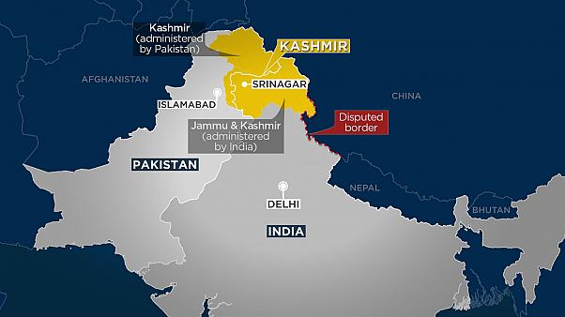
Tensions have escalated between the nations of India and Pakistan over terrorist attacks, which reignited a long-burning conflict between the two sides. The fight between India and Pakistan rests in a region known as Kashmir, which both sides claim the rights to. This dispute has already led to two wars and countless skirmishes between the two nations.
On February 14, a suicide attack, which the terrorist group Jaish-e-Mohammad (JeM) has since taken responsibility for, killed more than forty Indian soldiers and injuring at least seventy more. Twelve days later, on February 26, India sent 12 Mirage fighter jets to bomb suspected JeM terrorist camps; the bombing reportedly killed up to 350 people, and India later said the attack was a “preemptive strike.” These attacks violated a no-fly agreement known as the Line of Control and were labeled an act of aggression by the Pakistani government.
The next day, the Pakistani government shot down two Indian fighter jets which it claims had crossed the Line of Control. One plane fell on India’s side of the Line, while the other fell into Pakistan’s region where its pilot was captured. Two days later, on Friday, Pakistan’s Prime Minister, Imran khan, released the pilot with a call for peace.
Peace didn’t last long, however. The Guardian reported that overnight on Friday, fights broke out between India and Pakistan military across the Line of Control, which resulted in two Pakistani troops and at least six civilians killed.
The greatest fear surrounding this conflict, as many have pointed out, is that Pakistan and India are both rising nuclear powers. With tensions high and both sides claiming the land of Kashmir in its entirety, de-escalation is of utmost importance.
For further reading on this topic, look through this concise timeline: https://www.cnbc.com/2019/03/01/india-pakistan-conflict-timeline.html
This week’s final round goes deep into MAIN TOPIC. Other topics include LIST BEST TOPICS, and much more!
Parli Prep
March 4, 2019
Directions: The following is a “round robin” tournament with one out round. The first resolution reflects the spotlight topic on the title page. Use these resolutions to practice parliamentary debate. Use the hyperlinks to read up on concepts or topics unfamiliar to you.

Round 1
Resolved: India and Pakistan should be more concerned with de-escalation than coming out on top.

Round 2
Separation of Church and State has been taken too far.

Round 3
Great Britain should hold a Second Referendum.

Round 4
Resolved: Human Rights should always trump Religious Rights.

Round 5
Resolved: The United States’ current plan for the withdrawal of troops from Syria is the right course of action.

Round 6
Parents should not have the legal right to withhold vaccinations for children.

Final Round (Strike)
Voters should value a politician’s experience over their political affiliation.
Voters should place more weight on morals than policies.
Voters sometimes have an obligation not to vote.
Parli Prep
December 11, 2017
Directions: The following is a “round robin” tournament with one out round. The first resolution reflects the spotlight topic on the title page. Use these resolutions to practice parliamentary debate. Use the hyperlinks to read up on concepts or topics unfamiliar to you.

Round 1
This House sides with Masterpiece Cakeshop versus Colorado Civil Rights Commission.

Round 2
The people of Utah know best how to care for their land.

Round 3
This House should change its policy toward Syria.

Round 4
This House will drive the stake through the heart of the vampire.

Round 5
This House passes the first ban rather than the last ban.

Round 6
The USFG should substantially increase funding to the Temporary Assistance to Needy Families program.

Final Round (Strike)
This House will remove the child tax credit.
This House will remove the Alternative Minimum Tax.
This House will remove the state and local income tax deduction.

