The Hiding Place
Source Material of a Champion Duo Interpretation
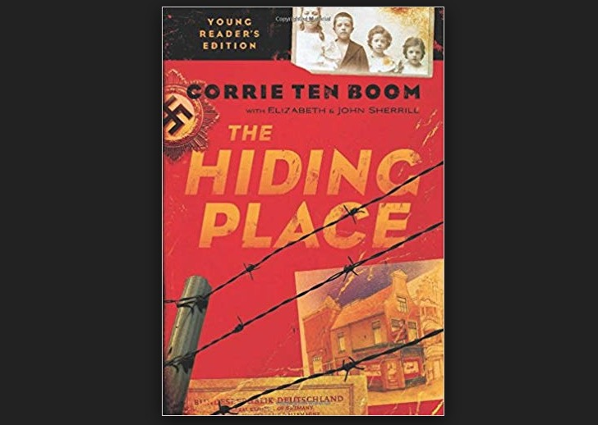

This unforgettable speech was performed by Andrea and Savannah Johnson in the years 2011-2012. Together they were finalists at every tournament they competed at. At the National Invitation Tournament of Champions, they received 10th place and they ended the season by being number 1 in their state.
Stoa explains Duo Interpretation in this way on their website (http://stoausa.org/wp-content/uploads/2017/07/Duo-Interpretation-Rules-2017-2018.pdf)
Description: In Duo Interpretation, two competitors create an original rendition of a story from one or more selection(s) of literature which captivates and moves the audience.

Goal: To select and analyze literature, bringing it to life through creative use of voice, facial expression, and movement without interacting face-to-face.

Directions: Use this source material to enhance your understanding of Duo. This speech is an excellent example of champion speaking. You may want to consider doing this event in Season 19.
The Hiding Place
by Andrea and Savannah Johnson
Into the Piece
Choosing a book to perform is one of the most challenging aspects of accomplishing an interpretive speech. Savannah and I went back and forth between different books, funny and serious, silly or in-depth. We ﬁnally decided on the book “The Hiding Place”, by Corrie Ten Boom. We ﬁrst read this book as a family last summer, and were thoroughly intrigued by the captivating story, as well as the excellent writing. Set in Holland in the 1940’s, Corrie tells of her and her sister Betsie’s struggles as they hide Jews in their home from the Nazis, eventually getting caught and taken prisoner. They suffer many cruelties, as well as tests of faith at the notorious Ravensbruck Concentration Camp. This piece ended up being the perfect piece for several reasons:
We could connect with the story. It’s about two sisters, which ﬁts us for obvious reasons! But you might be thinking, “Any two girls could really play the parts.” And although that may be true, I don’t believe we really would have had the emotion and depth that we had unless we were truly sisters. There are several intense sister-scenes in this duo, some of which have to do with Betsie being ill. I truly believe that we could not have had that intensity if we were not really sisters, because, although we have not been in any fatal situations together, we know what it’s like to be scared and concerned for one another. We were able to act those scenes out, without having to really act, and together we were able to learn so much from the Ten Boom sisters.
The audience could connect with the story. Although many duos are fun to watch and give lots of laughs, we felt lead to share a deeper message - one that people would remember long after they’ve forgotten the actors. We wanted to stand out from other duos somehow, so we decided to go with a duo that would make people cry, or at least tear up, and really seem to feel the emotions that Corrie felt. We also wanted people to accept the message we were trying to convey. I remember one of my friends saying that she’s watched our duo many times, and she still cries every time. There are still some lines from our piece that I have to remind myself of when I’m griping about something. One in particular is the scene in when Betsie and Corrie ﬁrst arrive at the concentration camp and realize that the barracks where they are staying are polluted with ﬂeas. Corrie is complaining, but then Betsie reminds her that the Bible says in First Thessalonians to give thanks in all circumstances, not just pleasant ones. That, and several other lines were what we wanted to make known to people. Everyone from all age groups is able to connect with this story, and at the end of the day, everyone is able to take something away from it.
The judges could connect with the story. Whether young or old, male or female, community or alumni, we usually had all of the judges teared-up by the end. But, as I mentioned earlier, our goal wasn’t just to make people puffy-eyed. We really wanted them to feel the emotion and depth that was poured into our duo. One judge wrote on a ballot: “This really is a great story! I love to see how God protected His children in history! You two should really perform this in other settings to bless other people with this amazing story! People should be told about the blessings that God does!”
After choosing a book, the next step is cutting the book. Unless it is a very short book, you are not going to be able to do the whole thing, so it is necessary to drop parts of the book, as long as you keep the main focus intact. You also may ﬁnd it necessary to cut certain characters, and that’s okay.
Savannah and I were a little wary about cutting characters and scenes, but as we went along, we realized that those things are what made it our story. We did not cheat the story line at all, but we molded the piece to make it our own, not just two girls reading the book.
During the process of cutting, we realized that the part of the book that we wanted to be our ending didn’t have any dialogue. You may come across this problem in your piece, and it’s challenging to ﬁnd a solution. After toying with different options, we decided to add a scene where different characters are conversing on a train, and we handed out different lines to the different characters. We stayed true to the thoughts that the book conveyed, but it was a neat twist to help make it our own.
We also realized that there were way to many characters in this book for each of us to act out. So we went through the parts of the book that we cut and chose just the characters that we would need to act out the story. Since Corrie was the main character and had many more lines and scenes than anyone else in the book, we decided that Savannah would be Corrie (since she’s the younger of us anyway), and I would be Betsie and any other additional characters along the way like Nazis, builders, and guards. Since this is already a very complex story, we liked how this helped to not confuse the audience, and also give a balanced performance between us.
So don’t be afraid to cut certain characters and scenes, just be sure to stay true to the content. It will help make the piece personal, and you’ll ﬁnd yourself really thinking of the story as yours instead of someone else's.
Blocking
In addition to good script-cutting, something that is really going to get the judge’s/ audience’s attention is good blocking. When synchronization, space management, and movements are well done, it’s very impressive and eye-catching for a higher rank.
Since our duo involved real life and in-depth characters instead of cartoon, in-your- face ones, we soon realized that we were not going to be able to do any giant synchronized movements like battles or dances. We were a little worried, because the thing that makes duo unique to any other form of acting is how the actors move together without looking or touching each other. But we realized that different duos require
Andrea and Savannah Johnson Duo Interpretation - The Hiding Place different means of acting out something, so we thought about what our characters were like. I’ll be covering this more in depth in a few minutes, but in our duo we really developed our characters, so much so that you felt like you really knew Corrie and Betsie. They were real-life, not two-dimensional. We didn’t need ginormous actions - we needed subtle ones. That was what made our duo do intense was the subtlety of it all. We had a couple of actions that we did together like a guard slapping Corrie, and bouncing up and down on a train, but we mainly had subtle, real-life actions.
Now, just because we didn’t have a large amount of synchronization, doesn’t mean we stood in one spot the whole time. We did quite the opposite. We used almost every corner of the stage, front back, side to side, and each diagonal. That way it didn’t get boring and monotonous to watch. In an intense duo like ours, we didn’t want to overwhelm the audience, so there were several calm scenes where we stayed stationary, but we used our space well, and that’s important if you don’t have a lot of synchronization.
You also have to decide what kind of movements you want according to your piece.
As I touched on earlier, we had a very intense and subtle duo, so we had real-life actions. Imagine this: you’re watching a cartoon movie like Tom and Jerry and the two animals are just lumbering around, no huge facial expressions, no giant waving of arms, no sliding over icy ﬂoors or getting hit on the head with pots and pans. Just slowly following each other around. Now imagine a movie with real-life characters and imagine them making such huge expressions that their eyebrows are above their heads and their eyes are about ready to pop out of their sockets, and their actions are so big that they go off the screen. Can you see how ridiculous this picture is? The actions clearly do not ﬁt the characters. That’s exactly the same with duo - you have to know what kind of duo yours is and go with the style of acting that ﬁts with your piece. Since our duo was real-life, we had minimal synchronization and small actions, along with subtle facial expressions.
Characters
The last thing that is really going to make your duo soar is the characters. It’s important to distinguish your characters from one another, and, if you have a dramatic duo, it’s also important to develop them throughout the piece so that the audience can really feel the emotions in each of them.
At our ﬁrst tournament we struggled a little with acting out real-life characters.
Several judges told us that they looked stereo-typical and two dimensional. There were several things that we did to help with this: accents, vocal pitch, facial expressions, and thoughts - that’s right, thoughts.
We started by giving each character their own accent; Corrie and Betsie had Dutch accents because they were from Holland (and any other characters that were from that area), the Jews had Jewish accents, and the Nazis had German accents. Now, this required a bit of learning on our part, but it ended up being a lot of fun to learn accents together, and we also have that knowledge if we were to ever need it in any other future pieces.
Since there were several Nazis, and two of us from Holland, we had to also distinguish the different people, not just the different races. So we gave each person a different tone of voice, i.e. guard number one who was a male had a low, husky voice, guard number two was a female who had a shrill, demanding voice, etc. Even though this may seem triﬂe at ﬁrst, it’s an important detail that may unconsciously be a large detail in the believability of your piece. We also used facial expressions to distinguish the characters. Betsie had a kind, concerning face, while Corrie had a bit more of an unhappy expression. The different guards also had different expressions of snobbery, cruelty, and anger. This was a lot of fun to play with, and another example of what I was mentioning earlier with making the piece your own.
The ﬁnal thing that really brought our characters to life was thoughts. This may sound very silly to you at ﬁrst, but let me explain. In order to act your character, you really have to be the character for that time. And in order to do that, along with the above mentioned things, you have to think like that person. What Savannah and I did to accomplish this was pull up our script on the computer and make sub-lines in italics under the real lines of things that this person might be thinking while saying the line. It may even be something completely opposite to what that person is saying. Here’s an example from the very beginning of our piece when Corrie is helping an elderly Jewish woman into her house:
Corrie: Please come in! I’m glad you made it safely. Please feel welcome. - But another jew? Where am I going to keep her, and how am I going to feed her? - I hope there were no Nazis following you.
Mary: Th-thank you. I’m very grateful for a place to hide. - But I probably won’t be allowed to stay here anyway. Corrie: Here - have a seat. You’re wheezing terribly. I want you to know that I care about you, and you’re not a big inconvenience. - But no one told me you wheezed; no wonder they kicked you out.
So although it might seem a little weird to you to have thoughts for your characters, believe me - it really helps you to bring the piece to life for yourself, which in turn helps you bring the piece to life for the audience.
After you’ve performed your duo at your ﬁrst tournament(s), you may ﬁnd that you want to tweak your duo in some way, whether it be an accent, character, or even a
Andrea and Savannah Johnson Duo Interpretation - The Hiding Place scene change. Read what the judges have to say on the ballots and change accordingly. Savannah and I made changes after every single tournament. We cut scenes, added scenes in, made script changes, and even completely re-characterized one of our characters. And it was just before NITOC that we added in all of the accents.
So don’t be afraid to spice your piece up a bit, or try new things out. You never know how it may beneﬁt the piece in the end.
From choosing the book, to cutting the script, to creating unique blocking and characters, duo is a wonderful experience and so much fun to perform. Whether you get 1st place or 101st place, at the end of the year you will look back and see that you learned so much. It is so rewarding to see that you shared an important message with so many people, and to see that you were able to further God’s kingdom! Many blessings as you endeavor to accomplish your own duo interpretation!

