Season 20
—
Debating the 2019-2020 NSDA Policy Resolution

Policy debaters always benefit by understanding current issues surrounding the year’s topic of study. The purpose of this article is to give competitors information about the Status Quo and its policies on the resolution:
Resolved: The United States federal government should substantially reduce Direct Commercial Sales and/or Foreign Military Sales of arms from the United States.
Table of Contents
Status Quo of U.S. Arms Exports 2
Quantity and Scope of US Arms Exports 3
Combatting Terrorism & Insurgency 3
Security & Loyalty of Allies 4
Weapons Leakage 5
Technology Leakage 6
Poverty & Economic Development 6
Human Rights & Democracy 7
Fueling Conflict 8
The Military-Industrial Complex 9
Substitution & Competition Among Suppliers 10
Worksheet: Status Quo of Arms Exports 11
Answers 13

Content collected and written by Vance Trefethen. Chris Jeub wrote the worksheets at the end of the essay.

Status Quo of U.S. Arms Exports
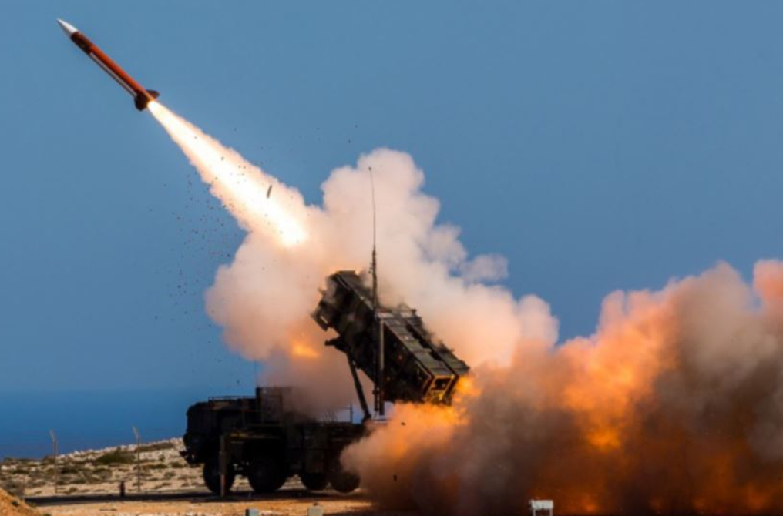

NSDA’s 2019-2020 Policy Resolution:
“The United States federal government should substantially reduce Direct Commercial Sales and/or Foreign Military Sales of arms from the United States.”
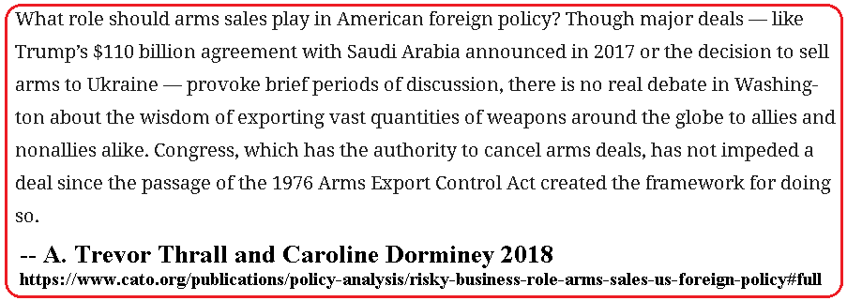
In this chapter we discuss each of the major areas of concern that could be a potential risk or a potential benefit to arms exports and outline areas of debate that may occur. These issues are sure to be repeated in various combinations in almost every debate round this year on the topic of arms exports.

Quantity and Scope of US Arms Exports
The United States is the largest exporter of armaments in the world today, selling about 30% of all such weapons globally. Russia is second with around 25%, followed by France, Germany, China and Britain, all under 10% each.
“The United States supplies arms to at least 98 nations, and it is the largest supplier to 20 of the 40 largest arms importers in the world. These arms include ammunition such as missiles, various aircraft, submarines, surface ships, anti-submarine weaponry, tanks, armoured vehicles, as well as electronics such as radar, sonar, and guiding systems.”
The top 10 customers of US weaponry and their recent quantities of arms exports are shown below:
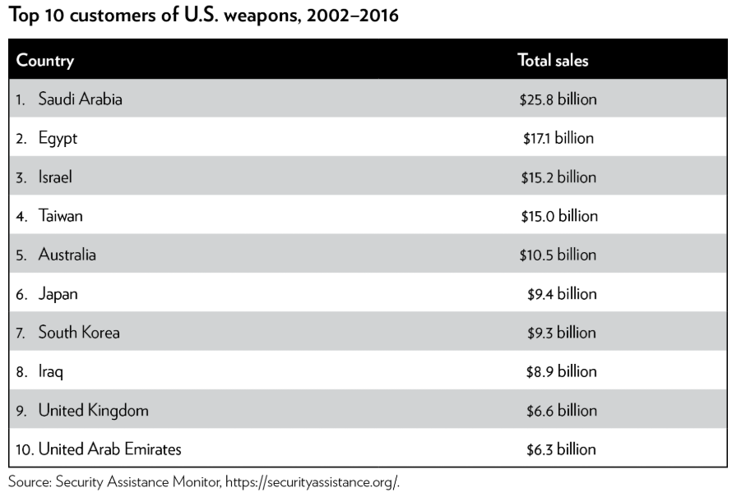

Combatting Terrorism & Insurgency
Numerous countries considered friendly to the United States face threats from terrorism and insurgency. Iraq has faced an existential threat in recent years from the radical Islamic State (ISIS) insurgent/terrorist movement, requiring large amounts of US military assistance to suppress. Egypt has faced threats recently from ISIS and al-Qaeda and has used US weapons to mitigate these threats. Afghanistan is also in an ongoing battle against the Taliban insurgency and receives massive amounts of US equipment in that effort.
As noted in the previous chapter, the events of 9/11 opened many previously closed doors of US arms exports to recipient countries that had been restricted for various reasons before that date. And lots of US equipment quickly flowed through those doors in the years that followed.
“On the six-month anniversary of the September 11 attacks, President George W. Bush declared that the United States was willing to provide training and assistance to any government facing a terrorist threat … 18 of the 25 countries in this series received more military assistance and 16 concluded more arms sales with the United States during the five years after the September 11 attacks than they had during the period following the end of the Cold War (fiscal years 1990-2001). In the first five years following September 11, 2001, the United States sold nearly five times more weapons through Foreign Military Sales (FMS) and Direct Commercial Sales (DCS) to these 25 countries than during the five years prior to that date.”
There are several issues to be debated and resolved with regard to the link between terrorism and increased arms exports. First, the question of whether the threat of terrorism is significant enough to justify any substantial policy, let alone large exports of military equipment. Second, whether the weapons we are sending are effective against terrorism in remote places or would have any effect on reducing terrorism in the U.S., assuming the countries we export to would actually use them to combat terrorists. Third, whether countries sign on to the “war on terror” simply as an excuse to get off of a restricted list and get arms exports, with no intention or capability of adding any value to anyone’s efforts against terrorism.

Security & Loyalty of Allies
The U.S. exports arms to nations with which we have a long-standing formal or informal security relationship, where those countries have traditionally faced external threats from hostile powers. Israel, Taiwan and South Korea are good examples. These nations either have been invaded or face threats of attack, and it is perceived to be in U.S. foreign policy interests to prevent that from occurring.
Other nations, such as Saudi Arabia and Egypt, receive large amounts of US weaponry as part of ongoing efforts to maintain them as allies or clients. It is perceived to be in the best interests of the U.S. to have Saudi Arabia (with its oil supplies and influence on world oil market) in our camp and under our influence. Egypt, a key player in Middle East stability and owner of the Suez Canal, is likewise an important nation to have aligned with the United States.
When we reduce or suspend arms exports to US allies, there is a tangible fear that they will turn elsewhere, reducing US influence and hindering US foreign policy objectives.
A long-time arms client of the United States with no history of Russian imports, Indonesia announced a deal with Russia in 2003 to purchase Russian Su-27/30s. …this remarkable turnaround in arms sourcing diversification appears to be the result of a U.S. arms embargo implemented in 1999 in response to Indonesia’s apparent human rights violations carrying out heavy-handed military actions in East Timor. Furious at U.S. meddling in something the government considered a domestic issue, Indonesia looked instead to Russia with the specific intent to “overcome the effects of [U.S.] arms sales restrictions.”

Weapons Leakage
U.S. weapons sent into countries with high levels of corruption or on-going conflict situations have a way of leaking into the hands of folks we’d rather not be arming. The lengthy US involvement in Iraq and weapons given to US-supported Iraqi forces left a legacy of large amounts of weapons among various groups throughout the region. Just one battle in 2015 in Mosul, Iraq, left over $600 million in US-supplied military equipment in the hands of ISIS fighters. In total, over several years, the amount of US equipment lost by Iraqi forces to ISIS was substantial:
“Others offer varying guestimates of the extent of the losses of U.S.-made military equipment and weapons to ISIS. “If you say they have captured the equivalent of at least three to four [Iraqi Army] divisions’ worth of equipment, much of it American-supplied, you would be very safe,” said Anthony H. Cordesman, a military analyst with the Center for Strategic and International Studies.”
Similar concerns have arisen from leakage of US-supplied weapons given to the Saudis and the United Arab Emirates during the Yemen War, currently still on-going. Militias allied with the Saudi coalition get US weapons from coalition partners, but the militias are not accountable to anyone for how they use them. Even if we completely trusted the Saudi and UAE militaries, their allied militias on the ground in Yemen are known to have committed war crimes with weapons that ultimately came from the U.S.
Overall, the Saudis and Emiratis “have used the U.S.-manufactured weapons as a form of currency to buy the loyalties of militias or tribes, bolster chosen armed actors, and influence the complex political landscape.” This practice is bad for Yemenis, particularly civilians who are being killed. Argued Wilcken: “arms-supplying states need to reflect hard on how their arms transfers are continuing to directly and indirectly fuel war crimes and other serious violations. The proliferation of unaccountable, UAE-backed militias is worsening the humanitarian crisis and posing a growing threat to the civilian population.”
In some situations, US forces find themselves fighting against enemies armed with US weapons. In Afghanistan, for example:
“Weaponry provided to the Afghan military over the last 16 years has slowly trickled down to the Taliban through corruption and battlefield losses. Armored vehicles, night vision devices, M-4s, laser illuminators and scoped optics have all found the way into Taliban hands over the years. And at times the U.S. has been forced to combat its own armored vehicles and weapons. For instance, captured U.S. up-armored Humvees are being used as suicide vehicle borne improvised explosive devices, or SVBIEDs. This tactic has also been a favorite of ISIS fighters in Iraq and Mosul, causing coalition forces to supply anti-tank weaponry to defeat the heavily armored mobile bombs.”

Technology Leakage
US defense contractors develop some of the most advanced weapons technology in the world. Many other nations, friendly or otherwise, would benefit from obtaining such technology and copying it, and inadequate controls or excessive distribution of such technology could be harmful to America’s security or economic interests.
“South Korea, one of America’s strongest partners in East Asia, is aggressively targeting U.S. advanced technology for its own use in a variety of Korean weapons programs, Foreign Policy has learned. From anti-ship missiles, electronic warfare equipment, torpedoes, a multiple-launch rocket system, and even components on a Korean-made Aegis destroyer, the United States is concerned about the uncanny resemblance those systems bear to American weaponry. Even the tanks Hagel watched on the range that day may be partial knock-offs: The Korean models have fire control systems that appear to be all-but-identical to the American versions.”
Others argue that technology leakage from weapons sales isn’t really a big deal, since other countries can’t really develop an advanced weapons industry just by looking at models of equipment coming from the U.S.
“Despite decades of arms purchases, technology transfer, blatant reverse engineering attempts, and hundreds of billions of dollars, China still turns to Russia for help with the most advanced weaponry such as fighter jets, helicopters, surface-to-air missiles, radars, and jet engines. If China, the second largest economy in the world struggles so mightily, what threat do smaller, less capable states pose? “

Poverty & Economic Development
Weapons exports to poor countries could potentially divert large sums from the national budgets of those nations that could either be devoted to building up its productive infrastructure or else left in the economy to promote economic growth. The impoverished in these nations can ill afford the vast sums their leaders elect to spend on weapons to boost their own prestige or fight unnecessary wars.
“A national budgeting process involves the allocation of public funds to various categories of public spending, subject to the constraints of the size of the total budget and the size of the national economy. This often involves significant redistribution of resources between income groups and generations in order to attain government social policy goals. Two of the main areas competing for resources are the military and social sectors. The purpose of a country’s military spending is to provide military defence of its national security (both its state interest and territory) and ultimately, of the security of its citizens. The purpose of social expenditure is to provide social services to the citizens of a country, and to build human capital to promote development. A common concern is that excessive military expenditure may often come at the expense of these social expenditures that are so crucial for a country’s human and economic development – the so-called ‘guns vs butter’ trade-off.”

Human Rights & Democracy
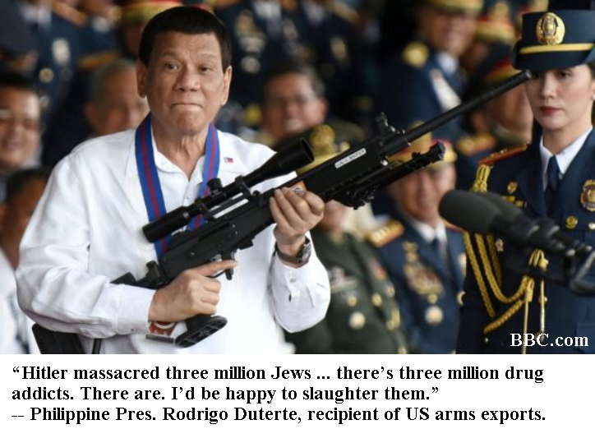
US weapons exports often go to countries that fail to uphold basic principles of human rights and democracy. This can be harmful in at least three ways. First, it encourages and rewards the recipient government, giving US approval to their dangerous behavior, possibly prolonging it, and signaling to its victims that the US favors their oppressors over themselves. Second, the weapons themselves are often used to commit abuses and atrocities against their own people or invasions of neighboring countries. Third, strengthening the military sector of some countries is dangerous because the military itself (as distinguished from its civilian leadership, if such exists) is a threat to the stability or integrity of the nation.
“Ethiopia, which is carrying out a brutal counterinsurgency campaign within its own borders, also launched an invasion of Somalia in December 2006 blamed for the deaths of scores of civilians and the displacement of at least 100,000 Somalis in indiscriminate violence in and around Mogadishu. Chad, which suffers from widespread turmoil and corruption, employs child soldiers in the ranks of its national army and is at a minimum tacitly involved in the ongoing regional conflicts in the Central African Republic and Sudan. By providing military assistance with a disregard for human rights conditions, the United States is not only giving up the opportunity to use military assistance as leverage to improve human rights conditions, but is also rewarding abusive governments for their unconscionable actions. Moreover, in some of these countries, the military has contributed to domestic political turmoil and instability. In 2006 and 2007, Chad, Nepal, Pakistan, and Thailand dealt with pervasive and significant upheaval. Nepalese security forces opened fire on peaceful strikes and anti-government demonstrations. Chad’s government barely survived a coup attempt. Thailand’s government was taken over in a “peaceful” military coup.”
Finally, arms sales can also have deleterious effects on recipient nations — promoting government oppression, instability, and military coups. As part of the war on drugs, America inadvertently enabled the practice of forced disappearances. In the cases of Colombia, the Philippines, and Mexico, American weapons feed a dangerous cycle of corruption and oppression involving the police, the military, and political leaders. Though the United States provides weapons to Mexico ostensibly for counternarcotics operations, the arms transferred to the country often end up being used by police to oppress citizens, reinforcing the “climate of generalized violence in the country [that] carries with it grave consequences for the rule of law.”
Others argue that a US arms export relationship actually improves human rights in the long run, by giving us leverage over the recipient country’s behavior. We can use the threat of an arms reduction or cut-off to motivate them to reform. For example, some have urged the US to use Saudi dependence on US arms exports as a tool to motivate reform or at least some measure of contrition over the murder of journalist Jamal Khashoggi in 2018.
“The Saudis have not concluded a single major arms deal with Washington on Trump’s watch. Nonetheless, the U.S. arms relationship with the kingdom is the most important leverage Washington has as it contemplates reacting to the alleged murder of Jamal Khashoggi.”
In March, 2019, Senators Ben Cardin (D-Md.) and Richard Durbin (D-Ill.) introduced the “Enhancing Human Rights Protections in Arms Sales Act,” which would require human rights criteria applied to US arms exports. This bill or other similar policy changes could be fertile grounds for Affirmative cases this year.

Fueling Conflict
It’s possible that exports of arms into volatile countries and situations may increase the likelihood or the intensity of armed conflicts. It’s also possible that conflicts fuel increases in demand for weapons. Which comes first, the chicken or the egg? And even if wars fuel the demand, would cutting the supply at least minimize the carnage?
“In a 1998 article, “Arms Transfer Dependence and Foreign Policy Conflict,” David Kinsella argues that states that enjoy a steady flow of arms – especially from multiple countries – tend to pursue more aggressive foreign policies. The increase in the recipient’s military capability makes victory in a potential conflict more likely, which in turn raises the likelihood that the state will start disputes, demand concessions from its neighbors in those disputes, and to escalate to conflict if negotiations fail to produce the desired outcome. Using case studies from Israel, Egypt, Syria, Iran, Iraq, India, Pakistan, Ethiopia, and Somalia Kinsella finds that, when a country has more than one weapons supplier, arms sales drastically increase the chances of conflict.”
In at least some cases, it’s possible that cutting off weapons would substantially reduce the conflict or even end the war. If one of the belligerents’ military depends on constant input of outside weapons, they may find it hard to continue prosecuting a war if the source of such weapons is cut off.
“Washington supports Saudi Arabia and its ally, the United Arab Emirates, through billions in arms sales. It also refuels their jets mid-air, provides training and shares intelligence. So if the U.S. wants to try to force the Saudis' hands, it has leverage. The best way to force the Saudis to change their ways is to stop sending weapons, according to Human Rights Watch’s Yemen researcher Kristine Beckerle.”
Of course, the benefit calculus of “ending a war” might depend on what happens when the war ends and who wins. If weapons are supporting a side that is more likely to uphold human rights (or less likely to violate them), then discontinuing assistance and letting them lose the war might be the wrong thing to do.

The Military-Industrial Complex
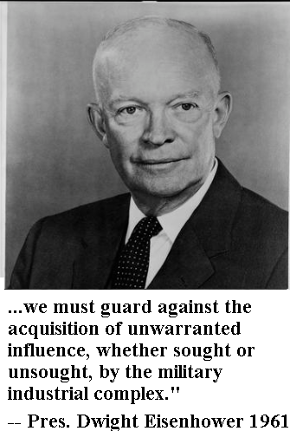
During his farewell address in 1961, out-going Pres. Dwight Eisenhower warned the nation about the growing influence of what he termed a “Military-Industrial Complex.” By that, he meant a segment of the economy consisting of corporations whose profitability depended on government military contracts. These corporations would have an incentive to lobby the federal government for more military spending, regardless of the actual national security need. Congressmen in districts having production facilities manufacturing weapons would be likely to support policies funding the purchase of such weapons, to maintain employment and ensure their own re-election.
All states and many congressional districts are home to the defense industry; in many districts the defense industry is the dominant corporate presence. A senator or representative who speaks out against arms sales thus risks losing the financial support of the defense industry as well as votes in their district. The defense industry lobby, moreover, is extremely active and well connected in Washington, D.C., spending more than $100 million a year on average over the past decade.
Arms exports obviously generate jobs in the U.S., and any Affirmative plan to reduce those exports would threaten those jobs. Much debate may occur about the number of jobs at risk from any specific Affirmative policy, and of course the larger debate will often be whether the human rights or lives at risk outweigh the jobs.

Substitution & Competition Among Suppliers
One of the most persistent Negative solvency arguments against the potential benefits of an Affirmative arms reduction will be the likelihood of replacement of the weapons by foreign suppliers. If Russia, France, China, Britain or other nations replace the U.S. weapons, it would appear that most or all of the benefits of a U.S. arms cutoff would evaporate, and only disadvantages would occur. The U.S. economy would lose the jobs in the export industry, and the U.S. government would lose its foreign policy benefits accruing from good relations with the recipient country, and whatever problems the arms were causing would continue to happen.
There are several issues to be debated that relate to this issue. First, in some cases, it is not easy for a nation that has built its military around compatibility with US equipment to immediately switch over to foreign equipment.
Second, Affirmatives will urge the Judge to vote on the issue of culpability – that is, the moral blame accruing to us by our perpetuation of the harms caused by the weapons we provide. In our interpersonal relationships, we certainly could not justify murdering someone by arguing that if we didn’t do it, someone else probably would have anyway.

Worksheet: Status Quo of Arms Exports
Name: ____________________________________ Date: ________________________
Answer the following in the spaces provided.
1. The?

2. What?

3. What did?

4. What Suprem?

5. As today?

6. What did it do?

7. Before?

8. Explain?

9. Has?

10. How many?

Answers
1.

BBC 2018 Tim Bowler https://www.bbc.com/news/business-43873518
Thomas C. Frohlich 2019 USA TODAY https://www.usatoday.com/story/money/2019/03/26/us-arms-sales-these-countries-buy-most-weapons-government/39208809/
A. Trevor Thrall & Caroline Dorminey 2018. https://www.cato.org/publications/policy-analysis/risky-business-role-arms-sales-us-foreign-policy#full
Rachel Stohl 2008. https://www.armscontrol.org/act/2008_01-02/stohl
Ray Rounds 2019. https://warontherocks.com/2019/04/the-case-against-arms-embargos-even-for-saudi-arabia/
Eric Pianin 2015. https://www.thefiscaltimes.com/2015/06/04/Fog-War-US-Has-Armed-ISIS
Eric Pianin 2015. https://www.thefiscaltimes.com/2015/06/04/Fog-War-US-Has-Armed-ISIS
Doug Bandow 2019 “Arms Sales to U.S. Allies in Yemen Are Endangering American Lives” https://www.cato.org/publications/commentary/arms-sales-us-allies-yemen-are-endangering-american-lives
Shawn Snow 2017. https://www.militarytimes.com/flashpoints/2017/07/25/us-weapons-complicate-afghan-war/
Gordon Lubold 2013. https://foreignpolicy.com/2013/10/28/is-south-korea-stealing-u-s-military-secrets/
Ray Rounds 2019. https://warontherocks.com/2019/04/the-case-against-arms-embargos-even-for-saudi-arabia/
Sam Perlo-Freeman and Catalina Perdomo 2008. https://www.sipri.org/sites/default/files/The_developmental_impact_of_military_budgeting_and_procurement_2008.pdf
Rachel Stohl 2008. https://www.armscontrol.org/act/2008_01-02/stohl
A. Trevor Thrall & Caroline Dorminey 2018. https://www.cato.org/publications/policy-analysis/risky-business-role-arms-sales-us-foreign-policy#full
Bruce Reidel 2018. https://www.brookings.edu/blog/order-from-chaos/2018/10/10/after-khashoggi-us-arms-sales-to-the-saudis-are-essential-leverage/
A. Trevor Thrall 2018 https://www.cato.org/blog/arms-sales-pouring-gas-fires-conflict
NBC News 2018. F. Brinley Bruton “The U.S. wants the Yemen war to end. Will it stop selling arms to Saudi Arabia?” https://www.nbcnews.com/news/world/u-s-wants-yemen-war-end-will-it-stop-selling-n929921
A. Trevor Thrall & Caroline Dorminey 2018. https://www.cato.org/publications/policy-analysis/risky-business-role-arms-sales-us-foreign-policy#full

