Season 20
—
Debating the 2019-2020 Stoa Policy Resolution

The purpose of this article is to give competitors greater understanding about current issues being debated and discussed in the literature on the resolution:
Resolved: The United States federal government should substantially reform its banking, finance, and/or monetary policy.
Table of Contents
Monetary, Bank & Finance Policy History & Current Issues 2
1600’s – 1700’s 2
The “Free Banking” Era 4
The Civil War and its Aftermath 5
Gold and Silver in the Gilded Age 6
The Federal Reserve – Part I 8
The Great Depression 9
The Federal Reserve – Part II 12
From Bretton Woods to Vietnam 14
The 2008 Financial/Housing Crisis 15
Current Issues, Briefing Topics & Case Ideas 18
Worksheet: Monetary, Bank & Finance Terminology 20
Answers 22

Content collected and written by Vance Trefethen. Chris Jeub wrote the worksheets at the end of the essay.

Monetary, Bank & Finance Policy History & Current Issues
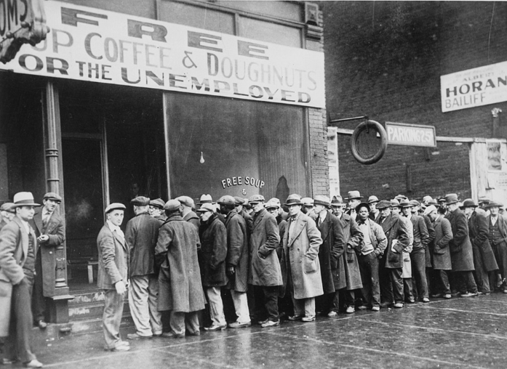

Stoa’s 2019-2020 Policy Resolution:
Resolved: The United States federal government should substantially reform its banking, finance, and/or monetary policy.
The scope of this topic is enormous, and since banking, finance and monetary policy are in the news every day, you will have no trouble finding ideas for cases when going Affirmative. You will also have a daunting research and preparation task ahead of you for Negative debates. In this chapter we will discuss the history of the topic, covering major issues and events up to the present day. This may give you some ideas for new cases and areas of research to prepare when going Negative.

1600’s – 1700’s
England, Spain and France were the major powers that colonized most of the portions of North America that now comprise the United States, and so their “monetary policies” (and the limitations of long distance travel in that era) determined the functioning of the economy in the colonies. The Spanish found vast quantities of silver in their colonial possessions and minted coins that circulated widely in the New World and in Europe. But English colonies had serious problems with their money supply. The British government banned the export of silver coins from the mother country to the colonies, partly because they believed the colonies existed for purpose of enriching England and partly due to shortages of silver coins within England itself.
Shortages of coins in the English colonies led the colonists to try creative solutions to have a functioning economy with a shortage in the money supply. One old standby was paper money, which could always be printed with a face value advertising that it was redeemable in precious metal coins, but with the hope that it never would be redeemed, so that the issuer could print far more of it than could actually be supported by the supply of metal. The results were predictable, as such paper money was soon understood to be unreliable and its value quickly depreciated.
Another solution was simply to use the Spanish silver coins as currency. The Spanish silver dollar was so widely used that it became the standard for the US monetary system after independence from England. The value of the Spanish dollar, however, was higher than necessary for many transactions and the colonists lacked smaller coins to make change. The solution was to cut the silver coin into eight pieces and give the pieces as change, hence the historical reference to coins as “pieces of eight” and a quarter dollar as “two bits.”
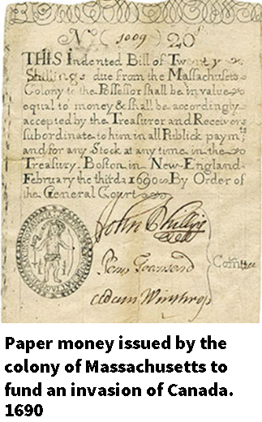
After independence, one of the first things our new nation did was to establish the dollar (based on the Spanish silver dollar) as the currency and establish its value and the components of its related coins. The coinage system thus defined (see picture below) remained in effect from the passage of the Coinage Act of 1792 until 1863.
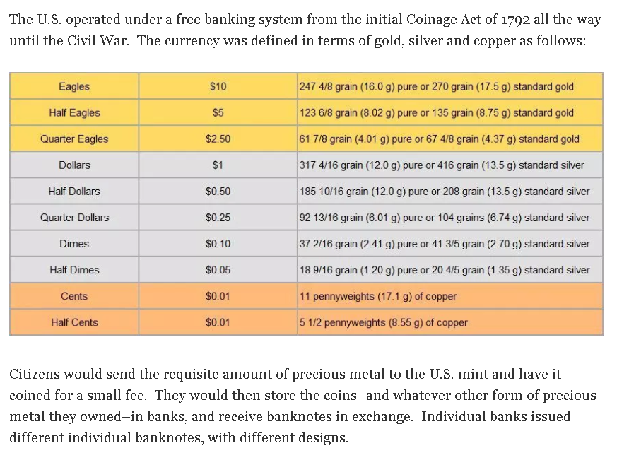

The “Free Banking” Era
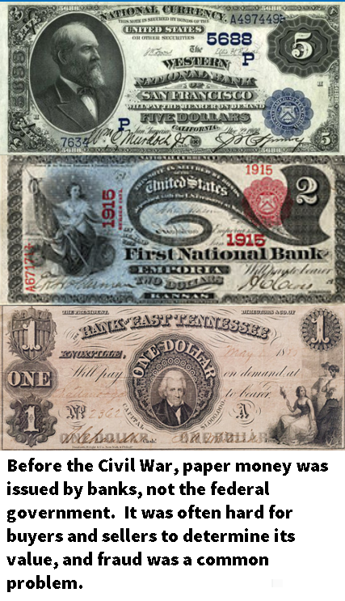
From the time of the Coinage Act until the Civil War, federally-issued precious metal coins and private bank-issued paper money circulated together in the US economy. This created a number of problems of efficiency and concerns about policy.
“Prior to the establishment of the national banking system, the national currency supply consisted of a confusing patchwork of bank notes issued under a variety of rules by banks chartered under different state laws. Notes of sound banks circulated side-by-side with notes of banks in financial trouble, as well as those of banks that had failed (not to mention forgeries). In fact, bank notes frequently traded at a discount, so that a one-dollar note of a smaller, less well-known bank (or, for that matter, of a bank at some distance) would likely have been valued at less than one dollar by someone receiving it in a transaction. The confusion was such as to lead to the publication of magazines that specialized in printing pictures, descriptions, and prices of various bank notes, along with information on whether or not the issuing bank was still in existence.
If you’re sitting in Boston and selling goods to the public, and someone pays for their purchase with a $1 bill from the Bank of East Tennessee (see picture, bottom), you’ve got a problem. How do you know whether that bank is still in business (remembering that there is no internet where you can look it up)? How do you know if that bank even exists, and issued that paper? How do you know if there’s any gold in its vaults to make the paper worth anything?
During this era there were also two attempts to establish a federally-chartered central bank to handle the finances of the federal government and regulate the monetary system of the United States. The “Bank of the United States” was proposed by Alexander Hamilton and established in 1791 over the objections of Thomas Jefferson. It was criticized both on constitutional grounds and for what some perceived to be a negative impact on the US economy, and it was allowed to die when its charter expired in 1811. This may have been an unfortunate convergence of events, considering what happened the following year, as the outbreak of the War of 1812 suddenly placed great financial pressure on the endangered US government.
Reeling from the financial pressures of the recently ended war, Congress established the “Second Bank of the United States” in 1816. Designed to handle all the banking business of the federal government, regulate and stabilize the currency, and solve financial problems created by the War of 1812, it had mixed results. Many blamed it for a recession from 1819-1822 as the Bank was seen responsible for slowing the availability of credit in the economy. Some saw it as successful at stabilizing the currency in the years that followed from 1823-1833. Pres. Andrew Jackson, a “man of the people” who opposed the interests of big business and the bankers, opposed the Second Bank and refused to renew its charter in 1836. A shortage of currency led to the “Panic of 1837” immediately thereafter.

The Civil War and its Aftermath
As wars usually do, the Civil War created a sudden demand by the federal government for money to pay for its exorbitant and unbudgeted costs. Pres. Abraham Lincoln was told by the big New York bankers that they wanted 24-36% annual interest to loan the Union government money to finance the War. Not surprisingly, he began looking for other ways to obtain the funds needed to pay for the nation’s military efforts.
The National Banking Acts of 1863 and 1864 created major reforms of the nation’s monetary system, and not incidentally opened some creative ways of financing the deficit spending the federal government was using to pay for the war. First, the Acts began moving the country in the direction of a uniform national paper currency and reducing or eliminating the confusing array of private banknotes then in circulation.
“…newly created national banks were empowered to issue national bank notes backed by a deposit of US Treasury securities with their chartering agency, the Department of the Treasury’s Comptroller of the Currency. The legislation also placed a tax on notes issued by state banks, effectively driving them out of circulation. Bank notes were of uniform design and, in fact, were printed by the government. The amount of bank notes a national bank was allowed to issue depended upon the bank’s capital (which was also regulated by the act) and the amount of bonds it deposited with the Comptroller. “
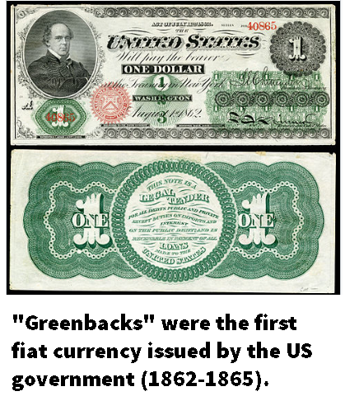
Requiring banks to buy bonds as backing for their deposits created an artificial market for federal bonds, which gave the Union an alternate source of borrowed funds, bypassing those greedy New York bankers we mentioned earlier.
“...the National Banking Acts …helped the Union government pay for the war. Adopted in the midst of the Civil War, the requirement for banks to deposit US bonds with the Comptroller maintained the demand for Union securities and helped finance the war effort.”
But why just borrow money when you can print it? The ongoing need for additional money to finance the Civil War also led Pres. Lincoln to issue the nation’s first “fiat currency,” commonly called “greenbacks” due to the color of the design on their back side.
“Between 1862 and 1865, the U.S. government issued more than $450,000,000 in paper money not backed by gold (greenbacks) to help finance the Union cause in the American Civil War. After the war, fiscal conservatives demanded that the government retire the greenbacks, but farmers and others who wished to maintain high prices opposed that move.”
The federal government ultimately did offer to redeem “greenbacks” with gold, starting in 1879. But in the meanwhile, their existence had an inflationary effect on the economy, as would be expected from any sudden increase in the money supply.

Gold and Silver in the Gilded Age
After the Civil War, industrialization proceeded at a rapid pace (at least in the North). The economy grew, although not without downturns and not uniformly throughout the nation. This era in American history, often called the “Gilded Age,” was characterized by sharp political divisions over the way the monetary system was designed, and whether it was fair to the farmers and common people or biased toward the interests of industrialists and bankers.
In 1871, German Chancellor Otto von Bismarck decided to demonetize silver, taking it out of his nation’s monetary system. The resulting drop in world demand for silver devalued it relative to other commodities (particularly gold), risking inflationary effects in nations that continued to use it.
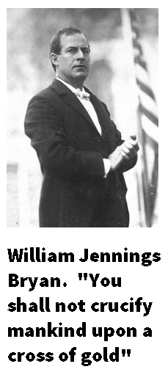
In 1873, Congress passed the Coinage Act, in which the U.S. followed Germany’s lead and decided to stop coining silver, putting US currency entirely on a gold standard. Taking silver out of the money supply had an immediate deflationary effect, with the predictable result of contraction of the economy and widespread unemployment. The “Panic of 1873” was the worst depression in the U.S. economy up to that time.
Advocates for returning silver to the monetary system urged the federal government to increase the money supply, which would have occurred at a rapid pace had the large quantities of silver found in the American West been brought into the economy. Inflation always benefits debtors and hurts creditors, and so politicians wanting to be seen as supporting the common man, the laborers, the farmers and the poor advocated for silver. William Jennings Bryan campaigned for President in the 1896 election on a platform of opposing the strict gold standard, in favor of bringing back silver along with gold to inflate the money supply. In one of the most famous political speeches in American history, he pleaded:
“Having behind us the producing masses of this nation and the world, supported by the commercial interests, the laboring interests, and the toilers everywhere, we will answer their demand for a gold standard by saying to them: ‘You shall not press down upon the brow of labor this crown of thorns; you shall not crucify mankind upon a cross of gold.’”
Bryan lost the 1896 election and the gold standard remained in place for another generation.

The Federal Reserve – Part I
In 1907, a major shock to the banking system forced many business and banking leaders to reconsider the configuration of America’s banking and monetary policies. The financial troubles of one large bank began to shake the public’s confidence in other related banks, resulting in a general run on the banks. Remembering the chart in the previous chapter on “fractional reserve banking,” you will recall that banks keep only a small fraction of their assets in readily available liquidity, with the rest invested elsewhere. When many depositors showed up at the teller windows in 1907 to reclaim their savings, the banks could not borrow enough money from other banks to satisfy the demand.
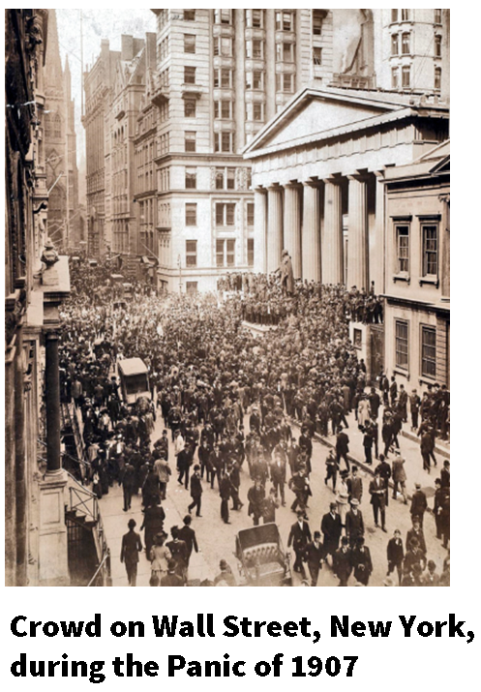
The ensuing panic led some of the leading bankers and politicians of the day to meet secretly at Jekyll Island, Georgia, in 1910 to begin planning a major reform of the system.
“Like many Americans, these men were concerned with financial panics, which had disrupted economic activity in the United States periodically during the nineteenth century. Nationwide panics occurred on average every fifteen years. These panics forced financial institutions to suspend operations, triggering long and deep recessions. American banks held large required reserves of cash, but these reserves were scattered throughout the nation, held in the vaults of thousands of banks or as deposits in financial institutions in designated reserve and central reserve cities. During crises, they became frozen in place, preventing them from being used to alleviate the situation. During booms, banks’ excess reserves tended to flow toward big cities, especially New York, where bankers invested them in call loans, which were loans repayable on demand to brokers. The brokers in turn loaned the funds to investors speculating in equity markets, whose stock purchases served as collateral for the transactions. This American system made bank reserves immobile and equity markets volatile, a recipe for financial instability.”
Following the recommendations of the Jekyll Island conferees, Congress voted in 1913 to create the Federal Reserve, a third attempt at a federally-chartered central bank designed to stabilize the money supply and manage the banking system.
“The Reserve Banks serve banks, the U.S. Treasury, and, indirectly, the public. A Reserve Bank is often called a "banker's bank," storing currency and coin, and processing checks and electronic payments. Reserve Banks also supervise commercial banks in their regions. As the bank for the U.S. government, Reserve Banks handle the Treasury's payments, sell government securities and assist with the Treasury's cash management and investment activities. “
In addition to the functions described above, the Federal Reserve plays an important role in influencing the nation’s money supply. We will revisit this later, since the way this role is carried out today depends on an important historical event that we must visit next.

The Great Depression
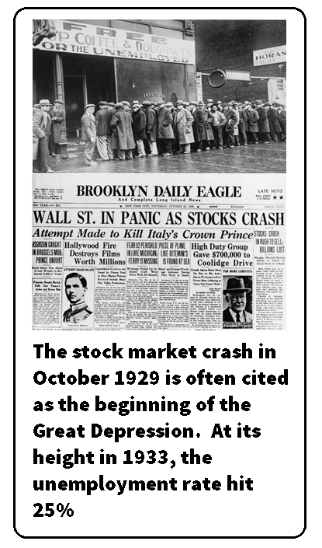
The stock market crash in October, 1929, is generally regarded as the opening blast of what became the greatest economic downturn in our nation’s history. The “Great Depression” lasted through the 1930s, with varying degrees of intensity, creating business bankruptcies, bank failures, high rates of unemployment, and a sense of mistrust in the reliability of the capitalist system to provide for the well-being of the common people. It led to dramatic changes in public policy, as President Franklin D. Roosevelt (in office from 1933 until his death in 1945) persuaded Congress to try radical measures to reform the banking and monetary system and to alleviate the suffering with various social programs collectively known as the “New Deal.”
The specific causes of the Great Depression are still being debated today, and it should be noted that none of them are mutually exclusive of one another. It is possible that a “perfect storm” of events occurred simultaneously which, taken individually, might not have created the Depression by themselves. It is also possible that some of these factors may not have caused the initial economic downturn, but may have made it worse and last longer than it would have otherwise. In no particular order, here are some factors to consider:
EASY CREDIT / CONSUMER CULTURE – The 1920s were the first generation in which widespread use of credit to buy consumer goods became available. Although credit cards didn’t really exist yet, installment plans and consumer loans exploded onto the market. It didn’t take long before many people bought new gadgets like refrigerators, record players, and mass-produced automobiles at affordable prices – affordable as long as you could make the payments. Any small downturn in the economy becomes worse if the economy is built on credit, because buyers who can’t pay back their loans not only stop buying stuff (slowing down factory orders, leading to layoffs), but also can’t pay for what they’ve already bought (leading to consumer and business bankruptcies).
STOCK MARKET BUBBLE – In the economic boom of the 1920s, the stock market was perceived to be heading only in one direction – up! People bought because prices were going up and prices went up because people bought more. On top of that, the practice of buying stock “on margin”– that is, paying only a small percentage of the actual cost of a stock purchase – exploded (an extension of the “easy credit” problem above). It works fine when you resell your stock a short time later at a profit, repay the borrowed unpaid balance, and pocket the profits. It gets everyone in trouble when stocks stop going up, brokers call their clients and demand payment for the unpaid balances, clients sell stocks to raise funds, but the stocks are worth less than before, they rush to the bank to get more money, but the bank doesn’t have the money because everyone else is doing the same thing. The stock market crashes, banks crash, and people go bankrupt and jump out of office buildings when their life’s savings are gone.
WEAK BANKING SYSTEM – There were numerous flaws in the banking system that led to bank panics and collapses in the United States. Some may have been caused by over-regulation (e.g. restrictions on interstate banking), while some may have been under-regulation (like allowing banks to invest depositors’ money in the stock market, so it was never safe in the bank as depositors’ thought it was).
FEDERAL RESERVE MONETARY POLICY – Many blame the Federal Reserve for not lowering interest rates and taking other steps to increase the money supply to combat the deflationary effects of the stock market and business contractions that were occurring at the beginning of the Depression. Increasing the availability of credit and money in the economy might have stimulated the economy and created a faster recovery. However, it is possible the Fed was constrained by…

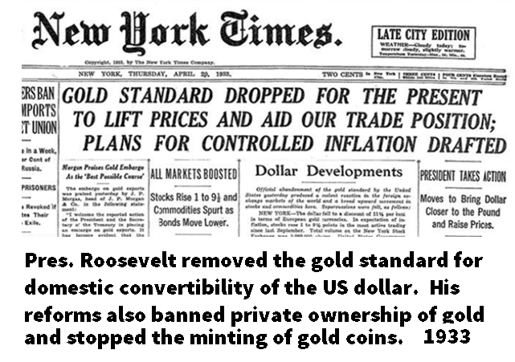
THE GOLD STANDARD – Since the US dollar was fixed by law to the value of gold, it was not as easy to inflate the money supply in 1933 as it is today. Some might argue that to be a good thing, while others partially blame the lack of monetary flexibility as one of the factors that worsened the Depression. Pres. Roosevelt took the US off the gold standard in 1933, and some economists argue that countries that went off the gold standard earlier during the Depression found economic recovery faster than countries that persisted longer on gold.
SMOOT-HAWLEY TARIFF – Early in the downturn, in 1930, Sen. Reed Smoot and Rep. Willis Hawley came up with a brilliant idea to turn things around. Their bill raised high tariffs on imported goods, with the goal of pricing them out of competition with American-made goods and motivating consumers to “buy American,” thus restoring manufacturing jobs in the United States. Unfortunately, the plan backfired. Foreign countries retaliated with tariffs of their own, driving down demand for US products previously exported overseas, and killing jobs in those industries. And it raised prices for consumer goods, which didn’t help consumers already struggling in hard times.
THE NEW DEAL – Federal programs designed to provide relief, create jobs , and improve the lot of the downtrodden may have, paradoxically, made things worse. The Social Security Act of 1935, for example, imposed payroll taxes on workers and businesses to pay for old-age pensions of future retirees. In the economic world, anything that is taxed will be discouraged and will have less of it supplied in the economy, because taxes make things more expensive. Taxing payrolls creates an economic incentive for fewer people to be put onto payrolls. Other government spending programs taxed or borrowed money out of the economy to be spent on government jobs – merely moving money around (and less efficiently than the private sector could have done), not creating any new businesses or jobs.
The banking, monetary and financial policy consequences of the Great Depression were profound. First, cutting the link between the US dollar and gold in 1933 for domestic transactions put the U.S. on the path to a fiat currency, expanding the ability of the Federal Reserve to inflate the money supply at will.
Second, numerous reforms to the banking system were created. One was the Glass-Steagall Act, which drew a sharp line between commercial banks (those serving public consumers, the “little guys”) and investment banks (those financing big deals on Wall Street for the financiers and big businesses). Commercial banks were subject to restrictions on what they could do with depositors’ money, in order to safeguard the life savings of the common customers who did their banking in them. Glass-Steagall was repealed in 1999, about which, more later.
Another reform was the establishment of the Federal Deposit Insurance Corporation, which provided a federal insurance guarantee on bank deposits up to certain limits. FDIC provides assurance to depositors that they will not lose their money no matter what happens to their bank, lessening the risk of bank runs based on rumors of insolvency.
The Depression also led to numerous regulatory reforms on Wall Street, in order to reduce fraud in the exchange of stocks and bonds. The Securities and Exchange Commission, established in 1934, enforces federal regulations on securities trading and requires various disclosures to be made by publicly traded companies in order to achieve fair and efficient markets.

The Federal Reserve – Part II
Post-Depression, the Federal Reserve was expected to take a more active role to try to ensure such an event never happened again. The “Fed,” as it’s commonly called, actively intervenes in the economy by taking steps to adjust the money supply, using these three tools:
I) The Federal Open Market Committee. FOMC influences interest rates and the money supply by doing four steps:
1. Create money digitally by fiat in accounts at the Federal Reserve banks.
2. Spend the newly created money on Treasury bonds. The extra demand for bonds (through laws of supply and demand) increases the general price of bonds, which lowers their interest rate.
3. The extra money circulates in the banking system, gets lent and re-lent (see the earlier chapter about “fractional reserve banking”) and at lower interest rates.
4. Lower interest rates and more money supply means more business expansion, more consumer spending, more homes purchased, etc. Taken too far, this could lead to higher inflation and its resulting economic harms.
Of course, FOMC could also do the inverse by selling some or all of the inventory of bonds in their inventory, with all the reverse effects (higher interest rates, lower money supply, cooling of business expansion and reduced consumer spending). Taken too far, this could lead to deflation and its resulting harms.
II) The Discount Rate. While the “Fed” doesn’t set by fiat interest rates in the entire economy, they can and do set interest rates by fiat for one specific type of lending: money lent overnight among banks within the Federal Reserve system. Remember the reserve requirement in the section on banking in the last chapter, and you will recall that when reserves run low, banks will need to augment them in order to be able to satisfy depositors’ demands for funds. Banks will borrow money to fill their reserves if they drop below a certain level or if they need more reserves to meet liquidity needs. The interest rate on such borrowing, if raised, will discourage banks from lending out as much of their reserves into the economy. If lowered, it will encourage more lending. All of the same effects on the money supply and the economy as noted in the FOMC example above will occur.
III) Reserve Requirements. A more direct way tell banks to keep more in reserve (with the effect of slowing lending and raising interest rates) or keep less in reserve (lowering interest rates and increasing lending) is to simply set a higher or lower reserve requirement. In the example in the previous chapter in the fractional reserve banking chart, we used a hypothetical 20% reserve requirement. If that had been raised to 30%, many of those loans that each bank made with their non-reserve funds would not have been made, since the money would not have been available to be loaned out, being forced to be held in reserve. The reserve requirement might also be raised if it were believed that banks might face a liquidity crisis and need more reserves to weather the storm. Another factor that could influence a bank’s decision about reserves is the Fed’s decision to pay interest on reserves. If such is paid, and the rate is high enough, it would induce banks to put more in reserve and less into the lending stream, since they would be earning “free” money (and “risk free” money) by leaving it in reserve.

From Bretton Woods to Vietnam
After World War 2, leading industrial nations convened to determine how international currencies would be traded, following the chaos and emergency measures of the war. The meeting, held at Bretton Woods, New Hampshire, resulted in an agreement to make the US dollar the pivot point of international currency markets. Other currencies would be valued in relation to the dollar, and the dollar would be valued in relation to gold.
“Between 1946 and 1971, countries operated under the Bretton Woods system. Under this further modification of the gold standard, most countries settled their international balances in U.S. dollars, but the U.S. government promised to redeem other central banks’ holdings of dollars for gold at a fixed rate of thirty-five dollars per ounce.”
Many believe the Bretton Woods era was a time of stability and economic growth to be envied by the decades that followed. But storm clouds were on the horizon.
In 1964, Pres. Lyndon Johnson announced his intention to build a “Great Society,” a goal that would require substantial increases in federal spending on social welfare programs. After winning the election in the fall of 1964, the following year Pres. Johnson also announced the escalation of the simmering war in Vietnam, to which the United States had already committed a small but growing amount of military support. Doing both of these simultaneously, without raising the taxes necessary to pay for them, resulted in more deficit borrowing by the federal government. The Federal Reserve obliged by increasing the money supply, but this was dangerous because the dollar was still officially linked to gold.
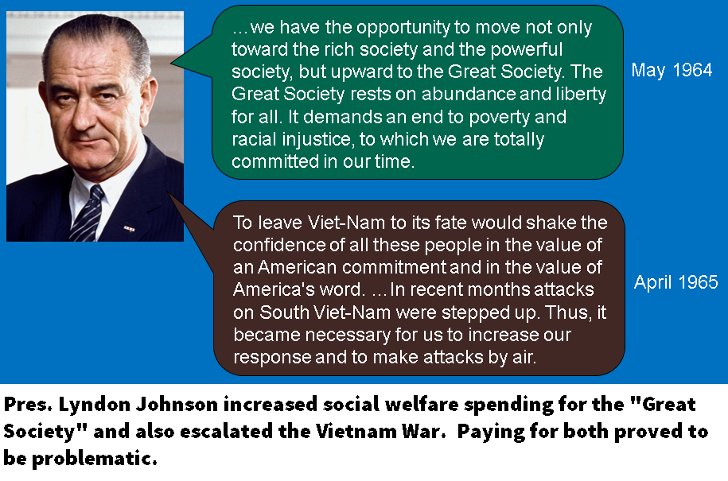
In 1971, Pres. Richard Nixon faced pressure from foreign governments who were starting to notice the disparity and began trying to redeem all those dollars for the promised gold at $35/ounce. Nixon knew that America’s gold reserves couldn’t keep up with the demand, so he closed the “gold window” and declared that the US dollar would henceforth no longer be convertible to gold at all. The US dollar became a pure “fiat currency.”
The results were predictable: the artificial increase in the money supply (enabled even further by the removal of linkage to gold) led to inflationary pressures on the economy as the supply of dollars increased (making each dollar worth less – simple supply and demand). What wasn’t predictable was that during the 1970s, not only would inflation be a serious problem, but unemployment began rising as well. Normally economists had expected them to be the inverse of each other, but the resulting “stagflation” (stagnation of the economy/employment + inflation of prices at the same time) troubled Americans all through the decade.
“Milton Friedman … believed prices could not increase without an increase in the money supply. To get the economically devastating effects of inflation under control in the 1970s, the Federal Reserve should have followed a constrictive monetary policy. This finally happened in 1979 when Federal Reserve Chairman Paul Volcker …drove interest rates to double-digit levels, reduced inflation and sent the economy into a recession.”

The 2008 Financial/Housing Crisis
During and after the 1980s, a general spirit of deregulation in the banking and finance sectors was in fashion. In 1999, Congress repealed Glass-Steagall, freeing up commercial banks to again make the kinds of investments they had not previously been allowed to make.
In 2001, the collapse of energy trading company Enron angered investors and the public, as it became apparent that corporate insiders had gotten away with shady accounting practices to deceive investors about the value of their stock, as they manufactured profits out of thin air and hid losses in secret accounts. These same insiders had been selling their company stock, while advising everyone that the company’s future was rosy. It was, in reality, headed for bankruptcy, as the shady deals collapsed, and many employees lost not only their jobs but their savings and their retirements. Congress passed new regulations on corporate accounting which, though possibly not part of this year’s topic, did suggest that the era of deregulation might be over, and that there was a growing sense in society that big corporations could not be trusted without strict government oversight.
Banks and big investment firms developed new investment vehicles that created risks often not clearly disclosed (and possibly not even clearly known). Many of these were based on the housing market, where low interest rates and the ready market for packaged mortgage-backed securities motivated lenders to reach deeper and deeper down the list of potential clients, extending loans, often knowingly, to customers who could never have paid them back. When these unqualified borrowers, euphemistically called “sub-prime,” began having trouble paying back loans they never should have taken, the housing market and the banking system both began to collapse. The resulting downturn in the economy was the worst since the Depression, and is often referred to as the “Great Recession.”
“Many argued that allowing banks to diversify in moderation offers the banking industry the potential to reduce risk, so the restrictions of the GSA [Glass-Steagall Act] could have actually had an adverse effect, …Furthermore, big banks of the post-Enron market are likely to be more transparent, lessening the possibility of assuming too much risk or masking unsound investment decisions. As such, reputation has come to mean everything in today's market, and that could be enough to motivate banks to regulate themselves. …in November of 1999, Congress repealed the GSA …commercial banks went back to getting involved in risky investments to boost profits. Many believe that the additional risk-taking, in particular, subprime lending, led to the 2008 financial crisis.”
Anger at the behavior of the banks was coming from all sides. First, why had they lent money to people who could never have paid it back? Second, why had they based their business model to such an extent on risky loans such that banks were at risk of collapse due to these bad bets? Third, what right now did they have to ask for government bailouts to save them from their own bad business decisions? And as always, the sight of banks foreclosing on average Americans’ homes never helps bankers’ reputations, whether the home-buyer was a good faith borrower who fell on hard times or an unqualified borrower who just wanted more than they could afford.
Congress reacted to the crisis by passing the “Dodd-Frank Wall Street Reform and Consumer Protection Act” (a.k.a. “Dodd-Frank) in 2010. Its policies were:
- Establish the Consumer Financial Protection Bureau (CFPB) to regulate credit cards, mortgages, etc.
- Establish the Financial Stability Oversight Council, Office of Financial Research, to study threats to US financial stability
- Restrict speculative investments by Banks (without reinstating Glass-Steagall)
- Setting rules & methods for orderly liquidation (bankruptcy) of banks and non-bank financial entities
- Investigating banks perceived to be “Too Big to Fail” to try to avoid the dilemma of either spending taxpayer dollars to save private banks in a bailout, or not spending it and having the entire banking system fail when a huge bank takes down all the others.
Banks further alienated the public as revelations came out regarding unethical behavior. For example, Wells-Fargo bank was caught creating fake accounts and charging their customers fees for things they never wanted.
“Janet L. Yellen, in her last act as Chairman of the Board of Governors of the Federal Reserve System, imposed what are being described as unprecedented sanctions on Wells Fargo Bank for the bank’s ”widespread customer abuses” of the last several years. The Fed cited not only the millions of customer accounts Wells Fargo opened without authorization, even forging some customer signatures, but also the more recent data that they had charged hundreds of thousands of their borrowers for unneeded guaranteed auto and collateral protection insurance for their automobiles. And let’s not forget the thousands of customers they enrolled in online bill pay without their authorization.”
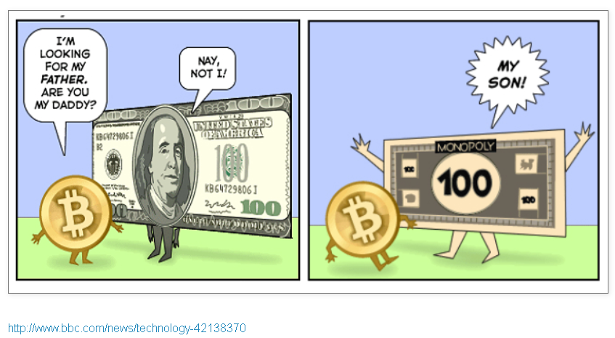
And finally we should briefly mention “cryptocurrencies,” a new phenomenon that appeared in 2009 with the advent of Bitcoin. Cryptocurrencies are fiat currencies created by private entities, not governments, and exist only online. They provide a medium of exchange in online transactions that promises to provide more anonymity, since computer programming techniques keep track of the location and amount of all units of the currency, and the buyer’s or seller’s names are not attached to it at any point. Over 4000 crypto currencies now exist and there is substantial debate over whether they are good or bad, beneficial or harmful. Their value fluctuates, and a recent bubble enriched and then impoverished Bitcoin holders as their value rose and then quickly crashed.

Current Issues, Briefing Topics & Case Ideas
Here is a short, incomplete, but hopefully useful bullet list of a few briefing topics based on current issues being discussed in the literature on banking, finance and monetary policies. We suggest you start with these as possible ideas either for Affirmative cases or for Negative briefing.
Currency modifications: abolish the penny, change the picture on $20 bill, $10 bill or dime
Gold Standard reinstatement
Federal Reserve issues
- reserve requirements
- abolish the Fed
- audit the Fed
- greater transparency
Repeal Dodd-Frank
Reinstate Glass-Steagall
Break up the big banks (so they won’t be “too big to fail”)
Currency manipulation by foreign trade partners
Predatory lending, usury limits
The “Cashless Society” – transition away from physical cash, do everything digitally. Good or bad?
Cryptocurrency regulation
Repeal FATCA (regulation of US citizens’ bank accounts in foreign countries)
Banking for state-legal marijuana operations, currently blocked by federal law
Repeal tax-exemptions for credit unions
Online lenders / Industrial Loan Companies (ILCs) – bypass regulations by going under State laws
Data privacy protection / cyber-hacking in the financial system
The “Volcker Rule”
Repeal or reform the Community Reinvestment Act
GNMA, FNMA, FHLMC – reform or abolish
Post Office banking
Increase or reform anti-counterfeiting measures
Debt collection abuses / regulations
Reform or reduce bank deposit insurance
Federal court decision Madden v. Midland Financing, on the “valid when made” lending rule

GENERIC BRIEFING IDEAS – for going Negative against unexpected cases
Economy is good, stable now
Federal Reserve doing great now
Fiat currency OK
Banking system stable now
Causes of the Great Depression – a list to allow arguing the “real” cause, whatever is different from AFF case
Causes of the Great Recession – a list to allow arguing the “real” cause, whatever is different from AFF case

Worksheet: Monetary, Bank & Finance Terminology
Name: ____________________________________ Date: ________________________
Answer the following in the spaces provided.
1. The?

2. What?

3. What did?

4. What Suprem?

5. As today?

6. What did it do?

7. Before?

8. Explain?

9. Has?

10. How many?

Answers
1.

https://www.philosophicaleconomics.com/2014/07/goldstandard/
https://eh.net/encyclopedia/us-banking-history-civil-war-to-world-war-ii/
https://eh.net/encyclopedia/us-banking-history-civil-war-to-world-war-ii/
https://eh.net/encyclopedia/us-banking-history-civil-war-to-world-war-ii/
https://www.britannica.com/event/Greenback-movement
“gilded” objects have a thin shiny coating of gold, but are made of cheap materials underneath
William Jennings Bryan at the Democratic Party convention in Chicago, 9 July 1896.
“Nationwide panics occurred on average every fifteen years” – a very important phrase to remember when debating this year. This is referring to a time “with” the gold standard and “before” the Federal Reserve. You will need to research evidence on this for Negative debates, since many Affirmative plans are supported by the myth that there were never any economic, banking or monetary problems before the Fed or under the gold standard.
https://www.federalreservehistory.org/essays/jekyll_island_conference
https://www.federalreserveeducation.org/about-the-fed/structure-and-functions
Canada did not have the major bank failures that the U.S. did during the Depression, suggesting that whatever system of bank regulation they had was superior to ours.
Transactions involving the US dollar in international trade as a “reserve currency” (where buyers and sellers in foreign countries use the dollar as an intermediate standard between their two national currencies in their foreign trade) were still pegged to gold, and the dollar could be redeemed for gold by foreign holders of dollars. See below for how this becomes a problem in 1971.
Normally federal bonds would be purchased like any other securities, on the open securities markets with money from investors (like individuals, corporations, mutual funds, endowment funds, etc.). When the Federal Reserve buys the bonds, it does so with newly created fiat money, which has the effect of injecting new money into the economy, increasing the money supply. You may certainly debate whether this is a good or bad thing.
https://www.econlib.org/library/Enc/GoldStandard.html Note that Bretton Woods did not reverse FDR’s removal of gold from conversion to the dollar within the U.S. Convertibility to gold applied only to international transactions. It remained illegal for American citizens to own gold until Dec. 31, 1974.
https://www.investopedia.com/articles/economics/08/1970-stagflation.asp
And since governments never have corruption or fraud, they are perfectly designed to root it out in private businesses…
www.investopedia.com/articles/03/071603.asp (brackets added)
Richard M. Bowen, Feb 2018
Although I have my own doubts on whether these are “substantial” reforms of monetary policy, other debaters may want to run these, so you might want to brief against them. The day to day impact of these reforms would likely be minimal.
https://www.cuinsight.com/postal-banking-not-a-solution-nafcu-tells-congress.html. This is not as farfetched as it sounds. From 1911-1967, US Post Offices offered savings accounts (my father had one). Their popularity surged during the Depression because people were scared of banks, since so many had crashed and lost their depositors’ money. In France today, the postal service also functions as a full bank, with checking accounts, ATMs, etc., in competition with regular banks. You can cash checks in the same line where you mail packages, if you have an account with them.

